AIGA IAN| EARLY CAREER RESEARCHER | UNIVERSITY OF PAPUA NEW GUINEA

The effects of gender-based violence on women and men’s mental health in Papua New Guinea: A case study in Kupiano Station, Kelerakwa Village and Wavulu Landmass Area, Central Province, Papua New Guinea

Summary: Gender-based Violence is closely linked to mental health challenges among men and women. The study examines how the incidence of gender-based violence affects men’s and women's mental health in selected communities, thereby shedding light on GBV triggers, coping and recovery mechanisms, and barriers to seeking assistance. This policy brief provides recommendations to tackle mental health challenges associated with GBV in the communities.
- The triggers such as arguments over lack of provision and support from men, women’s overwork and burden, jealousy, and infidelity escalate into physical, emotional and psychological violence.
- GBV has a significant effect on the mental health of women and men. The research reports women experiencing depression, fear, anxiety and suicidal thoughts while men face regret, guilt, shame and suicidal thoughts–often caused by perpetrating or observing violence and worsened by alcohol and drug abuse. Children exposed to violence may possibly continue the violence when they are older, experiencing emotional and educational disadvantages that continue trauma generation after generation.
- Churches are the main support systems in the community with minimal or zero government services leaving survivors with zero professional mental health care and legal support.
- Bride price and patriarchal structures ensnare the GBV survivors restricting them from seeking assistance due to feelings of ownership, fear of gossip and community judgement.

What is the development issue?
Gender-Based Violence (GBV) in rural PNG communities is prevalent yet often underreported and considered insignificant. This is a critical development issue that affects families, contributes to poverty, causes social problems and perpetuates poor mental health for both men and women. In Wavulu, Kelerakwa and Kupiano, gender-based violence is prevalent and rooted in the cultural elements of the rural settings such as bride price, gender roles and male decision-making structures.

GBV in Papua New Guinea (PNG) is predominantly perpetrated by intimate partners (men) towards women that encompasses sexual violence, physical assault, psychological abuse, emotional and financial violence (Mkandawire, 2009). The consequences of GBV are extensive, with substantial connection to mental health issues among men and women in PNG (Ganster-Breidler, 2010; Jewkes et al., 2017).
GBV correlates with higher incidences of depression, Post-Traumatic Stress Disorder (PTSD), anxiety, alcohol abuse among women, suicidal thoughts and attempts, trauma, mental illness and suppression, physical injuries, and death (Ganster-Breidler, 2010; Ian, 2023; Jewkes et al., 2017; Médecins Sans Frontières, 2011). GBV also often leads to low self-esteem, shame and loss of self-respect where women survivors feel that they are the reason violence eventuated. For instance, a study revealed that 70% of Intimate Partner Violence victims experienced low or very low self-esteem (Dhouib et al., 2021). Additionally, GBV survivors may withdraw from their communities and social activities, fearing social stigma or further violence, and become self-preserved and isolated (Ian, 2023). These results highlight the urgent need for initiatives focused on preventing domestic violence and providing mental health assistance to affected women. Their sense of safety and well-being is severely compromised, leading to emotional and psychological scars that can last long after the violence.
Furthermore, GBV exposure results in some marriages and relationships dissolved that leaves men mentally depressed. To deal with the mental depression, men deal with it by increasing their alcohol consumption and drinking themselves away (Ian, 2023; Jewkes et al., 2017). While GBV affects men and women differently, the mental health effects on men in PNG are significant and often unnoticed. A detailed examination of the literature indicates that IPV perpetrators frequently face a variety of psychological issues, such as problems with anger, anxiety, depression, suicidal tendencies, personality disorders, alcoholism, and gambling addiction, with elevated rates of comorbidity (Sesar et al., 2018). The normalization of violence makes prevention efforts less effective, as men find themselves dealing with violence both as perpetrators and as victims of 'discipline' outside their homes (Lusby, 2014). Men also experience social disgrace and isolation as perpetrators. The perception of the community changes once the man becomes a perpetrator. The community does not see the person with flaws but a perpetrator (Ian, 2023). These insights highlight the mental health challenges men encounter from the GBV exposure. Therefore, it is important for the narratives of men and women regarding mental health issues associated with GBV be known, to advocate for government to strengthen their implementation on the policies to address this critical issue.

Research Aim: This study uncovers the mental health challenges associated with gender-based violence in the communities. While the physical and emotional impacts on women have been commonly documented, men’s mental health impacts from GBV are often overlooked. This qualitative study explores the participants’ views and experiences of psychological impacts of gender-based violence in Kelerakwa village, Kupiano Station and Wavulu Landmass Area. Therefore, the study aims to understand how the incidence of gender-based violence affects women’s and men’s mental health.

Research question: What are the effects of gender-based violence on women and men’s mental health in Wavulu Landmass Area, Kupiano Station and Kelerakwa Village? The four main objectives of this research were;
- To explore the effects of gender-based violence on women’s and men’s mental health
- To assess mental health services associated with gender-based violence at the community level
- To understand the ripple effects of mental health impacts in the communities
- To propose solutions to address mental health issues associated with gender-based violence
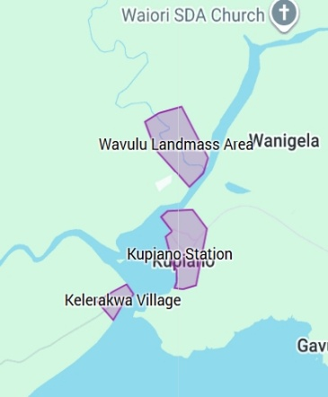
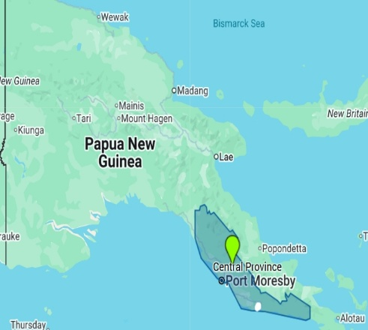

Figure 1. Map of Papua New Guinea (left) showing the boundaries of Central Province outlined in blue. The arrow pointing to the white dot indicates the research sites. The map on the right shows the locations of the research sites, outlined in purple. Adapted from Google Maps by the author. Map data ©2026 Google.

Methodology: A qualitative research approach was utilized involving 51 participants through interviews and focus groups from Kelerakwa village, Kupiano station and Wavulu Landmass area in Central Province, Papua New Guinea aged 18–71 years. The study encompassed the perspectives of councillors, community elders, health workers, district public servants, youth, community and church leaders in the community both women and men. Data were analysed thematically. The fieldwork took place from 13 October to 20 October 2025 across the three sites. This research progressed after receiving research ethical clearance from the School of Humanities and Social Sciences (SHSS) Research Ethics Committee at the University of Papua New Guinea and in-country research approval from National Research Institute of Papua New Guinea.

Key findings
The key themes that emerged are organized into four main parts: GBV triggers and occurrence, impacts of GBV on women and men’s mental health and children, coping mechanisms and support systems, and cultural and systemic blockages to support. See Appendix A for the conceptual diagram of the findings.

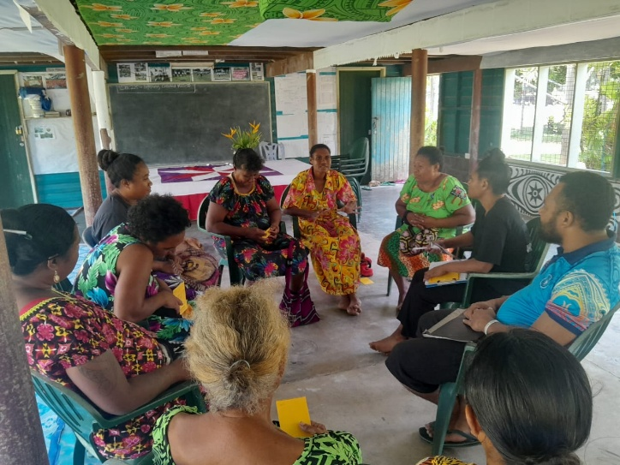
Figure 2: Focus Group participants from Kupiano Station.

- GBV Triggers and occurrence

Gender roles have existed for a long time. Traditionally, gender roles were already distributed or delegated by former generations of what men and women will do in society. However, violence is often triggered when men fail to uphold their expected role for the family through gardening, fishing and other income generating activities.
One focus group participant noted: “Man must provide… if the man just roams around… then there is possibility of triggering violence.” (FGD01)
In addition, women complain about the lack of support from men while women literally overwork. They go for gardening, they cook, clean the house, cut firewood, bear and raise the children with minimal or zero support from men. This intensifies into extreme pressure, which reveals as complaints leading to a key trigger of violence from men. Jealousy and infidelity is reported also as a trigger for violence occurrence whether assumed or real for both men and women.

These insights emphasise how the triggers such as arguments over lack of provision and support from men, women’s overwork and burden, jealousy and infidelity escalate into physical, emotional and psychological violence. Existing laws and policies on violence response and prevention must be strongly implemented.

- Impacts of GBV on women and men's mental health and children

The mental health impacts of GBV are highly evident. Women suffer psychologically from GBV experiencing sadness, worry, fear, stress and depression. They overthink, lose weight and withdraw from social activities and community gatherings. Suicidal thoughts are prevalent among women survivors. A critical theme emphasized in the study. However, it was highlighted that only the thought of their children stops them from committing suicide.
“You feel like dying. But thinks of the children.” (KII01)
In addition, some women often leave their partners and go back to their parents. Otherwise, they continue to suffer in silence. They (women) often become isolated halting participation in community and church activities due to shame, fear and low self-worth. In addition, women live in relentless fear of their partners, leading to alertness and failure to break free mentally from the abusive setting.

Furthermore, there is a clear distinction in mental health impacts experienced by men instigating violence and as a men witnessing violence. Study reports that men who perpetrate violence experience regret, guilt, shame, isolation and frustration after the occurrence. Obviously, some may become suicidal overthinking about the perpetration of violence against women and sometimes man feel suicidal when the woman leave as a result of violence. Nevertheless, men cope with the mental health impacts with alcohol and drug consumption, further violence and internalize their feelings due to societal expectations of being a man.
“Men release their stress through violence. They go and consume alcohol and drug to manage stress related to violence.” (KII03; KII16)
Interestingly, the report highlights men feeling anger, pity, and sadness when they witness GBV in their sight. They feel disputed, wanting to interfere but do let it go. They fear retaliation from the perpetrator. These insights underscore the mental health challenges faced by men witnessing or causing violence.

The study also highlights the impact GBV has on children. Children who observe the violence are likely to repeat the process in their future relationships when they grow up. They learn that violence is a norm in the family life.
“By witnessing their parents’ violence daily… when they get older they tend to cause violence.” (KII26)
Children who observe GBV experience lack of concentration in education. Their education is severely affected. Children exposed to GBV develop behavioral problems such as disobedience, stubbornness, bitterness, trauma and anger. There is obvious parental neglect of their basic needs like food, school fees, family time and parental care. They are not met due to family disunity and poverty. Interventions targeted at improving men and women’s mental health may disrupt the challenges of GBV. Early interventions, especially during childhood and adolescence, are essential for disrupting the cycle of violence and mental health challenges (Rees & Silove, 2011).
- Coping mechanisms and Support Systems
Moreover, men and women cope with the stress related to violence either in unhealthy or healthy ways. The unhealthy ways men cope with the stress are through alcohol and drug consumption, committing adultery and further violence. While women cope with the stress by internalizing the pain and suffering in silence, leading to the mental health issues reported above. Some men and women involve in gardening, fishing, cutting grass, cleaning up, and community services to manage stress healthily. They also use prayer and temporarily leave the situation to cool off.
The primary conflict resolution method for resolving the violence incident between the conflicting parties is through the customary reconciliation ceremonies in these communities.
One participant cited: “So when she goes… the man does "Rala rage" a special dish… kills pig, contribute money, food and bring it to the parents of the wife.” (FDG01)
This customary practice is significant for restoring and sustaining peace but does not address the real psychological trauma deep within.

Evidently, the church is the only main support institution in the community apart from the customary reconciliation process. The contribution of the church is substantial where church leaders provide spiritual counselling, reconciliation, mediation and intervene during the violence outbursts. Although, professional clinical mental health care is noted absent, they play an important role to restore peace between the conflicting parties. There is evidence of minimal or zero government services supporting individuals that suffer mentally from violence. Participants reported lack of legal support, ineffective law enforcement, zero counselling services and mental health professionals and minimal awareness programs from the government. The government representatives such as the District Community Development Officer and local Ward Councillors were noted ineffective. For instance:
“Government programs are not available... Only the church is involved.” (KII03)
More or less, sometimes immediate families step in to support the survivors. However, the wider community and clan structures are often highlighted as not supportive, sometimes propagating gossip and judgement instead. The support systems must be equipped with resources to assist survivors in the communities.
- Cultural and systemic blockages to Support
Bride price payment is a cultural obligation done by the man. Bride price payment is cited repeatedly as a major barrier for GBV survivors accessing and seeking mental health support or external assistance. Women endure suffering from violence to validate the payment of bride price. Bride price ensnares the GBV survivors and creates a sense of ownership. For example;
“If man puts the bride price, she will not go back to the parents even when she goes through violence.” (KII14)

In patriarchal social and power structures, the male is given more authority than the female (Wassan et al., 2021). From an epistemological view, almost ninety per cent of the societies in PNG are made up of patriarchal social structures. The findings highlight a strong patriarchal norms and power imbalance existence. This power dynamic silences women, especially from the outside communities and those within the community, discouraging them from the right to seeking assistance from their families and limited available support services.

Furthermore, fear of gossip from the community hinders women survivors to seek assistance and speak out about their suffering. This thought entraps them reaching out for assistance. Additionally, women have trust issues with clan and church leaders sharing their issues highlighting the flaws of handling the confidential information effectively. The fear of gossip, lack of trust and shame averts women from seeking help. Overall, these barriers silence and prevent survivors from accessing limited support available in the community.

Implications

PNG rural communities such as Wavulu Landmass Area, Kelerakwa Village and Kupiano Station, reported gender-based violence prevalent. The psychological impacts of gender-based violence is a serious development issue in Papua New Guinea and the Pacific. The following recommendations as implied by the data demands comprehensive strategies to prevent mental health challenges associated with GBV.
MFAT and Donor Partners: A serious gap identified in Kelerakwa village, Wavulu Landmass Area and Kupiano Station is the zero presence of mental health care professionals and access to support services such as professional clinical counseling for GBV survivors. Fund GBV mental health programs, train church leaders and engage community-based volunteers as counselors in trauma-informed care and GBV case management.
Policy Intervention: The government of Papua New Guinea recognizes the importance of addressing the issue of Gender Based Violence. Strengthen the implementation of the National Strategy to Prevent and Respond to Gender Based Violence 2016-2025 and National Health Plan 2021-2030 of Papua New Guinea having more emphasis on the mental health aspect of GBV. Strengthen the capacity of relevant Local Level Governments, District and Provincial Health Authorities to engage local welfare and health officers to work with the communities to enforce GBV case management and legal support, provide counseling and referral pathway support to the survivors.

Church and NGO partnerships: Church is the primary institution that provides support to the survivors in the community apart from cultural reconciliation processes. Churches should form partnerships with NGOs to get appropriate training to deal with all forms of violence and their effects correctly and do referrals.

Community stakeholders Collaboration: Collaborate between all community stakeholders such as churches, ward development committee, community professionals, community leaders, members and institutions to advocate on GBV and its integration into school curriculum and challenge detrimental norms and practices around bride price, gender roles, and support survivors recover from violence. Conduct awareness campaigns on mental health issues associated with GBV that are suitable for the community and considers cultural relevance.

Engaging Men and Boys: Conduct programs to empower men through education and economic opportunities, life skills, financial planning and addressing poverty could reduce the pressure on GBV triggers. Community programs specifically for men are also recommended to encourage responsible and positive fatherhood, reassess their masculinity, hold men accountable for violence perpetration and create men’s support networks for preventing and ending violence.

Limitations and further research

This research is the first carried out on GBV associated with mental health impacts in the nominated communities. The main limitation in the research was language barrier. Despite engaging the translators, few of the interview questions were not understood well. The questions were repeated and simplified properly in the vernacular language before they answered the questions. The limited sample size could mean that the implications around the surrounding areas are likely biased. Above recommendations should be adapted and piloted in Wavulu, Kelerakwa and Kupiano. These findings may not be applicable to all the PNG contexts. In future research, develop interventions that can be generalized across PNG to address mental health issues.

References
Dhouib, H., Omri, S., Daoud, M., Amar, W. B., Smaoui, N., Feki, R., & Maalej, M. (2021). Intimate partner violence and self-esteem. European Psychiatry, 64 (S1), S836–S836. doi:10.1192/j.eurpsy.2021.2208

Ganster-Breidler, M. (2010). Gender-Based Violence and the Impact on Women’s Health and Well-Being in Papua New Guinea. Contemporary PNG Studies, 13, 17-29.

Ian, A. (2023). Impacts of gender-based violence on women in Hula community (Unpublished Honors dissertation) University of Papua New Guinea, Port Moresby, Papua New Guinea.

Jewkes, R., Jama-Shai, N., & Sikweyiya, Y. (2017). Enduring impact of conflict on mental health and gender-based violence perpetration in Bougainville, Papua New Guinea: A cross-sectional study. PloS One, 12 (10). http://dx.doi.org/10.1371/journal.pone.0186062

Lusby, S. (2014). Preventing Violence at Home, Allowing Violence in the Workplace: A Case Study of Security Guards in Papua New Guinea.

Medecins Sans Frontieres. (2011). Hidden and Neglected: The Medical and Emotional Needs of Survivors of Family and Sexual Violence in Papua New Guinea. Medecins Sans Frontieres, Papua New Guinea.

Mkandawire, B. (2009). Gender-Based Violence and HIV/AIDS Impacts on the Malawian Community. The Society of Malawi Journal, 62 (1), 1-14.

Rees, S.J., & Silove, D.M. (2011). Gender‐based violence and the threat to women's mental health. Medical Journal of Australia, 195.

Sesar, K., Dodaj, A., & Šimić, N. (2018). Mental health of perpetrators of intimate partner violence. Mental Health Review Journal.

Wassan, M. R., Abdul, R. C., & Syed Faisal, H. S. (2021). Violence against Women in Pakistan: Causes, Consequences and the Way Forward. International Research Journal of Arts and Humanities, 49 (49), 49.

Appendices
Appendix A: Conceptual diagram of the findings

Heart of the issue
-Rigid gender roles
-Patriarchal culture
Effects on Children

Acknowledgment

I firstly give glory and honor to God Almighty, Jesus and the Holy Spirit for sustaining me through this research. I acknowledge the funding support received from MFAT/DevNet. This research would not have been possible without the support from MFAT/DevNet. I am forever grateful and indebted to MFAT/DevNet. I also thank my supervisor (Dr. Dora Kuir-Ayius) for her guidance, research communities and participants from Kelerakwa village, Kupiano Station and Wavulu Landmass Area and research assistants for the completion of the research data collection. The views expressed are entirely my own and do not necessarily reflect the position of DevNet, the New Zealand government, the New Zealand Ministry of Foreign Affairs and Trade or any other party.

