Hanh Dang| Doctor of Philosophy | University of Otago

Climate change vulnerability and adaptive capacity of Ethnic minorities in Mountainous Northern Vietnam

Summary: Environmental changes, such as shifts in the predictability and intensity of climate patterns, and the decline in the fertility of land, have created challenges for the continuing sustainability of livelihood strategies for indigenous people in Vietnam. A changing climate is one of the most significant obstacles to achieving the Sustainable Development Goals particularly for ethnic minorities, who are facing multiple stresses due to intensifying climate-induced environmental, social and economic changes. While this is widely acknowledged in literature, there is comparatively little understanding about the adaptive capacity of these social groups, or about the barriers they face when undertaking adaptation actions and implementing climate action plans. The research uses qualitative data from Lai Chau province to analyse how agroecological conditions and socio-economic marginality influence livelihoods and climate-induced adaptation in this region. It does this through in-depth interviews and focus group discussions with 51 representatives of different groups of people, including a cross section of ethnic minorities living in Ban Bo commune, and local government staff, NGOs as well as field observations and document analysis.

Highlights from this research:
- Ethnic minority communities are highly vulnerable to climate impacts such as droughts, floods, and typhoons due to their limited access to resources, low income, and geographical and linguistic isolation. Their main agricultural livelihoods are particularly affected, including rice, maize, and tea cultivation.
- Adaptation efforts are underway, involving both institutional and grassroots measures. However, there are four key barriers to effective adaptation: conflicting priorities and approaches to adaptation; limited resources and infrastructure; knowledge gaps; and communication challenges.
- There are significant variations in adaptation strategies among ethnic groups, with Thai and Lao communities, demonstrating higher adaptive capacities due to better education and financial conditions.
- There is a critical need for a more integrated, bottom-up approach to climate adaptation that addresses the specific vulnerabilities of ethnic minority groups.

What is the development issue?
Ethnic minority communities are among the groups most vulnerable to climate change in Vietnam (Nguyen et al., 2021). These groups are typically economically, politically and socially marginalised due to limited access to resources, geographic isolation, language barriers, poor economic conditions, and limited education. Previous studies in Vietnam have shown that adaptation strategies adopted by these communities often focus on short-term coping, such as shifting cropping calendars, diversifying income sources, or migrating for work (Trinh et al., 2019; Huynh et al., 2020). By contrast, a growing body of international research highlights the potential of indigenous knowledge and social networks as important resources for strengthening adaptive capacity and promoting long-term resilience (Nyong et al., 2007; Leonard et al., 2013). However, there is little research in Vietnam that examines how ethnic minorities’ indigenous knowledge and social capital contribute to adaptation. This gap suggests an opportunity to better integrate local knowledge and community linkages into climate adaptation strategies.
In Lai Chau, ethnic minorities derive their main livelihoods from agriculture, with variations in the mountainous region reflecting different biophysical and agroecological conditions. People predominantly cultivate rice, maize and tea, and raise indigenous pigs. The environmental changes, including shifts in the predictability and intensity of climate patterns (rainfall and temperature), and the fertility of land have created challenges for the continuing sustainability of these livelihood strategies for indigenous people.
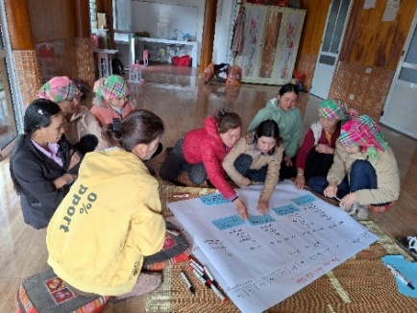
Photo 1: Hazard and crop calendar (FGD with women).
Photo taken by research assistant

Key findings
This research is designed to gain a comprehensive understanding of how ethnic minority communities in Northern Mountainous region of Vietnam are vulnerable to climate change, what their adaptation strategies are, and their enablers and barriers to climate adaptation.

The key findings are:

Vulnerability to climate change
The commune has experienced the harmful impacts from climate changes particularly from droughts, different types of flooding, tropical typhoons and forest fires. Crop cultivation is most affected especially rice, maize crops and green tea trees. Livestock farming, forests and surface water resources are all impacted by a changing climate. Ethnic minorities including H’Mong, Giấy, Kháng and Lự are the most affected seriously due to their social-economic, cultural and traditional situations as well as their lifestyles and language barriers. Many households live in high-risk locations such as steep hillsides or flood-prone areas, making their crops and homes more vulnerable to droughts, landslides and floods. H’Mong ethnic group live on mountains and are isolated to other groups. They also usually go to the farthest remote forests to collect non-timber forest products (e.g., medicinal plants, bamboo, and firewood) as part of their broader livelihood strategies. This way of living and working causes them to have limited access to information disseminated by the commune or local government, especially before typhoons or flooding events occur.
“We, the whole village, lost all the green tea plants last year due to drought. Drought, drought. It was too burning hot at over 45oC, too sunny. No rain at all, lack of surface and groundwater. All our plants were burnt out” (FGD #1, with local female group).

The impacts of a changing climate are not confined to changes in livelihood strategies. Indeed, some cultural and historic sites of the ethnic minorities including sacred lands, mountains/hills and forests are also affected by extreme events like wildfires and floods.
Migration has started taking place in the Ban Bo case study area in response to the impacts of climate changes. Young people (aged 15- 30) prefer to leave the commune to seek new jobs, making new homes at big cities in Vietnam.
Unemployment is also making Ban Bo commune vulnerable to changes in climate and extreme events. There are several groups of people, including young people (aged 20- 35) that have no stable, permanent jobs. This means that they gain limited income which is needed for their climate change adaptation. There are also issues specific to ethnic minorities, since there are elderly people in the case study area that cannot speak Vietnamese effectively. This limits their opportunities to access information on the impacts of climate changes and constrains their ways of responding to climate change impacts: running small businesses such as market stalls or home-based food production, or working with external organisations and companies to improve their livelihoods and incomes.
Adaptation measures have already taken place in the case study area, and these are implemented by both local government and local people. The adaptation of Ban Bon commune is basically top-down. This means adaptation actions of the commune are to execute or roll out central government policies. Adaptation measures are heavily based on the directives from higher levels of government including district, provincial and central governments.
Efforts in adaptation are to address both climate and non-climate challenges. They have upgraded local roads not only to reduce risks from flooding but also to help local people’s easier transport and economic activities more effectively. Similarly, local farmers are demonstrating new crop varieties to better adapt to climate change, but also to gain more productivity and incomes from those crop varieties.
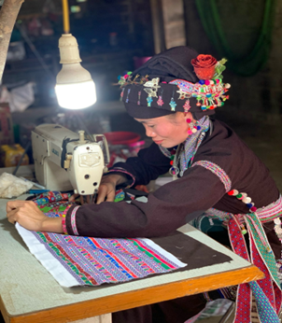
Photo 3: A Lào ethnic woman diversifies incomes by sewing Photo taken by: Hanh Dang

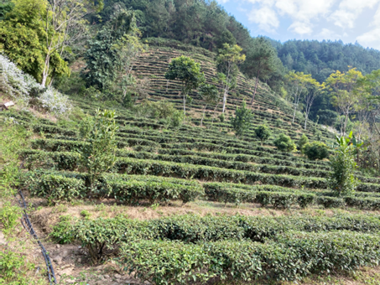
Photo 2. Green tea fields to cope with drought
Photo taken by Hanh Dang

“Our people have learned to grow different types of crops to cope with the changing weather. Some survive the drought like green tea, others grow better in the rain- it’s how we protect our food and our way of life” (Interview #5, with a village leader).

Different adaptation approaches have been used to respond to the impacts of climate change and extreme events. These include institutional, economic and social measures. The local government has set up local committees to develop annual plans in response to flooding and typhoons. Similarly, local farmers have also set up interested groups to support each other in adaptation and natural disaster preparedness and response. Community or mass organisations such as Women Unions and Farmers Unions play a crucial role in adaptation. Those people and groups have been engaging in educating and communicating how climate change and natural disasters affect the people, livelihoods and infrastructure.
Women play crucial roles in implementing adaptation measures in case study area. They are leading awareness events on food security, managing household water storage, adopting climate-resilient crops in their home gardens, and coordinating mutual-help groups for saving and credit schemes. They are also often the first responders in protecting children and the elderly during floods and storms. In this way, women are not only supporting their own households but also strengthening collective resilience.
There are significant variations found in the adaptation strategies of the different ethnic groups. The Thai and Lao people are the most proactive ethnic groups in adapting to climate change events. They often build concrete houses using bricks and cement to respond to the impacts of flooding or typhoons. The Lao people tend to diversify their livelihoods and income by leaving the commune to seek new jobs in big cities, or they move to safer places to live. This variation is perhaps explained by several factors: in general, these ethnic groups have a higher level of education; they have good financial condition or knowledge on adaptation; they have better access to information because they speak and understand Vietnamese better. In contrast, the H’Mong people are focused on adjusting their crops in terms of cultivation or harvesting time to fit theàoaof weather changes.

Enablers to climate change adaptation
Good governance system and political stability. The local government has set up committee for climate change, and they have developed plans for climate changes adaptation and disaster management. Vietnam in general and Ban Bo in particular have a stable political status. This is helping adaptation efforts of the commune or Vietnam gain progress. Generally, both local people and local government support and roll out all national policies and directions to climate change adaptation.
The unitedness of the people. They are especially united in difficult situations of the commune. For example, during and after a climate-related events like flooding they often helped each other to address the consequence of the events. Similarly, the local people are willing to offer labour to support each other during cultivation or harvest seasons, or buiding houses.
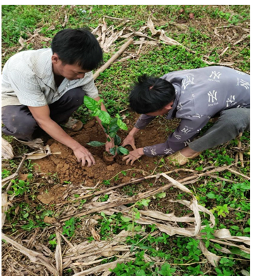
Photo 4: Helping each other plant green tea
Photo taken by: CISDOMA
Social learning among farmers or among local government agencies is a strong enabler. This approach is taking place in all aspects of life. For example, the local farmers often share their ways of cultivation for their crops with other farmers to better adapt to the changes in weather patterns. Similarly, once a household built a good house for climate change impacts, other families would also learn techniques from that house’s owners for their house building.
“In times of crisis, like floods and droughts, our community always stands together. Even with limited resources, we help one another. Unity is our greatest capacity” (FGD #2, with male group).

Barriers to effective adaptation
Conflicting Priorities: The adaptation of Ban Bo commune is basically top-down. This means adaptation actions of the commune are to execute or roll out central government policies. Adaptation here is heavily based on the directive from higher levels of government including district, provincial and central governments. However, the government's top-down approach and focus on economic development, which includes exploiting natural resources, often clashes with local people's adaptation needs. There is also a disconnect between the government's preference for large-scale physical infrastructure projects and the community's preference for "soft" measures like building adaptive capacities and diversifying livelihoods. The different priorities/pathways to adaptation between the local people and government agencies are a barrier to adaptation. As a result, the government agencies have not yet allocated proper budget and personnel resources for this work.
Knowledge Gaps: Both local people and government staff have limited knowledge on long-term climate change impacts, often perceiving it in terms of immediate events like floods and typhoons. Generally, they get that data and other information through local meetings or members of community groups’ members. Local government staff have not been trained properly concerning climate change impacts.
Limited resources and infrastructure: Low incomes and limited resources constrain the ability of the households to prepare for and respond to climate impacts. At the same time, Ban Bo is a poor commune therefore they have limited resources and capacities to address challenges from climate change. Physical infrastructure in the commune is old and has not had the application of advanced techniques or materials to adapt properly to hazards especially tropical typhoons. For local farmers, they have very limited lands for crop production or livestock farming. This may reduce their capacity to adapt to climate change impacts. In crop cultivation, local farmers do not have access to good crop varieties that can be used to adapt effectively to climate change impacts. To reduce the risks from flooding, the local famers need shorter rice varieties.
Part of the issue with crop variety availability is that farmers depend on private sector/commercial agriculture companies concerning inputs for their crop cultivation. The varieties from previous seasons cannot be stored for the next crop because they cannot survive or are poorly suited to the next season’s conditions or resilient to new diseases. The farmers need to follow the instructions of the local agriculture department on what varieties to use. Thus, the price of varieties is determined by private companies. A further constraint is that irrigation for crop production is not effective and the related infrastructure is not well developed, including concrete or plastic pipes to contain and transport water effectively.
Communication challenges impact upon adaptation measures. Language barriers, particularly for the elderly who cannot speak Vietnamese, limit access to information. The isolated living situations of some groups like the H'Mong make it difficult for government staff to disseminate information.
In addition, people of the commune live very far away each other. Several families are living on the top or middle of isolated mountains. This is posing challenges for government staff in communicating as well as implementing adaptation projects to address climate change impacts.
Photo 5. In depth interview with a Lự ethnic woman
Photo taken by research assistant

Photo 6. Some people had to use their fingerprints as signature
Photo taken by Hanh Dang
Implications
Top-down approaches would miss people most at risk. Current adaptation efforts are often directed from higher levels of government, but local communities have different priorities. Adaptation is more effective when it is driven from the ground up.
Adaptation barriers are interconnected. Limited resources, low climate literacy, language gaps, and remoteness compound exposure to hazards. Solutions must therefore be joined up, not piecemeal.
Different groups require tailored responses. Thai and Lao communities have stronger adaptive capacity thanks to education, finance, and language skills while H’Mong households face isolation and information barriers. One-size-fits-all approaches are ineffective and risk leaving the most vulnerable behind.
Recommended actions
More support with funding for community-led adaptation through trusted Vietnamese organisations; inclusive communications; promoting fairer agricultural markets (e.g. transparent contracts and farmer–buyer dialogues in tea and seed sectors); and investing in climate literacy training for local officials and leaders are recommended.
International agencies are recommended to support applied research on vulnerabilities and test bundled solutions (combining climate information, finance, and market access); align climate finance with locally led, multi-ethnic delivery models; and strengthen safeguards so projects in mountainous areas use culturally appropriate engagement.
It is recommended that Vietnamese governments at all levels embed participatory planning in local adaptation; ensure that consultations are undertaken in ethnic languages and inclusion of women, youth and farmer groups; and expand access to stress-tolerant crops, supported by community seed banks.
Expected outcomes
If these actions are taken, communities are likely to reduce crop losses in rice, maize, and tea through improved varieties, better water systems, and timely advice. Adaptation efforts will also deliver greater equity and inclusion, supported by women’s leadership, bilingual outreach, and approaches tailored to different ethnic groups.
Limitations and further research
The current research was focused on understanding how eight ethnic minority groups in Ban Bo commune face and address the impacts of climate change. There are several other ethnic groups living in Vietnam that are also facing climate change impacts, but they have different vulnerability and adaptive capacities. Thus, the findings and lessons learnt from the current research should be understood within the context of the case study. In addition, the current research findings are arguably relatively subjective and context specific since they are based on the knowledge, experience and practical observations of climate change shared by the research participants who only live in Ban Bo commune. Finally, the research is focused on how economic sectors such as crop production and livestock adapt to climate change because these are the main livelihood sectors of the case study. While this provides valuable insights, it also limits the understanding of how other important sectors such as education or health may be affected or adapting.
Future research should study other ethnic minority groups who are living in Vietnam to have a comprehensive understanding of how those groups face and experience the impacts of climate change and how they adapt. Secondly, using both quantitative and qualitative methods is a good approach to build solid insights to climate change impacts. These could help local people and policy makers in adaptation planning and decision making. Finally, future studies should research other key sectors of communities in Vietnam including education or health to understand how these sectors are affected by climate change and how they can contribute to adaptation strategies.

References
Huynh, D., Sætre, P. and Dao, T., 2020. Indigenous knowledge in relation to climate change: Adaptation practices used by the Xo Dang people of central Vietnam. Heliyon, 6(11), p.e05656. https://doi.org/10.1016/j.heliyon.2020.e05656
Leonard, S., Parsons, M., Olawsky, K. and Kofod, F., 2013. The role of culture and traditional knowledge in climate change adaptation: Insights from East Kimberley, Australia. Global Environmental Change, 23(3), pp.623–632. https://doi.org/10.1016/j.gloenvcha.2013.02.012
Nguyen, T.A., Nguyen, B.T., Van Ta, H. and others, 2021. Livelihood vulnerability to climate change in the mountains of Northern Vietnam: comparing the Hmong and the Dzao ethnic minority populations. Environment, Development and Sustainability, 23, pp.13469–13489. https://doi.org/10.1007/s10668-020-01221-y
Nyong, A., Adesina, F. and Osman Elasha, B., 2007. The value of indigenous knowledge in climate change mitigation and adaptation strategies in the African Sahel. Mitigation and Adaptation Strategies for Global Change, 12(5), pp.787–797. https://doi.org/10.1007/s11027-007-9099-0
Trinh, T.Q., Rañola, R.F. Jr., Camacho, L.D. and Simelton, E., 2018. Determinants of farmers' adaptation to climate change in agricultural production in the central region of Vietnam. Land Use Policy, 70, pp.224–231. https://doi.org/10.1016/j.landusepol.2017.10.023

