JOLENE WESCOMBE | PHD DEVELOPMENT STUDIES | MASSEY UNIVERSITY

Ethiopian midwives as agents of change

Summary:
- Empowering midwifery practice is enacted through familial-type relationships embedded in local communities.
- Role modelling is a powerful tool for empowerment through mentoring midwives in education and practice, midwives’ peer-to-peer role modelling, and mobilising women peer-to-peer within communities.
- Compassionate respectful care and “Mikirke”, a two-way model of communication and sharing, create woman-centred care.
- Community trust is damaged by unreliable supplies of contraceptive choices.
- Efforts to create health professional and community understanding of the midwifery scope of practice is essential to midwives’ empowerment.

What is the development issue?
This research seeks to forefront Ethiopian midwifery in informing maternity care that brings real community change in development settings. Midwives are central to the United Nations’ Agenda 2030 for Sustainable Development Goals (SDGs) 3 and 5 to reduce maternal mortality rates and empower women. Yet, women from Sub-Saharan Africa still account for 70% of all maternal deaths in 2020 (WHO, 2023, p. xiv).

The Lancet series (Renfrew, Downe, et al., 2014) on midwifery care identified that rapid upscale of training and deployment of qualified midwives in low to middle-income countries has led to a decline in maternal mortality. Despite these achievements, it has become evident that medical skills alone are not enough. An epidemic of disrespect and abuse towards women in childbirth and a demoralised workforce have undermined the success of maternal health strategies. Consequently, poor quality maternity care has now surpassed lack of access to care as the primary barrier to reducing maternal mortality rates (WHO, 2024). Centring empowerment of women and girls is foundational to reduce maternal mortality.

Ethiopia’s women face profound geographical, structural, and sociocultural barriers to utitlising maternity care (Ayenew et al., 2021). Mountainous terrain, lack of roading and transportation in rural areas, and cultural traditions contribute to 46% of rural women still giving birth unassisted by skilled birth attendants (Melesse, et al., 2024).

Ethiopia’s frontline workforce of both female and male midwives is at the core of the dramatic success in reducing maternal and neonatal mortality and morbidity (Ethiopian Ministry of Health, 2015). However, midwives are demoralised by systemic underinvestment in physical and human resources which impede their efforts to provide quality care. Resources are concentrated on medical aspects of care to the neglect of women’s psychosocial needs (Mordal et al., 2021). Ethiopia has prioritised developing a patient-centred quality of care strategy (Ethiopian Ministry of Health, 2016) that encompasses system-wide action, cultural change and the agency of frontline professionals to empower those in their care (Ethiopian Ministry of Health, 2015, p. 119). With male midwives comprising a third of the Ethiopian workforce (Ethiopian Midwives Association, 2020, p. 1), midwives’ efforts to empower women are posited in complex gendered issues.

Ethiopia’s midwives have great potential to act as agents of change for women’s empowerment, but as an underinvested workforce, they themselves must first be empowered. This research project addresses Ethiopia’s vast system of female and male midwives’ great potential to act as agents of change for women’s empowerment in remote rural communities. Systematically equipping midwives through quality education, mentoring, and essential resources, will facilitate sustainable community change on the frontlines of women’s health.
Key findings
The aim of this research is to explore culturally relevant empowerment in Ethiopian midwifery practice. The four primary research questions directing this project are:

- How do Ethiopian midwives conceptualise empowerment in midwifery practice?
- Do Ethiopian midwives incorporate an empowerment approach into their practice and if so, how?
- What challenges do Ethiopian midwives face when looking to incorporate an empowerment approach when working with women?
- In what ways does the gender of midwives influence Ethiopian midwifery practice and empowerment outcomes for women?

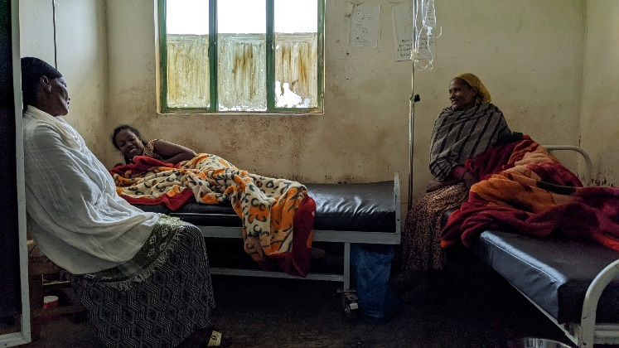
Fig 1. Family women supporting a labouring mother and a newly birthed woman in a labour room. Author photo.

This research utilised a qualitative methodology prioritising in-depth narratives with key informants – 51 midwives in rural practice and 105 local women surrounding rural midwifery clinics. Mixed methods across two phases of fieldwork included semi-structured interviews, focus groups using participatory methods, and participant observation (Appendix 1). During the second phase, initial findings were presented to midwives for feedback. Preliminary research findings demonstrate that empowerment within Ethiopian midwifery is relationally embedded through trusted familial relationship models, community engagement, and woman-centred care.

Empowering midwifery relationships are characterised by trusted familial constructs of mother, mentor, sister and brother.

A trusting, friendly personal woman-midwifery relationship is emphasised in the WHO report Transitioning to Midwifery Models of Care (2024, p.117). This is reflected by Ethiopian participants describing midwife-to-woman relationships as like a mothering role:

“We want a midwife to become ‘Endanat’, like a mother.” – (two midwives)

“What would you be afraid of – if she is just like family?” – (local woman)

Both midwives and women express that a midwife should relate to women in a familiar maternal manner. The question must be asked how male midwives might fit within this model. Midwives also described their roles as sisters and brothers within the community:

“I am a Hamlin midwife… I am happy to help my sisters and my community.” – (midwife)

“The other male midwives empower women… Yeah, we all are midwives.” - (midwife)

And community members expressed roles for both female and male midwives, indicating that woman-centred care, knowledge and skills are more significant than gender:

“Whether they are a male or female, the first thing is to treat in a good way.” - (local woman)

“If a person has good knowledge, he can do good things. Whether he is a male, or she is a female, first he or she needs to have good knowledge and skill.” - (local woman)

“Because I love her… I can say it is good… if both females and males help… I want to say that loving and helping a mother is good.” – (brother supporting labouring sister)

These relationships encompass a midwifery model that utilises familial constructs to build trust and relationship with women and communities.

Empowerment is affected through localised, multidirectional person-to-person role modelling: mentoring midwives in education and practice, midwives’ peer-to-peer role modelling, and mobilising women peer-to-peer within the community.

In a country with over 80 languages, access to known local maternity caregivers, who speak the local language, and understand local customs is essential to building trust and engaging communities.

“On … the model of midwifery education… Hamlin College, I think they are role models. Because one, first they [recruit] their students from the community…. they know the culture of that area; they understand the community…. There is nothing new for them after graduation. Even if there is no difference in case of the environment, they know the language of the area, they understand, and they know the different taboos. They can understand, and they can do accordingly.” - (male midwife)

Role modelling is considered essential. This is implemented through midwifery mentors during midwifery education and professional practice and through midwives’ peer-to-peer support.

“Mentoring is very essential for rural health centres all around the country because mentoring, it is a role model for quality of service… the mentor shares knowledge and skill, even psychosocial sharing and how to handle the community life at rural areas.” – (midwife)

“Role modelling is essential for us. It is one of the best one. This peer-to-peer sharing knowledge and skill… as my brother said… especially for midwifery education is necessary.” – (male midwife)

Empowering a midwife through mentoring and role modelling has a directly empowering impact on women. This role modelling is subsequently replicated woman-to-woman within community.

“Empowering a woman empowers community… This is hundred percent! Midwives empower women, who then empower other women.” – (midwife)

“If you find an empowered woman in the community, she teaches the other women. And, you know, even for a kebele… if there is an empowered midwife, and she empowers some women, and they disseminate the information for the others, so that, that kebele is a role model directly for the other settings. And they use the health facilities properly, and they know what they are, what they need to get from the healthy facilities, their rights, and … their obligations. So, empowering midwives is directly related to empowering the mothers.” – (midwife)
Empowerment is understood to be symbiotic, mutually benefitting all in the community, as an empowered midwife models quality woman-centred care to women who become peer educators within their own communities. This in turn, increases utilisation of maternity services and decreasing maternal and neonatal mortality.

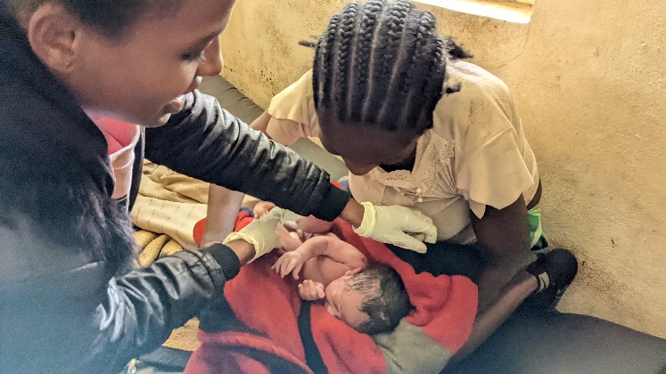
Fig 2. A midwife guiding a new mother in newborn care. Author photo.

Woman-centred care is modelled as compassionate respectful care and “Mikirke”, a two-way model of communication and sharing.

These reflect shared values with other international midwifery practice models of woman-centred care or partnership.

“In our work, compassionate respectful care is the necessary thing for the mothers…. If, when we care the mothers as a relative, as a family, as a good relation, when we share with the mother in good way our idea, they hear us, and they become a good decision maker.” – (midwife)

“If a midwife is a role model, and if she’s fulfilled CRC [compassionate respectful care], all mothers will want her care; all women want her knowledge, her skill, her support… all the community want to get access to that health care… the maternal death decrease. This is the power of the role modelling.” – (female midwife)

“Mikikir”, or “counselling”, is described as a two-way discussion, a mutual sharing of information, and listening to problems.

“Both counselling and emotional support is working to save our lives.” – (local woman)

“Counselling is more important. Before telling us, we have this or we don’t have this, first he or she needs to counsel us.” – (local woman)

“I think the number of the mothers that come for the [antenatal care] increased after we counsel deeply, and we listen their problems properly.” – (midwife)

‘Counselling’ was considered to directly impact saving lives and empower women by increasing women’s use of maternity services. The midwives’ ability to deliver woman-centred care was seen as dependent on the skilled role modelling received during their education and professional mentoring. Staff shortages and high workloads also affected their ability to provide adequate time to deliver woman-centred care.

Resource shortages of preferred contraceptive choices significantly impair women’s trust in midwives.

Contraceptive choice is understood by rural women as a choice between life and death, directly addressing food scarcity, child malnutrition, and poverty.

“If we don’t have family planning service when we want to use it, we may give birth within a year. During that time the baby, our children, may not grow in a good way. So, we have to have a gap between our children.” – (local woman)

“When I go, they say we don’t have the Depo, and when I come again, they say they don’t have…. I stay for a long time waiting for them. And… they start telling about long acting family planning. This is a problem that we have when go there.” – (local woman)

“You are lying!” – (local woman to midwife)

Local women’s distrust and anger over poor resourcing of their preferred contraceptive choices was vocalised repeatedly during research focus groups and clinic observations. Arguments and angry exchanges were frequent occurrences in family planning clinics, where midwives were blamed for shortages and accused of hiding supplies. This was detrimental to the midwives’ work to build trust and relationship with the women and community.

Lack of understanding of the broad scope of midwifery practice hinders midwives’ efforts.

Lack of understanding of the value of midwifery skills in the community contributes to underutilisation of maternity services. Local communities believed midwives are nothing more than traditional birth attendants. Midwives also experienced limitations placed on applying their skills by other authorities misunderstanding the midwifery scope, calling them “goalkeepers” and “delivery nurses”. Adequate resourcing is not provided, and fit-for-purpose policies are not implemented at governance levels.

“There were many challenges, like midwifery profession unaccepted… health professionals… think that the midwife doesn’t do anything like them. They [think] the scope of midwifery only like vital signs and take the coming baby at second stage. And they think midwife cannot manage any complication.” – (midwife)

“If health care professionals don't understand our work, how will the community… or how will other people understand how it works?” – (midwife)

“The broad scope of midwifery practice is misunderstood at all levels…. It needs training of health care professionals and other related professionals.” – (midwife)

A lack of midwives in leadership from governmental to local health centre level is viewed as a contributing factor to poorly designed and misunderstood policies. Midwives are prevented from using their knowledge and skills in practices by uncomprehending health professionals in authority. Advocacy by local leaders, superiors and the Ethiopian Midwives Association was voiced as helping to create understanding, as was midwives engaging with communities through education about midwifery care.

A working theoretical framework

Empowerment was expressed as resulting from dynamic and interdependent relationships between midwives, women, and communities. As midwives were effectively educated, equipped, resourced, and supported, and as they role-modelled woman-centred care, this had a flow-on impact through women to the wider community.
Empowering or deploying [midwives] throughout the country around rural areas changes attitudes, the behaviours of the overall community. The midwife is the expert of change for this care… They are experts of change for the community.” – (midwife)

Building on Rao’s (et al., 2016) Gender Empowerment Framework, an Ethiopian midwifery framework (Fig. 3) encompasses relationally embedded care in local communities, characterised as familial in nature – multi-directional and interdependent, expressed through female and male midwives, women, and their families and communities.

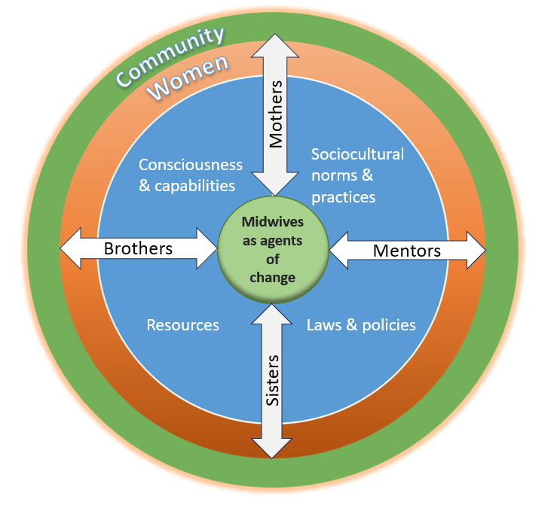
Fig. 3. A Working Midwifery Empowerment Framework, authors own.

Implications
These research findings indicate that investment in quality midwifery education, well-resourced and supported midwives, and active relationally based community mobilisation are primary strategies for achieving SDGs to reduce maternal mortality rates and to empower women.
When you compare the investment of when you invest on midwife, directly, you invest on pregnant mother, on the community issues… investment of government on the midwife… it is very low. Sometimes you can find a shortage of resources in primary health and community level…. It affects the midwifery education, quality service, so many things.” – (midwife)

Development organisations should:

Prioritise funding maternal health strategies designed for midwives as frontline workers in local communities.

Train and support midwives through peer-to-peer mentoring and role modelling throughout education and practice.

Train midwives in compassionate respectful care.

ensure consistent resourcing to build community trust in maternity services.

educate other health professionals about the midwifery scope of practice and encourage midwives in leadership roles.

Institutional and technical resources alone cannot effect sustained change in developing maternity settings. Relationship modelling and support empowers highly skilled and knowledgeable midwives, practicing women-centred care through building trust and relationships at a community level. This relational model of midwifery practice empowers women and communities, bringing effective and sustainable change for development.

Limitations and further research
While participants included both Hamlin and government trained midwives, female and males of multiple ethnicities, findings are not statistically representative of Ethiopian midwives collectively. This study did not quantify any differences between perception or experiences between Hamlin-trained or government-trained midwives or by gender. Further research is needed to explore and measure the impact of relational midwifery models of community engagement on socioeconomic wellbeing and gendered empowerment outcomes.

However, as emphasis on local actors and relationships is a key finding, localisation of development initiatives will help mediate the effects of cultural and geographical diversity in Ethiopian maternity care.

References

Ayenew, A. A., Nigussie, A. A., & Zewdu, B. F. (2021). Childbirth at home and associated factors in Ethiopia: A systematic review and meta-analysis. Archives of Public Health, 79(48), 1-18. https://doi.org/10.1186/s13690-021-00569-5
Ethiopian Ministry of Health. (2015). Health sector transformation plan 2015/16 - 2019/20. https://www.globalfinancingfacility.org/ethiopia-health-sector-transformation-plan-201516-201920
Ethiopian Ministry of Health. (2016). Ethiopian national health care quality strategy 2016-2020: Transforming the quality of health care in Ethiopia. https://www.medbox.org/document/ethiopian-national-health-care-quality-strategy-2016-2020#GO
Ethiopian Midwives Association. (2020). Technical brief: The state of Ethopian midwives 2019. E. M. Association.
Melesse, D., Tadele, A., Mulu, S., Spicer, N., Tadelle, T., Wado, Y., Gajaa, M., Arja, A., Blumenburg, C., Manage, T., Gonfa, G., Plessis, E., Hamilton, E., Mihretu, A., Usuamael, A., Mengesha, M., Gelaw, S., Worku, A., Woldie, M., Abate, B., Getachew, T., Wondirad, N., Zelalem, M., Tollera, G., & Boerma, T. (2024). Learning from Ethiopia’s success in reducing maternal and neonatal mortality through a health systems lens. BMJ Global Health, 6;9(Suppl 2):e011911. https://doi.org/10.1136/bmjgh-2023-011911
Mordal, E., Hanssen, I., Biratu, A. K., & Vatne, S. (2021). Providing safe maternity care under challenging conditions in rural Ethiopia: A qualitative study. BMC Health Services Research, 21(323), 1-10. https://doi.org/10.1186/s12913-021-06324-4
Rao, A., Sandler, J., Kelleher, D., & Miller, C. (2016). Gender at work: Theory and practice for 21st century organizations. Routledge.
Renfrew, M., Downe, S., Homer, C., & Mcfadden, A. (2014). Midwifery: An executive summary for the Lancet's Series. The Lancet(June 23), 2-8.
World Health Organization. (2023). Trends in maternal mortality 2000 to 2020: Estimates by WHO, UNICEF, UNFPA, World Bank Group and UNDESA/Population Division. W. H. Organization. https://www.who.int/publications/i/item/9789240068759

World Health Organization. (2024). Transitioning to midwifery models of care: Global position paper. Geneva: WHO.

Appendix 1
Methodology and methods

This project methodology is a qualitative exploration using deep participant narratives and participatory practices. Participants were centred through prioritising their insider’s lived understanding and voices. This is an inductive process exploring the meaning created by culture and context, a co-construction with participants.

Reflexivity is required on my own positionality, with aspects of being both an outsider as a white foreigner and an insider as a woman, mother, midwife and NGO partner. While these factors required careful navigation during my research, they are also the same relationships that created and enabled this research opportunity and facilitated trust from participants.

I conducted 55 semi-structured interviews along with 13 focus groups using simple and pairwise ranking for rural women and Venn diagrams for midwives. Participant observations were conducted over five weeks on site 24 hours per day shadowing Hamlin and government-trained midwives in remote midwifery centres.

My participants included midwives from Hamlin College of Midwives master’s program and Ethiopian Midwives Association (n= 26 female and 25 male).

My sampling was not randomised and is not statistically representative, but it does include a depth and cross section of key stakeholders. It was also conducted with an initial data gathering phase and a subsequent validation phase presenting my initial findings back to the midwives for their input.

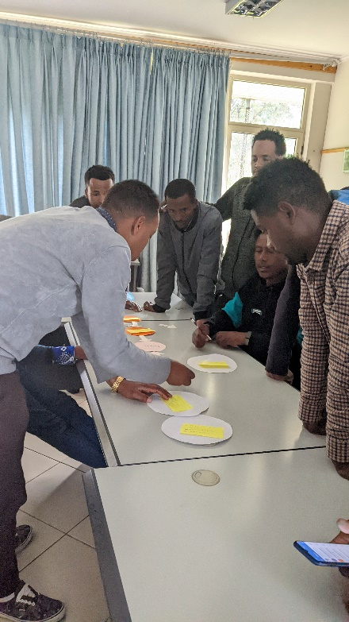
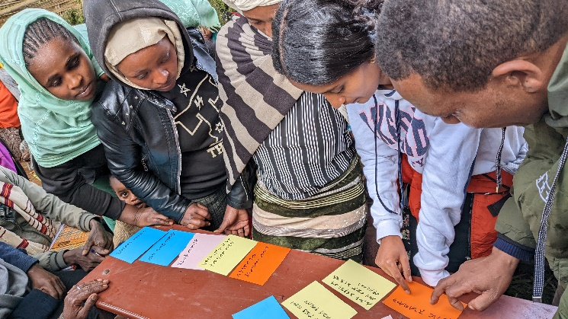

Fig. 4 Local women doing simple ranking in a focus group. Author photo.

Fig. 5. Midwives’ focus group Venn diagram. Author photo.

PARTICIPANT TYPE (Phase 1) | NUMBER OF METHOD TYPE | NUMBER PARTICIPANTS | GENDER
INTERVIEWS
Semi-structured interviews (SSI) Hamlin midwives | 3 | 3 | 3F
Group interview Hamlin midwives | 5 | 3 | 3F
Unstructured Interviews Hamlin midwives | 4 | 3 | 3F
SSI Hamlin midwife mentors | 1 | 1 | 1F
SSI Government midwives | 3 | 3 | 3F
SSI Midwife Management | 10 | 9 | 3F, 7M (2Male MW)
SSI Local women | 19 | 17 | 17F
Group interview local women | 4 | 9 | 9F
SSI Local men | 2 | 2 | 2M
TOTAL INTERVIEWS | 51 | 44 | 36F, 9M
FOCUS GROUPS
Focus group midwives | 3 | 24 | 6F, 18M
Focus group local women | 5 | 79 | 79F
TOTAL FOCUS GROUPS | 8 | 103 | 85F, 18M
OBSERVATIONS
Participant observations | 21 labours (including 12 births) | 21 | 21F
Participant observations | 21 ANC/PNC/FPC | 25+ | 21F, 4M
TOTAL PARTICIPANT OBSERVATIONS | 42 | 46+ | 42F, 4M
TOTAL PARTICIPANTS |  | 193+ | 163F, 31M

PARTICIPANT TYPE (Phase 2) | NUMBER METHOD TYPE | NUMBER PARTICIPANTS | GENDER
Semi-structured interviews (SSI) Hamlin midwives | 2 previous | 1 | 1F
SSI Government midwives | 2 new | 2 | 2F
TOTAL INTERVIEWS | 4 | 3 | 3F
Focus group MSC midwives – previous participants | 1 | 10 | 6M  4F (1x Hamlin, 1 x Govt)
Focus group MSc midwives – new participants | 2 mix | 7 | 4M  3F
Focus group mentor midwives - previous | 1 mix | 1 | 1F
Focus group mentor midwives - new |  | 5 | 5F
Focus group EMA midwives – previous participants | 1 mix | 1 | 1M
Focus group EMA midwives – new participants |  | 3 | 2M  1F
TOTAL FOCUS GROUPS | 5 | 27 | 14F 13M
Participant observations | x | 11 | 11F
Participant observations |  | ANC/PNC/FPC
TOTAL PARTICIPANT OBSERVATIONS | x | 11 | 11F
TOTAL PARTICIPANTS |  | 41 | 28F 13M

