INDIGENOUS PANEL SESSION SPEAKERS
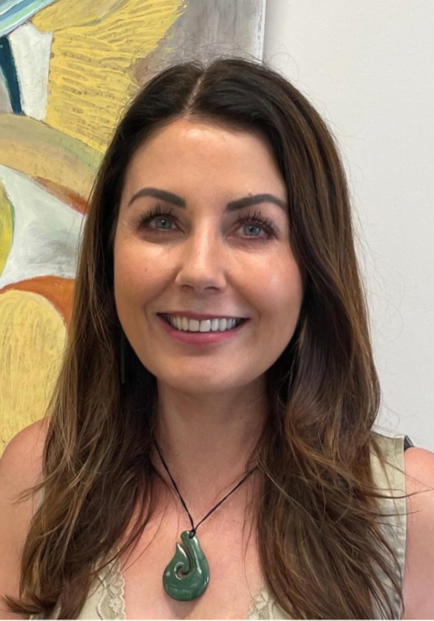
Rochelle Stewart-Withers

Rochelle Stewart-Withers, of Ngāti Rāhiri Hapū o Te Ātiawa whakapapa, is a Professor of Indigenous and International Development with the Institute of Development Studies, Te Kunenga Ki Pūrehuroa Massey University, Aotearoa New Zealand. An Indigenous feminist scholar, she has also served as Kaiārahi Te Tiriti o Waitangi for the College of Humanities and Social Sciences (CoHSS) at Massey.

Her research critically explores the potential of sport to improve economic and social outcomes in the Global South and for Indigenous Peoples, particularly at community and whānau levels. Since 2001, she has conducted research across the Pacific and Aotearoa, building a strong body of work that centres Indigeneity, values culture, and draws on Indigenous frameworks and worldviews. She is a proud mum to five young people and nanny to Waimoana.

Benny Wilson

Professor Benny Wilson is a Jagera man who has worked in the tertiary sector since 2015. His expertise includes Indigenising the curriculum, assisting non-Indigenous academic colleagues to embed Indigenous ways of knowing into their units, and the intersection between narrative and place-based education systems. He has worked as a coach, teacher, facilitator, and consultant across a range of institutions and schools since 2007. Throughout his academic career, he has worked on ARC projects connected to both Indigenous education and Indigenous health. His current research explores place-based narrative as an Aboriginal epistemology and its application for modern education systems.

In 2022, Benny was named ACT Scholar of the Year in 2022 at the ACT NAIDOC Awards. In 2023, he was awarded the Neville Bonner Award for Indigenous Education at the Australian Awards for University Teaching for his significant contribution to higher education. In 2025 he and his colleagues started the Country as Teacher Practitioners Network which links educators from across NSW and the ACT in their journeys teaching students how to relate with Country.

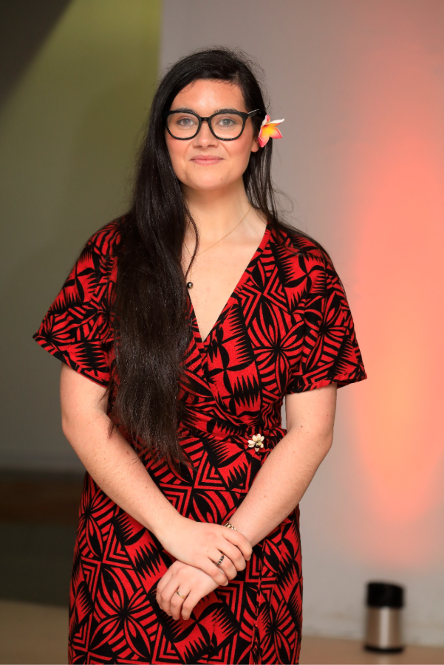
KDee Aimiti Ma'ia'i

Dr KDee Aimiti Ma'ia'i is the Te Tomokanga Postdoctoral Fellow at Waipapa Taumata Rau University of Auckland. She is an interdisciplinary scholar, working across Pacific Studies, Pacific History, and Development Studies. Her research interests include the the continuities between colonial orientations and postcolonial development, Pacific regionalism, agricultural development, and New Zealand's foreign policy approaches in the Pacific. Her doctoral research, completed at the University of Oxford as a Rhodes Scholar, was in Global and Imperial History from where she explored the agricultural foundations of Pacific regionalism. She is currently teaching a critical development course in Pacific Studies, working towards the publication of a book, and curating a public history exhibition that explores the exporting of bananas from the Pacific in the twentieth century.

