MELANIE ALTEMUS | PHD OF PSYCHOLOGY | TE HERENGA WAKA | VICTORIA UNIVERSITY OF WELLINGTON

Cross-cultural Power, Connection and Impact of Volunteer Tourism in Fiji: Insights from Local iTaukei Perspectives

Summary:
- Local stakeholders and voluntourism hosts report that the social and financial benefits of voluntourism may outweigh the associated risks and costs for certain local communities.
- Voluntourism dynamics may perpetuate and reinforce perceptions of power imbalances and social hierarchies between tourists and hosts.
- Suggestions include:
1) NGOs and government-funded international volunteering should prioritise partnerships with existing local development goals and practitioners.
2) Policymakers from tourists’ countries of residence and hosting policymakers should provide guidelines for ethical, regenerative and culturally driven voluntourism practices.
3) Framing voluntourism as collective action rather than individual endeavours, such as a professional development opportunity.

What is the Development Issue?
While conducting this research, an iTaukei provincial officer described hospitality in Fiji as “our lifestyle”. In 2024, nearly one million visitors arrived in Fiji, surpassing the local population. Among them, participants of international development volunteering and voluntourism. Numerous international organisations lead volunteer programs and arrange homestays for volunteers within iTaukei villages. While this provides opportunities for meaningful cultural exchange, the inherent power dynamics and commodification of interactions between visitors and iTaukei hosts risk perpetuating neocolonial practices and beliefs (McLennan & Thomas-Maude, 2023). Development research indicates that voluntourism poses challenges worldwide to achieving sustainable tourism development, community autonomy, and safety (Chen, 2022; Higgins-Desbiolles et al., 2023; Sin, 2009; Wearing & McGehee, 2013).
As participation grows, existing policies should adapt to manage the impact of international development volunteering and support local community autonomy. Centring the voices and experiences of Indigenous host communities, who are historically excluded, in development research and policy could foster ethical voluntourism policies, research, and practices (Movono et al., 2023; Smith, 2021).
Present Research
To capture firsthand accounts of the nuanced balance between socioeconomic benefits and challenges that voluntourism presents, this qualitative project engages directly with members of an iTaukei village with experience hosting voluntourism groups. By centring iTaukei stakeholders and village hosts, it addresses three key questions:
- What is salient to an iTaukei host community’s experience with voluntourism?
- To what extent is voluntourism approved and desired by the community and government stakeholders?
- How do hosts perceive their positionality within a voluntourism dynamic? Does voluntourism influence a sense of autonomy?
A preliminary consultation trip was conducted for the research team to meet, seek permission from the vanua (Nabobo-Baba, 2008), and gain a holistic understanding of the development issue. Fieldwork commenced in the Nadroga-Navosa province on Viti Levu from June to July of 2024. This included participant observation and informal Talanoa (Nabobo-Baba, 2020), or collective conversation, with 17 households in a rural inland village. This was supplemented by Talanoa with government officials and stakeholders. This research draws from concepts of participatory action research (Cornish et al., 2023) and is guided by Unaisi Nabobo-Baba's Fijian Vanua Research Framework (FVRF) (2008). Embedding myself in the community to the best of my ability, recommended by the FVRF and local experts, was an ethically driven decision intending to prioritise the community’s comfort, agency and well-being throughout the research process. Using an interpretive epistemology, results explore how subjective experiences are considered in their contexts. However, my outsider positionality as a White researcher from the Global North required ongoing reflexivity and ethical vigilance to ensure that my presence did not unduly influence participants and that interpretations remained respectful and authentic.

Key Findings
Participants shared stories, feelings, and experiences of hosting voluntourism, along with the perceived benefits and costs of hosting volunteers. Notably, a near-consensus was reported for the approval of hosting volunteer tourists despite some concerns and clear power imbalances.
Figure 1. Photos From the Field

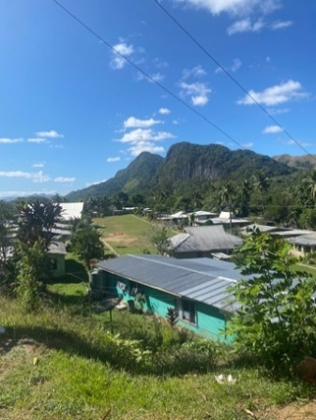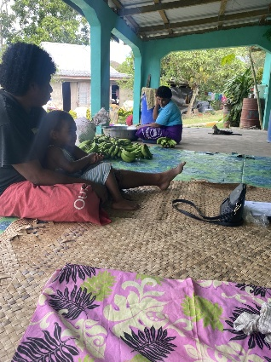

Note. View of the village (Left). A typical setting for Talanoa in this research (Right).
Approval of Cultural Exchange
Participants reported both material and social benefits during Talanoa. However, young volunteers’ positive impact on village youth through friendly interactions, practising English and exchanging worldviews and cultural values was particularly emphasised. Participants credited volunteers with the village youth remaining in school and consequently rejecting the village social norm of dropping out of school to work on family farms. Rather, those youth now aspire to attend university or seek employment outside of the village.
While most participants spoke positively about this, some noted that certain community members prefer “the old ways”. The shift in youth aspirations was consistently cited as a key example of how volunteers influenced the village “mindset” across generations.
Money Talks: Associating Volunteers with Money
Direct financial assistance is typically helpful for small island developing states (SIDS). The present rural village community has received several large donations, including from day visitors participating in village tours. Participants explained that the association of outsiders with financial opportunity builds a social perception of visitors as “dollar signs”.
The village has hosted a range of volunteers, but participants mostly found an international, short-term voluntourism company to be most salient. Around 20 young adults stayed in village households, and hosts are paid to provide food and accommodation for two volunteers. The voluntourism company required homes to meet ‘hosting standards’ such as flush toilets. However, by excluding households that lack modern conveniences from the financial benefits, this impacts economic inequality within the village. This individualistic approach also misaligns with the collective village norms, where group needs and decisions are prioritised. In Fiji, collective norms are sustained by trust and are evident in the communal effort of childcare, open doors to all, and the kerekere systems. Those who did not host volunteers conveyed happiness for those who did, but some who hosted expressed that it felt “unfair”.
Effectiveness of Volunteer Development Efforts
While village members recounted social benefits of voluntourism, there were scarce mentions of the development efforts. In fact, many participants could not recall the projects that volunteers had led a few years prior. It was pieced together that the volunteers conducted workshops for groups within the village, and some participants reported that this division of the village was against the norm, although still appreciated. The lack of recall could be explained by the organisation not leaving a record of the project procedure or materials with the community, and some participants expressed that providing this would be helpful. This aligns with Unaisi Nabobo’s explanation that returning findings and leaving something with the host community is key to promoting Indigenous sovereignty over changes to the Vanua (2008). This suggests the need for increased communication with host communities on appropriate sustainability efforts for development projects to truly serve their purpose.
A government stakeholder demonstrated how these factors may contribute to critiques of international volunteering :
Some NGOs just come to raise the funds, and just to make them seen, and to be in the pictures they take for the project at this village. But no further assessment is done.

Although volunteers may intend to help, this reported behaviour sounds more performative than effective. If volunteers surpass the local experts and leaders, issues may worsen. The stakeholder explained that a lack of clean drinking water is the biggest threat to rural Fijian villages in this province. Stakeholders, including village members (see Fig. 2), hold valuable knowledge and experience with the land. Mistakes may lead to the village and volunteers wasting resources and burdening the government or hosts to fix the failures left behind. Notably, this participant stressed that they wish to be consulted because the land “can also kill you”. This supports ongoing conversations in development that Indigenous knowledge and expertise on their lands should be sought, respected and prioritised before implementing Western solutions.
Figure 2. My Village Host Showing Me Her Farm
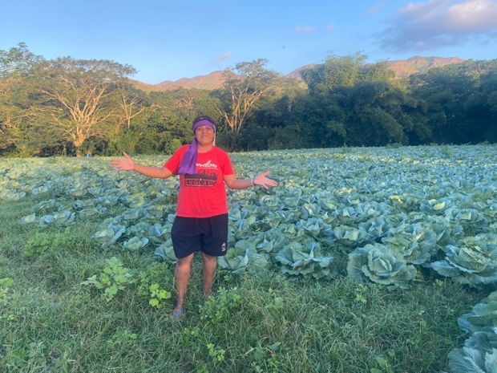
Interviews revealed that, along with hospitality as a “lifestyle”, hosting often takes priority over spending time tending to crops and other responsibilities. On the coast, iTaukei villages are more exposed to tourists, work opportunities and technology, so villages are beginning to deny hosting international volunteers due to concerns about depleting natural resources and ineffective or even “exploitative” development projects. In contrast, rural inland villages may view hosting volunteers as one of the few avenues to outside resources.
Bonds without Borders
During Talanoa, village participants expressed pride, warmth, and gratitude for past volunteers and other kaivalagi (foreigners). Their homestays in the village seemed to foster meaningful, cross-cultural relationships with their hosts:
The first time we sat together, we shared tears. Yeah we shared tears. And I knew there was something deep inside there, eh? And I could tell, I could feel it too.
- Member of i-Taukei Village (F, 68)
Some participants described an immediate trust in outsiders and a perceived obligation to follow their lead in development projects. This aligns with ‘tight’ cultural values which emphasise fulfilling one’s role within the community and showing politeness toward outgroup members, especially to those with higher perceived power.
Figure 3. Long-term Volunteers and Village Member
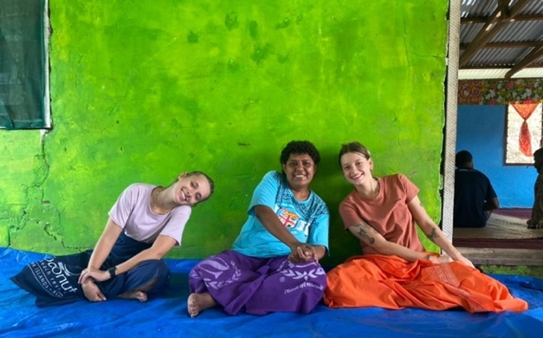
Openness and trust may also stem from the central Fijian values of hospitality and collective sharing. Yet, in rural villages, pronounced disparities in academic knowledge, resources and access to the West may contribute to the villagers’ self-description of being “behind”.
In the Global North, voluntourism has been criticised as stemming from colonial narratives of saviourism and perpetuating dependency and power imbalances between tourists and Indigenous hosts (McLennan & Thomas-Maude, 2023). Similar comparisons were discussed with village members:
Participants described missionaries who brought religion to Fiji with admiration and positivity, framing them as saviours. However, imbalanced power dynamics are evident in the constrained cooperation described between volunteer groups, Fijian villages and government bodies:
When the volunteers come, they bring about similar changes to when the missionaries came, shining the light and truth to help us change and become better people.
- Member of i-Taukei Village (F, 62)
But some NGOs, they bring direct to community without consent. That is the problem we are facing right now....the processes are there to be taken.
- Government Stakeholder
By bypassing the appropriate permissions, combined with limited government support, rural villages in this province are left to manage the risks and external pressures associated with voluntourism.
Autonomy of Hosting Communities
Overall, perspectives on the aforementioned topics were typically consistent within the village. However, when asked to identify the best leaders for development projects, variation emerged. Participants did not overtly share concerns about following volunteers’ direction, and some said outsiders, with their greater access to academic knowledge and resources, were better positioned to take on decision-making roles:
It depends on what they come to do, we should support them. They bring with them many ideas, so we just need to be supportive.
- Member of i-Taukei Village (F, 63)

While others, including elders in the village and government stakeholders, advocated for increased collaboration with the community.
The next time they come, the volunteers can ask what we need and want them to do.
- Elder Member of i-Taukei Village (M, 68)
Meaningful community collaboration and prioritisation of stakeholder voices are essential for sustainable development through tourism, as illustrated in the Tourism Resilience Framework (Movono et al., 2023) and in decolonising research practices for SIDS (Nabobo-Baba, 2008).
Voluntourism is criticised for reinforcing existing socioeconomic hierarchies, but it remains uncertain whether limited collaboration directly reduces local autonomy. One government stakeholder expressed the view that volunteers can, in fact, motivate villagers to act more independently, noting that he encourages villages “try first” before seeking government assistance. I observed steps toward increased autonomy in the village that aligned with Western models of growth, including operating small businesses like canteens within the village and holding open meetings on financial literacy and entrepreneurship.
Implications
This project brings attention to the moral complexities embedded in colonial histories, contemporary political systems, technological change, and persistent inequalities in access and privilege.
Decision makers should recognise that both village members and stakeholders value aspects of voluntourism, while also critically reassessing the roles volunteers and programmes play in international development. Voluntourism programmes must prioritise culturally appropriate project planning, collaboration with local stakeholders, respect for local leadership structures, and outcomes that can be sustained by the community. Neglecting these factors increases the risk of rejected voluntourism requests, perceptions of village exploitation, and diminished trust between communities and volunteer organisations. The findings illustrate inefficient attempts at cooperation between Fijian stakeholders and external volunteers, which can unintentionally perpetuate development challenges (e.g., clean water access). However, there are clear opportunities to strengthen this cooperation while preserving the helpful and even beloved elements of voluntourism for host communities.
The Creation of Voluntourism Guidelines for Nadroga-Navosa Province

The initial proposal of this project prompted members of the Nadroga-Navosa Provincial Council to request that my collaborator, Lite Seruvakula, and I develop a standardised set of guidelines for individuals and organisations interested in volunteering in the province. These guidelines draw on the present findings and aim to protect both community and volunteer wellbeing by improving collaboration between stakeholders. We recommend the following three A’s when approaching voluntourism in the Nadroga-Navosa: Adapt, Ask, and Anticipate.
Adapt refers to researching the local culture and understanding community expertise on the development issue of interest. Volunteers should then adapt their project to complement ongoing, local initiatives. For example, the Ministry of iTaukei Affairs’ Individual Village Development Plans (IVDP) provide a structured and needs-based evaluation specific to each village. This offers a natural entry point for effective, coordinated projects that may benefit from volunteers’ time and resources.
Ask involves formally seeking permission from the Provincial Office and the Ministry of iTaukei Affairs. Volunteers should provide a detailed project proposal that outlines the rationale, who benefits and how, safety considerations for the community and volunteers, and plans for sustainability. Where a specific village is involved, groups should also coordinate with the Turaga-ni-Koro (village headman) to ensure the work aligns with community priorities.
Anticipate refers to the planning not only of the conclusion of volunteers’ stay, but also the progression of the project for the hosts. To start, a summary of the volunteers’ efforts should be provided to the village. Organisations should prioritise regenerative goals from the design phase to post-trip care, ensuring the community can independently extend or adapt the development after volunteers leave. The volunteer organisations hold responsibility for ongoing impacts and for supporting ongoing results.

Suggested Actions

A dearth of accessible information on the social impacts of voluntourism means volunteers often lack a moral perspective on this complex cross-cultural interaction. Suggested actions for MFAT and other decision makers to strengthen cooperation include:
1) Partner with existing local development goals and practitioners (as discussed above);
2) Disseminate clear guidelines for ethical and effective international volunteering, potentially through MFAT’s “SafeTravel” pages or a dedicated international volunteering tab;
3) Support community-requested, skilled volunteers and ensure robust background checks. Government-funded programmes such as Volunteer Service Abroad should continue prioritising skilled professionals. Village participants expressed interest in learning from skilled outsiders (e.g., engineers, plumbers), which could lead to community-led and sustainable development. However, stronger screening, particularly for volunteers working with children, should be in place to prevent harm and protect children’s wellbeing.
4) Frame voluntourism as collective action rather than individual endeavours. Just as volunteers were credited with shaping hosts’ mindsets, recognising the immense value of the Fijian collective mindset is essential. Collective approaches should be integrated into any aid approach, especially as research increasingly shows how collective motivation drives advocacy and pro-environmental behaviours. International volunteering should also be framed as joining an ongoing, community-led movement that continues beyond the presence of volunteers.
Finally, decision makers should invest in continued research and consultation because community landscapes and tourism evolve. We must invest in understanding how cross-cultural interactions like voluntourism connect to human and cultural well-being and change.
Limitations and Further Research
While other Fijians may share the reflections presented by the stakeholders and villagers in this study, inclusive exploration with coastal villages, settlements, other ethnicities, and provinces would provide further clarity on voluntourism in Fiji. Similarly, a Fijian researcher asking similar questions may elicit different insights, particularly regarding community-level impacts that may be more readily shared with an insider. It’s imperative to acknowledge that positionality as an outsider poses limitations to this study. For example, social desirability bias may be present throughout the data due to my perceived power and proximity to international volunteers, and participants’ motivation continue hosting volunteers. Additionally, even with translator assistance, a language barrier inhibits nuanced understanding of word choice. As a trained community-based interviewer, I sought to mitigate these limitations through reflexivity, participant-led discussion when possible, probing questions for clarification, and culturally sensitive engagement in the field.
Through local collaboration and ongoing reflexivity, I aim to act as a vehicle to deliver the perspectives of grassroots stakeholders directly impacted by voluntourism. I have shared insights and calls to action with volunteer groups in Aotearoa, interested readers of the published PhD thesis, and now with the Ministry of Foreign Affairs and Trade. Future research could explore how these presented guidelines might be adapted for other provinces or host communities.
References
Bandyopadhyay, R. (2019). Volunteer tourism and “The White Man’s Burden”: Globalization of suffering, white savior complex, religion and modernity. Journal of Sustainable Tourism, 27(3), 327–343. https://doi.org/10.1080/09669582.2019.1578361
Biddle, P. (2021). Ours to explore: Privilege, power, and the paradox of voluntourism. Potomac Books, an imprint of the University of Nebraska Press.
Chen, J. (2022). Space, time and structure: Unpacking relationships in international development volunteering. Progress in Development Studies, 22(4), 335–351. https://doi.org/10.1177/14649934221084887
Cornish, F., Breton, N., Moreno-Tabarez, U., Delgado, J., Rua, M., de-Graft Aikins, A., & Hodgetts, D. (2023). Participatory action research. Nature Reviews Methods Primers, 3(1). https://doi.org/10.1038/s43586-023-00214-1
Higgins-Desbiolles, F., Scheyvens, R. A., & Bhatia, B. (2023). Decolonising tourism and development: From orphanage tourism to community empowerment in Cambodia. Journal of Sustainable Tourism, 31(12), 2788–2808. https://doi.org/10.1080/09669582.2022.2039678
McLennan, S., & Thomas-Maude, J. (2023). Othering or authenticity?: Voluntourism and cultural exchange in Peru and Fiji. Journal of Hospitality and Tourism Management, 56, 155–162. https://doi.org/10.1016/j.jhtm.2023.06.020
Movono, A., Scheyvens, R., & Ratuva, S. (2023). Beyond bouncing back: A framework for tourism resilience building in the Pacific. Journal of Interdisciplinary Research, 76(1). https://doi.org/10.26021/14346
Nabobo Baba, U. (2020, April 25). Talanoa: An Indigenous Pacific Research Approach. https://unaisinabobobaba.wordpress.com/talanoa-as-empathetic-apprenticeship/
Nabobo-Baba, U. (2008). Decolonising framings in Pacific research: Indigenous Fijian Vanua Research Framework as an organic response. AlterNative: An International Journal of Indigenous Peoples, 4(2), 140–154. https://doi.org/10.1177/117718010800400210
Sin, H. L. (2009). Volunteer Tourism—“Involve me and I will learn”? Annals of Tourism Research, 36(3), 480–501. https://doi.org/10.1016/j.annals.2009.03.001
Smith, L. T. (2021). Decolonizing methodologies: Research and indigenous peoples (First published in Great Britain 2021, Third edition). Zed.
Wearing, S., & McGehee, N. G. (2013). Volunteer tourism: A review. Tourism Management, 38, 120–130. https://doi.org/10.1016/j.tourman.2013.03.002

In the simplest translation, Vanua refers to interconnectedness inclusive of culture, chiefs, knowledge systems, relationships, values, land, and spiritualities.
Kerekere: a traditional practice of communal resource-sharing.

