Joseph Brockliss | Master of Development Studies | Massey University

Pedagogies of Plurality. Chiapas, Mexico.

Summary:

- Community-led Indigenous education models in Chiapas offer culturally and environmentally centred pathways to well-being, grounded in autonomy, educational liberation, and ecological sustainability.

- Top-down state interventions have historically disrupted Indigenous ways of life while failing to produce economic or occupational security for the people of Chiapas, while Zapatista schooling re-embeds education within traditional practices of trade and governance.

- For many Indigenous communities in Latin America, education grounded in Buen Vivir and post-development principles has been shown to foster dignity and self-determination more effectively than standardised, Western-centric schooling models.

- Policy actors must rethink how educational support is delivered, shifting from prescriptive programming toward relational, community-embedded partnerships.

What is the development issue?
Indigenous communities in Chiapas, Mexico, have long faced educational inequality, cultural marginalisation, and systemic poverty due to colonial legacies and neoliberal development agendas (Harazduk, 2014). Despite reforms, state education models often fail to reflect the social, linguistic, and economic realities of these communities. In contrast, the Zapatista movement has established autonomous education systems that are culturally relevant, community-directed, and designed to support collective well-being, or buen vivir as it is referred to in many Latin American countries (Acosta, 2020).

Despite being one of the most resource-rich states in Mexico, Chiapas remains one of the most marginalised, with high rates of poverty and educational exclusion, particularly among Indigenous populations. Government led education initiatives have often exacerbated this situation by undermining Indigenous knowledge systems and languages, reinforcing external models that disconnect schooling from local realities (Harvey, 1998). In contrast, the Zapatista model challenges these dominant development paradigms, offering a powerful example of grassroots resistance and a reimagined form of education that is rooted in cultural identity, autonomy, and community needs (Baronnet & Stahler-Sholk, 2019).

The research aimed to examine how the inclusion of Indigenous knowledge in Zapatista and other autonomous Indigenous schools in Chiapas intersected with the well-being of the Indigenous communities. This aim was framed by three guiding questions:

• First, why did the Zapatistas choose to create their own curriculum post the
signing of NAFTA?

• Second, what challenges have Zapatista and other autonomous Indigenous communities in Chiapas faced in moving away from the national education
system and developing their own education models?

• And lastly, how has the development of autonomous education structures by the
Zapatistas and other Indigenous communities in Chiapas influenced the well-being of Indigenous peoples in the region?

Key findings
The findings suggest that Indigenous education in Chiapas strengthens collective well-being and academic achievement when it is rooted in local language, values, and knowledge. Education is being reclaimed as a source of dignity, no longer a tool for assimilation. Language revitalisation, agroecological practices, intergenerational learning, and autonomy were identified as critical to resilience and empowerment. As one participant stated:

“It (education) focuses on the need to raise awareness in the children and not only teach them the facts… What is most important to us as promoters of education is that the children are conscious of their situation and free.”

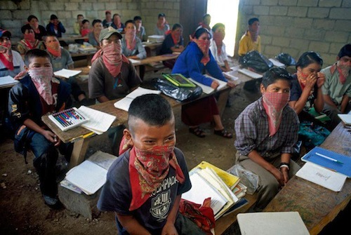
Zapatista students wearing bandanas in a community-built classroom. (Source: The Roar Mag, n.d.).
Education, when embedded in community life, connects language, agriculture, spirituality, and ethics into a holistic system (Reyes-Martínez, 2022). Well-being does not arise from isolated interventions but from the weaving together of education with health, social relationships, and cultural survival. Autonomy emerged as both the cause and the outcome of this process, enabling communities to define their own visions of development and resist external impositions.
Indigenous educators emphasised that State schooling historically labelled them as marginal or deficient, fostering internalised oppression. In contrast, autonomous schools affirm identity by teaching in Tsotsil and Tseltal, embedding buen vivir values, and involving elders. Stakeholders acknowledged challenges such as limited resources, gender dynamics, and threats from paramilitary or cartel forces, but underscored resilience and adaptability as defining features of their struggle.

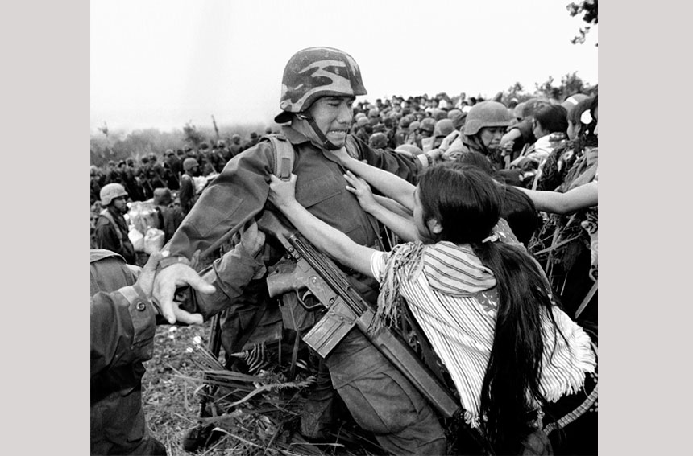
Indigenous woman from Chiapas resisting military advancements (Source: Valtierra,1998).
The State’s homogenising model of mestizaje has failed, deepening dispossession and disempowerment. Its emphasis on labour market preparation clashes with Indigenous values and worsens inequality. As one participant stated:

“Mainstream education is designed to create employees for capitalism. In contrast, this
system teaches children to be aware that education is meant to serve life, not just to secure a job.”

Autonomous education, by contrast, succeeds because it is for the people, by the people. It fosters agency, critical consciousness, and ecological stewardship, while repurposing outside tools in culturally grounded ways. Its success is rooted in refusing fragmentation and affirming life as interconnected.
For children, hearing their mother tongue in school transforms classrooms into affirming spaces of growth rather than exclusion (Henze & Davis, 1999). For communities, autonomy and epistemic sovereignty restores dignity and strengthens social cohesion. At the broader scale, the Indigenous autonomous schools of Chiapas challenges mainstream development paradigms by showing that alternatives are not only possible but thriving. It reframes education as collective empowerment, feeding into global conversations on post-development, decolonisation, and rethinking well-being. This was noted by a participant who stated:

“The curriculum focused on strengthening local culture and reviving the community’s knowledge systems. A key part was valuing the students' native language, making sure students felt welcomed and understood in the way knowledge was conveyed.”

Implications
The findings suggest that development actors must shift their approach from prescribing external education models to building genuine partnerships with Indigenous communities. Well-being in Chiapas does not emerge from isolated schooling initiatives but from education that is embedded within the broader social fabric, reflecting cultural identity, ecological stewardship, and collective ethics.
Key implications include:
- Recognise Indigenous knowledge as equal: Development actors must treat Indigenous knowledge systems as equal to, rather than subordinate to, Western frameworks.
- Strengthen community autonomy: Support mechanisms should reinforce self-determination instead of undermining it.
- Protect resilience: Interventions should shield Indigenous education initiatives from political, paramilitary, and economic pressures that threaten their sustainability.
- Redefine success: Evaluation must be based on community-defined markers of dignity, sustainability, and cultural continuity—not solely Western metrics like test scores or graduation rates.
New Zealand’s role:
- Direct influence on Chiapas is limited, but Aotearoa can use its diplomatic voice to encourage the Mexican government to end military intimidation against Indigenous communities.
- The greater value lies in learning from Chiapas and applying lessons domestically and regionally. New Zealand development organisations should respect Indigenous knowledge, honour cultural practices, and centre identity and self-determination in partnerships.
Regional lessons – the Pacific:
- The Chiapas experience highlights the risks of undermining Indigenous cultures or assuming they will not assert their own agency. Once relationships fracture, repairing them is extremely difficult.
- In the Pacific, where China’s influence is rising, New Zealand must engage with humility, respect, and long-term commitment, avoiding coercion or unilateral action.
- Historical arrogance in negotiations with Pacific communities has left scars; repairing and protecting these relationships is essential for regional stability.
At home – Aotearoa:
- The current push for a “unified culture” and sidelining of te reo Māori risks repeating mistakes made by the Mexican State toward its Indigenous peoples.
- Actions such as the removal of te reo from schoolbooks may be perceived by Māori as cultural suppression, accelerating mistrust between Māori and the State.
- A more constructive approach would be a pluraliversal spirit that recognises and respects Māori cultural agency and sovereignty.
Consequences of action vs inaction:
- Action: Approaches rooted in humility and respect can make education a site of reconciliation, strengthen Māori–State relations, and support Pacific partnerships that affirm Indigenous identity.
- Inaction: Assimilationist policies or disregard for Indigenous agency risk deepening mistrust, marginalising Indigenous voices, and fracturing domestic and regional ties. As Chiapas shows, once educational and cultural relationships reach breaking point, repair is exceedingly difficult.
“Any education system engages in violence when it takes language away from Indigenous youth. For the Indigenous peoples of Chiapas, such a loss is not only a loss of identity but also an egregious violation, one that can inflict profound harm on the youth themselves, their communities, and their broader movements if they are denied the right to speak their Indigenous language.” — Dr Levi Gahman

Limitations and further research
This research has some limitations, most notably that it has been conducted from the perspective of an outsider rather than from within the Indigenous communities the researched focused on firsthand. While reflexivity and solidarity guided the approach, the absence of authorship from an Indigenous Chiapas citizen limits how deeply the findings can represent lived realities. These limitations mean that the recommendations provided above should be seen as a starting point rather than definitive guidance, underscoring the importance of privileging Indigenous voices in future policy and practice.
Significant knowledge gaps also remain. For example, there is little comparative research into how autonomous Indigenous education models might be adapted across different global contexts, such as Māori communities in Aotearoa or First Nations in Canada and Australia. Likewise, there is insufficient investigation into the links between Indigenous-run schools and measurable well-being outcomes, the sustainability of such systems in resource-constrained contexts, and the long-term impact of Indigenous centrered education on cultural survival, confidence, and community resilience.
Addressing these gaps is important because education plays a pivotal role in shaping both cultural continuity and social well-being. Without deeper Indigenous-led, culturally grounded research, development actors risk continuing top-down approaches that misrepresent or undermine Indigenous priorities. Future research must therefore centre Indigenous scholars, use Indigenous languages, and explore partnership models that respect autonomy while addressing material resource needs. Only through such work can policy and development practice better support education as a site of decolonisation, resilience, and empowerment.
Opening the door to Indigenous voices in development means listening even when those voices raise uncomfortable criticisms of the so-called “good work” that development actors claim to be doing or have done. In academia, the chronic underrepresentation of Indigenous perspectives has long allowed such critiques to be drowned out by the weight of Western scholarship. Too often, the testimony of one Indigenous scholar documenting harm is refuted by dozens of Western academics praising the same practice as a success, while simultaneously building careers and accumulating academic capital.
In practice, authentic relationship-building is essential, yet difficult to achieve when academic, social, and economic gain continue to shape interactions. From both the findings of this research and my own dialogue with Indigenous communities, I feel strongly that these communities worldwide are increasingly unwilling to be told “what is good for them,” especially by Global North nations grappling with their own current economic, social, and cultural crises.

References
Acosta, A. (2020). Buen Vivir: a perspective for rethinking the world. In C. Burkhart., M. Schmelzer & N. Treu (Eds.), Degrowth in Movements: Exploring Pathways for Transformation (pp. 87-99). John Hunt Publishing, Winchester.

Baronnet, B., & Stahler-Sholk, R. (2019). “Never again a México without us”: education and indigenous autonomy struggles in México. In R. Aman & T Ireland (Eds.), Educational Alternatives in Latin America: New Modes of Counter-Hegemonic Learning, 63-87. Palgrave Macmillan Cham. https://doi.org/10.1007/978-3-319-53450-3

Corlett, E. (2025, August 20). Why is the New Zealand government cutting Māori words from some school books? The Guardian. https://www.theguardian.com/world/2025/aug/20/maori-words-school-books-new-zealand
Edel, C., & Paik, K. (2025, April 8). China’s power play across the Pacific. Centre for Strategic and International Studies. https://www.csis.org/analysis/chinas-power-play-acrosspacific#:~:text=When%20Kiribati%20and%20Solomon%20Islands,have%20not%20all%20proceeded%20smoothly
Harazduk, I. (2014). Zapatistas and the Mexican educational system: a critical analysis of curriculum [Dissertation]. American University.
https://doi.org/10.57912/23868528.v1

Harvey, N. (1998). The Chiapas rebellion: The struggle for land and democracy. Duke University Press.

Henze, R., & Davis, K. A. (1999). Authenticity and identity: Lessons from indigenous language education. Anthropology & Education Quarterly, 30(1), 3-21.

Reyes-Martínez, J. (2022). Cultural participation and subjective well-being of Indigenous
in Latin America. Applied Research in Quality of Life, 17(2), 635-654.
https://doi.org/10.1007/s11482-021-09910-0

The Roar Mag. (n.d.). [Zapatista children in class]. The Roar Mag. https://roarmag.org/essays/zapatista-autonomous-education-chiapas/

Valtierra, P. (1998). Women of X´oyep, Chenalhó, Chiapas [Photograph]. Secretaría de Cultura, Gobierno de México. https://www.cultura.gob.mx/revelandomexico/pedro-valtierra/

