NURUSSAADAH MOKHTAR | PHD IN GEOGRAPHY | UNIVERSITY OF OTAGO

Rethinking Urban Food (In)security in the Age of Supermarket Urbanism in Malaysia

Policy Takeaways

Supermarkets dominate food access, limiting choice and marginalising local markets for low-income urban households.

Welfare programs boost purchasing power but channel households towards supermarket reliance.

Community-based urban agriculture provides adaptive options, while commercial farming focuses on profit over equitable access.

Mobility, transport and market location shape access to affordable and nutritious food.
- Coordinated policies are needed to improve low-income household food security.
Box 1: Key Policies Snapshot—Existing Access to Vegetables for Poor Urban Households

- Ministry of Finance
Programme: MySTR & MySARA food/grocery assistance.
Scope: Supporting purchase of non-perishable items from supermarkets and non-food essentials to reduce the burden of rising living costs.
Limitation: Do not cover fresh produce, including vegetables.

- State & Local Planning Authorities
Policy: Zoning and development approvals.
Scope: Facilitating establishment of supermarkets and hypermarkets in neighbourhoods.
Limitation: Supermarkets dominate food retail; limit alternative fresh food access.

- Federal Agricultural Marketing Authority (FAMA)
Programmes: Wholesale markets, morning (farmers) and night markets (traditional & local food markets).
Scope: Supporting farmers and providing access to local fresh produce.
Limitation: Wholesale markets are far from urban neighbourhoods; fresh produce including vegetables in farmers and night markets are more expensive than supermarkets. MySTR & MySARA schemes cannot be used.

- Division of Urban Agriculture, Dept. of Agriculture & Local Planning Authorities
Policy: Community-based & commercial urban agriculture (UA).
Scope: Supporting both community scale and commercial scale of vegetable production in urban areas.
Limitations: Community-based UA focused on social cohesion & minimal effect on vegetable consumption. Urban poor households are not the target market of commercial UA, which produces high-end vegetables with MyGAP certification, supplying supermarkets and exporting overseas.

What is the development issue?
Rapid urbanization and expansion of supermarkets have reshaped food access in Malaysian cities, concentrating food distribution within dominant retail chains and marginalizing non-supermarket food outlets. Prior to the growth of the supermarket industry, food retailing in Greater Kuala Lumpur was more dispersed and embedded within wet markets, small grocers, and neighborhood-based food economies, reflecting a less commercialized and less corporatized urban land-use landscape. Today, urban food security is increasingly constrained by issues of affordability and accessibility, with healthy diets becoming progressively out of reach for low-income households (Azizan et al., 2018; Teoh, 2024). Fruits and vegetables, essential components of a balanced diet, represent a significant share of household food expenditures, rendering them particularly unaffordable for vulnerable populations.
These pressures are occurring alongside rising urban poverty. According to the World Bank (2023), nearly 490,000 Malaysian households remain below the national poverty line, and urban poverty rose from 3.8% in 2019 to 4.5% in 2022. Within low-cost housing areas, residents commonly adopt dietary patterns marked by low fruit and vegetable intake and high consumption of ultra-processed foods (Eng et al., 2022). Alarmingly, 86.7% of respondents in low-income communities report consuming fruits and vegetables fewer than five times per day, indicating widespread nutritional deficiencies (Azizan et al., 2018).
Urban food insecurity is therefore driven less by vegetable availability and more by supermarket dominance, pricing, welfare design, and planning decisions, which shape who can afford and access healthy food. These dynamics restructure local markets, urban farming, and household practices, limiting nutritional equity for the urban poor.

Why this issue is important
Despite multiple policy instruments (see Box 1), poor urban households continue to face persistent barriers to affordable and accessible healthy food, due to cost, distance, and welfare-related retail restrictions. Without addressing these structural drivers, interventions risk reinforcing existing inequities rather than improving dietary outcomes.

Background of the issue
In response to urban food insecurity, urban agriculture (UA) has emerged as a potential solution, offering localised solutions to urban poverty and inequality (Shariff et al., 2020). Initiatives to repurpose vacant urban land to support community-based food production reflect broader policy efforts to strengthen food security and local resilience. However, the capacity of urban agriculture to address challenges posed by supermarket dominance, or to leverage its expansion, remains underexplored, particularly regarding issues such as land access (Tornaghi, 2014; Yap, 2023).
This debate reflects two contrasting approaches to urban food security. On one hand, supermarket urbanism, driven by land commodification and economies of scale has reshaped food systems in rapidly urbanizing cities, often prioritising efficiency and profitability over equity (Battersby & Haysom, 2020; Vivero-Pol, 2017). On the other hand, urban agriculture, though presenting a sustainable local food production alternative, faces numerous obstacles, including land scarcity, and lack of policy support (Blay-Palmer et al., 2023; Tornaghi, 2014).

Methodology
To answer the research questions 1) How does supermarket urbanism affect the affordability and accessibility of food for the urban poor in Malaysia? (Box 2) and 2) How and under what conditions does urban agriculture function as a form of adaptation to the economic and social challenges faced by the urban poor within supermarket-dominated food systems? (Box 5), this policy brief draws on two participatory mapping workshops conducted in the low-income neighbourhoods of Kota Damansara and Damansara Damai in Selangor, Malaysia’s richest state by GDP. Each workshop involved seven women residents aged 18 and above, recruited through purposive and snowball sampling. Participants, with average ages of 54.6 and 51 years and household sizes of 4.1 and 4.9, largely lived below Selangor’s poverty line of RM2,830. Using collaborative mapping, spatial identification of food sources, and group discussions, the workshops documented local food points, gaps in access, supermarket dependence, barriers to fresh food, and vegetable consumption practices.
To complement community-level insights, semi-structured interviews were conducted with officials from the Ministry of Agriculture and Food Security, and urban planners in Greater Kuala Lumpur, providing policy and implementation perspectives on urban agriculture, food security, and urban planning.
Additional interviews comprised individuals engaged in urban agriculture within Greater Kuala Lumpur, selected from both community-based initiatives and commercial urban farms.

Key Findings
Box 2: How does supermarket urbanism affect the affordability and accessibility of food for the urban poor in Malaysia?
1 Price Dominance Structures Food Access
Supermarkets dominate affordability. Urban poor households prioritise low prices over convenience or cultural preference, often travelling further for cheaper fresh produce.
2 Supermarkets as De Facto Welfare Food Infrastructure
Welfare programmes channel households into selected supermarkets. This increases purchasing power but limits choice and marginalises local markets and community farms.
3 Uneven Food Landscapes Constrain Choices
Local markets (pasar tani, pasar malam) remain important, particularly for traditional vegetables, but are less visible, less accessible, and often costlier. Mobility and transportation shape household food options.
4 Planning Protection Amid Supermarket Price Dominance
Even formal planning and land zoning cannot counter supermarket dominance. Price and economies of scale keep local markets and permanent wholesale markets less competitive for urban poor households.

1 Price Dominance Structures Food Access
For most low-income urban households, food access is overwhelmingly shaped by price sensitivity, leading to a strong preference for supermarkets perceived as offering the lowest prices and acceptable freshness. Affordability, rather than nutritional value or cultural preference, primarily determines vegetable purchasing decisions. Participants reported prioritising supermarkets such as EconSAVE, HeroMarket, Giant, and NSK, even when these outlets were less tidy or required additional travel, because they consistently offered cheaper fresh produce.
A smaller group of households with access to private transport adopt alternative procurement strategies, travelling beyond their immediate neighbourhoods to faraway wholesale markets to purchase vegetables and other fresh produce at substantially lower prices than nearby supermarkets. Even after accounting for transport costs, wholesale markets were perceived as more economical for bulk weekly purchases:
“My husband goes to the Selayang wholesale market every week because there is a wide variety of goods and the prices are much cheaper… even after calculating the cost of petrol, it is still cheaper than buying at nearby grocery shops and supermarkets.”
This pattern highlights the role of mobility and access as key mediators of food purchasing choices, showing that price dominance is not uniform across households but is influenced by resources, transport options, and willingness to travel. By linking price sensitivity to mobility, these findings cross-cut other thematic insights on urban food accessibility and constrained household choice.

2 Supermarkets as De Facto Welfare Food Infrastructure
Cashless grocery assistance schemes unintentionally reinforce supermarket dominance by structuring where and how grocery assistance can be redeemed. Under Malaysia’s Sumbangan Tunai Rahmah (MySTR) and Sumbangan Asas Rahmah (MySARA) schemes, monthly grocery assistance is automatically credited to recipients’ national identity cards and can only be used for approved items at selected registered supermarkets and grocery chains (see Box 3 for an overview of the voucher mechanism). Importantly, fresh vegetables are not included among the items covered by the schemes, as that assistance primarily supports the purchase of staple food items, processed and shelf-stable foods, and non-food essentials.
Box 3: How Malaysia’s grocery voucher assistance works
Eligible recipients receive a monthly grocery allowance credited automatically to their national identity card (MyKad). The allowance can be used only to purchase basic food and household necessities and cannot be withdrawn as cash.
- Households classified as extremely poor or poor receive a monthly allowance for 12 months.
- Other eligible low-income households and elderly individuals without partners receive the allowance for 9 months.
- The value of support ranges between approximately USD 10–20 per month, depending on household category.

While this design helps households manage rising living costs by easing expenditure on essential groceries, it also embeds welfare delivery within supermarket infrastructures and does little to directly improve access to fresh produce. This dynamic was clearly articulated in both community workshops. As one participant explained:
“EconSAVE and SEGI are quite far from our neighbourhood, but we usually shop there once a month, at the beginning of the month, to stock up on our monthly groceries. We are still willing to travel the longer distance because EconSAVE is cheaper. This is especially important for us because we receive government assistance and redeem our grocery vouchers there.”
Participants’ food purchasing practices were strongly shaped by the retail restrictions embedded in MySTR and MySARA. Because MySTR and MySARA credits could only be redeemed at participating supermarkets, households prioritised these outlets regardless of distance, store conditions, or personal preference. Several participants reported travelling further or relying on neighbours for transport to reach supermarkets such as EconSAVE, Giant, and NSK which were perceived as affordable and compatible with voucher use. Although participants acknowledged the convenience and financial relief provided by the schemes, particularly the ability to purchase multiple essential items in one location, the schemes constrained retail choice by limiting access to wet markets, and other local food outlets often regarded as fresher or more culturally appropriate for vegetables and fresh protein.

3 Uneven Urban Food Landscapes Constrain Choice
In one community workshop, single mothers who have more limited mobility described how they navigate urban food access amid supermarket dominance and spatial inequalities. While supermarkets offer variety, competitive prices, and voucher compatibility, many households live closer to mini grocery shops and local markets. Local markets, such as pasar malam, and pasar pagi, continue to provide culturally significant and traditional vegetables, even if slightly less convenient or more expensive. Household mobility still mediates choices, with shared transport or coordinated trips helping families access preferred outlets:
“We discuss among ourselves which day we want to go, and then we go together by Grab. We usually go together like this. It helps us save some money because we share the cost.”

Access to traditional vegetables is particularly constrained. These vegetables are typically available only at night markets, NSK supermarket, with night markets providing the freshest and widest variety. As one participant described:
“Only at the night market can we buy traditional vegetables. In Damansara Damai, the night markets sell many types of traditional vegetables, such as terung pipit, pucuk gajus, ulam raja, and pucuk putat. Even if these items are available in supermarkets, they are very rarely found and are usually less fresh.”
Collaborative spatial mapping in a low-cost neighbourhood within a transit-oriented development in Petaling Jaya revealed a heavily commodified food environment (see Box 4). Within a 1 km radius, almost all types of fast-food outlets were present, alongside other franchise food and beverage outlets. This underscores how urban poor households are situated in uneven food landscapes, where healthy and culturally relevant food options such as traditional markets or community farms are spatially marginalized, limiting their everyday dietary choices.
Box 4: Spatial mapping illustrating dominance of commodified food entities in the urban environment of Damansara Damai
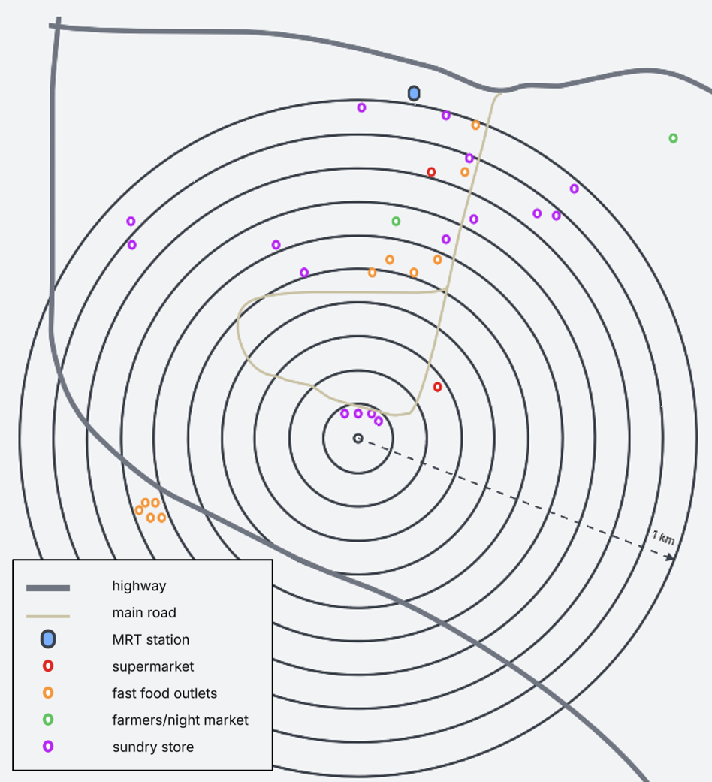

4 Planning Protection Amid Supermarket Price Dominance
Planning interventions, such as zoned commercial land for permanent pasar tani and wholesale markets, provide regulatory recognition and permanence, but do not ensure price competitiveness. Supermarkets still undercut prices through economies of scale and centralized procurement, making traditional local markets less attractive to low-income households, for whom affordability is key.
Households actively navigate this uneven food landscape. Social networks, mobility, and shopping strategies allow them to access preferred outlets, showing that while supermarket dominance shapes choices, local markets remain important for cultural and dietary needs.
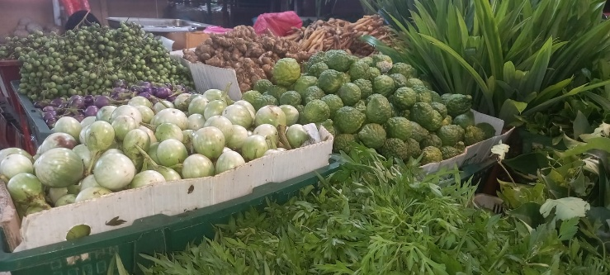
Photo 1: Traditional vegetables at a FAMA-operated wholesale market
Box 5: How and under what conditions does urban agriculture function as a form of adaptation to the economic and social challenges faced by the urban poor within supermarket-dominated food systems?

5 Community-based Urban Farming Delivers Uneven Food Security Gains
Household-level food production can reduce reliance on supermarkets, but benefits are uneven. Participation, household capacity, and planning decisions determine outcomes. Some land is repurposed for other urban functions, limiting food production.
6 Commercial Urban Agriculture Reinforces Food Commodification
Commercial farms prioritise profit and supermarket supply chains. They rarely improve access to affordable vegetables for the urban poor and do not serve as a food security solution.

5 Community-based Urban Farming Delivers Uneven Food Security Gains
Community-based urban farming offers opportunities for household food production and community engagement, but its contribution to food security remains uneven and fragile, shaped by participation levels, policy incentives, and competing urban priorities. Findings from the first community workshop indicate that while most participants had access to individual garden plots, only a small number actively and consistently harvested vegetables. One active gardener reported a substantial reduction in reliance on supermarkets through regular harvesting, whereas most participants experienced minimal direct food benefits. Access to land alone does not translate into improved food security; outcomes depend on household capacity, time, health, and sustained engagement.
“As for me, I rarely buy vegetables anymore because I prefer to eat what I grow myself… In the mornings, I go to the garden, see what is available, bring it home, and eat whatever I have.”


Photo 2: Productive community farm plot managed by a participatory workshop participant
A growing number of community-based farms are responding to commercial incentives, producing vegetables for sale rather than prioritising community nutrition. While this generates income and supports the local food economy, it can shift focus away from promoting healthy diets for low-income households. Many initiatives also pursue mixed goals such as community empowerment, income generation, or local problem-solving, rather than consistent household food provision. Without targeted support or incentives for nutrition and food access, their potential to improve diets for poor urban households remain limited.
Planning and land-use decisions further restrict the food-producing role of community farms. Findings from the second community workshop show that land initially allocated for a community-based farm was repurposed to relocate street food stalls to address traffic congestion. While responding to urban management concerns, this decision reduced the site’s food-producing function and limited its contribution to local food access. Importantly, local planning authorities in Greater Kuala Lumpur have facilitated the use of vacant urban spaces for both community and commercial farms, showing the potential for policy to support urban agriculture if aligned with food security goals. As explained by an urban planner:
“Previously, urban farming was mostly carried out on idle land, there was no specific zoning, so approvals were handled on a case-by-case basis based on land ownership or temporary occupation license. Now, urban farming in Kuala Lumpur has been formally included in the zoning plan through the land use class rule, making the approval process clearer and more systematic.”

6 Commercialisation of Urban Agriculture Reinforces Food Commodification
Commercial urban agriculture is primarily shaped by profit imperatives and market alignment, offering limited equity benefits for low-income urban households. Interview findings indicate that commercial producers prioritise supplying selected supermarkets and retail outlets that can accommodate higher prices, tailoring production to commercial standards rather than affordability or local food needs:
“We target selected supermarkets like AEON because we have to maintain our standards. We can’t sell to places like Lotus’ as we can’t compete on price—our vegetables would only fetch around RM4 per pack there, compared to RM11.80 at AEON. Selling at lower-priced supermarkets would mean a loss, especially when competing with vegetables from Cameron Highlands.”
Producers further noted that competition with large-scale suppliers, such as those from Cameron Highlands (the country’s largest production area of vegetables), makes it economically unviable to sell vegetables at prices accessible to urban poor consumers. As a result, commercial urban farms align closely with supermarket supply chains, reinforcing the commodification of food and the dominance of supermarket-based food systems.
While commercial urban agriculture contributes to income generation, market growth, and supply diversification, it does not function as a food security mechanism. Its orientation towards profitability limits its role in improving access to affordable, nutritious vegetables for low-income households.
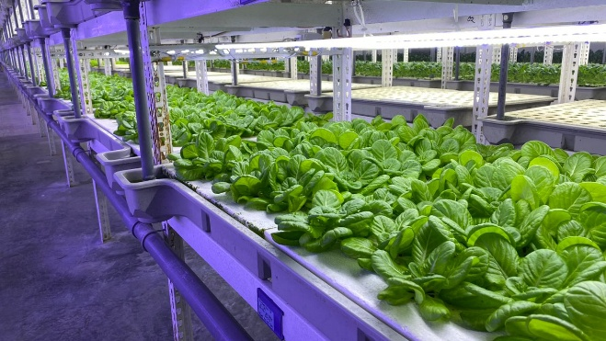
Photo 3: Rooftop plant factory of a commercial urban agriculture company in Greater Klang Valley

Policy Implications
Supermarket dominance shapes affordability and access
- Large supermarkets, mostly locally owned, channel low-income households through pricing and welfare programs, limiting choice and marginalising local markets.
- Mobility and spatial constraints further restrict access.
Urban agriculture is adaptive, not resistant
- Community farms can support household food access, but benefits are uneven and dependent on participation and planning.
- Commercial urban agriculture prioritises profit, offering limited benefits for low-income households.

Policy design determines equity outcomes
- Welfare, planning, and urban agriculture initiatives can either reinforce inequities or support adaptation, depending on clear food security objectives.
Local markets remain critical but marginalised
- Pasar tani, pasar malam, and wholesale markets provide culturally important vegetables but are less visible, less accessible, and often more costly than supermarkets.
Nutrition policies must be system-oriented
- Behaviour-focused programs alone are insufficient; food prices, retail landscapes, and access mechanisms must be addressed to improve diets.

Policy Recommendations
Box 6: Key policy recommendations
- Expand and diversify welfare food access
Target actor: Ministry of Finance
Action: Allow vouchers to be used at supermarkets, local markets, and community farms to improve choice.
- Integrate mobility and transport
Target actor: Local Planning Authorities
Action: Support transport or delivery services to improve access to affordable fresh produce beyond supermarket catchments.
- Secure and resource community farms
Target actor: Local Planning Authorities
Action: Provide land tenure, technical support, and nutrition-focused guidance to maximize household-level food benefits.
- Maximise community-focused urban agriculture for food security
Target actors: Department of Urban Agriculture & Local Planning Authorities
Action: Ensure community-based UA explicitly targets food security outcomes, aligns with local nutrition and welfare policies, and supports equitable vegetable access for urban poor households.
- Align nutrition policy with food environment
Target actor: Ministry of Health
Action: Include local markets and community farms in system-level reforms to improve affordability and access, without assuming supermarkets alone meet dietary needs.

Lessons for Development Partners
Supermarket dominance matters: Large supermarkets shape urban food access.
Urban agriculture is context-dependent: Community farms aid household adaptation but require secure land, incentives, and equity-focused design.
Mobility and access are critical: Transport, infrastructure, and market location shape access to affordable, nutritious food in Pacific and Southeast Asian cities.
Coordinate interventions: Support integrated interventions that link targeted food subsidies or cash transfers with urban planning measures (e.g., zoning for fresh food outlets, support for wet markets and community food initiatives) and nutrition-focused public health programmes.
Support local markets: Strengthen culturally and economically important markets to enhance food security, in line with MFAT’s regional initiatives.

Limitations and Further Research
- Findings are drawn from selected low-income urban communities in Greater Kuala Lumpur, Malaysia; results may not capture all regional variations.
- Policy implications may need local adaptation in different urban contexts.
- Further research is needed on supermarket reliance and urban agriculture to guide more effective, equitable food security policies.

Acknowledgements and Publication Details
The author acknowledges the support of Postgraduate Fieldwork Grant from both The Aotearoa New Zealand International Development Studies Network (DevNet) and the Tarling Trust-NZASIA Southeast Asia, which facilitated fieldwork in Greater Kuala Lumpur, Malaysia from June to August 2025.

To reference the policy brief: Mokhtar, N. (2026). Policy Brief – Rethinking Urban Food (In)security in the Age of Supermarket Urbanism in Malaysia. The Aotearoa New Zealand International Development Studies Network.

References
Azizan, N. A., Thangiah, N., Su, T. T., & Majid, H. A. (2018). Does a low-income urban population practise healthy dietary habits? International health, 10(2), 108-115.
Bank, W. (2023). "Raising the Tide, Lifting All Boats” Malaysia Economic Monitor (Malaysia Economic Monitor, Issue. W. Bank.
Battersby, J., & Haysom, G. (2020). Urban Food Security. In R. Massey & A. Gunter (Eds.), Urban Geography in South Africa : Perspectives and Theory (pp. 251-263). Springer International Publishing. https://doi.org/10.1007/978-3-030-25369-1_16
Blay-Palmer, A., Halliday, J., Santini, G., Carey, J., Malec, R., Taguchi, M., van Veenhuizen, R., & Young, L. (2023). The City Region Food System: Broadening Space for Urban Governance. In (1 ed., Vol. 1, pp. 353-364). Routledge. https://doi.org/10.4324/9781003055907-29
Eng, C. W., Lim, S. C., Ngongo, C., Sham, Z. H., Kataria, I., Chandran, A., & Mustapha, F. I. (2022). Dietary practices, food purchasing, and perceptions about healthy food availability and affordability: a cross-sectional study of low-income Malaysian adults. Bmc Public Health, 22(1), 192. https://doi.org/10.1186/s12889-022-12598-y
Shariff, N., Hamidi, Z., & Osman, M. (2020). Does small scale sustainable urban agriculture (SUA) alleviate the economic burdens of low-and middle-income households. Malaysian Journal Of Consumer And Family Economics, 24(2), 145-154.
Teoh, A. N. (2024). Unhealthy but not by Choice: Food Environment and Nutrition Inequalities. K. R. Institute.
Tornaghi, C. (2014). Critical geography of urban agriculture. Progress in Human Geography, 38(4), 551-567.
Vivero-Pol, J. L. (2017). Food as commons or commodity? Exploring the links between normative valuations and agency in food transition. Sustainability, 9(3), 442.
Yap, C. (2023). New geographical directions for food systems governance research. Progress in Human Geography, 47(1), 66-84. https://doi.org/10.1177/03091325221133808

