Sieni Tiraa | Master of International Development | Massey University

The ambivalent relationship between land tenure and tourism development on Rarotonga, Cook Islands.

Summary:
- The research examines how customary and statutory land tenure systems operate in practice under tourism-led economic pressure, drawing on qualitative evidence from landholders to understand lived experiences of land use and decision-making.
- Findings show that customary and market-based tenure systems function in a dynamic relationship, at times reinforcing each other while also producing tensions, rather than operating as strictly separate or opposing systems.
- Tourism development has contributed to a reinforcing cycle of land leasing, access to finance, and further development, which has increased the economic valuation and financialisation of land and intensified leasing activity.
- Despite these pressures, land continues to be valued and managed through relational and communal frameworks, with commercial use negotiated alongside responsibilities to family, place, and shared authority, resulting in ongoing tension between economic imperatives and cultural obligation.

What is the development issue?
This research examines how tourism-led economic development is reshaping land tenure, land use, and land values in Rarotonga, particularly through the interaction between customary land tenure systems and market-based leasing arrangements. It focuses on how these systems operate in practice under increasing development pressure, and how landholders navigate competing economic imperatives and cultural responsibilities. The aim and objectives of the research are as follows:
Aim: To understand the relationship between land tenure and tourism development on Rarotonga and the changes over the past twenty years.
Research question 1: How does land tenure affect tourism development?
Objective A: Examine the customary approaches and legal postcolonial governance structures of land tenure on Rarotonga.
Objective B: Explore the influence that land tenure has had on tourism development from the perspective of landholders on Rarotonga.
Research question 2: How does tourism affect land tenure?
Objective C: Explore the influence that tourism development has had on land use and land tenure from the perspectives of landholders on Rarotonga.

Tourism is the primary economic driver of the Cook Islands and a central pillar of national development strategy (Becken et al., 2025). On Rarotonga, tourism growth has intensified demand for land for accommodation, infrastructure, and related services. See Appendices, figure 1 for aerial shots of Muri area on Rarotonga (prime tourist area) to highlight the difference in development between 2005-2025. On Rarotonga, almost all land is held under native freehold title that applies customary tenure, governed by communal ownership, inherited rights, and shared authority (Marshall, 2018). Development therefore occurs within a hybrid system where customary land relations intersect with legal, market-based mechanisms such as leasing and finance (Horan, 2012). This context creates both opportunities for economic participation and significant governance challenges. The stakeholders involved is as follows:
- Landholders and kopu tangata (extended families), who retain rights and responsibilities over land
- Lineage authorities such as chairperson, secretary to coordinate family meetings
- Government institutions such as the Ministry of Justice through the court administration, lawyers, judges, land agents, surveyors
- Tourism developers and investors both local and external
- Financial institutions, which enable development through lending linked to lease arrangements such as the banks
- Communities more broadly, who experience the social, cultural, and environmental impacts of development such as rising prices of goods, lack of access to public beaches etc
See Appendices, figure 2: ‘Akapapa’anga: A culturally embedded approach for a holistic view of the stakeholders/actors involved and the intersection at the development interface.

While the Cook Islands has a small population, the scale of tourism-related pressures is significant relative to the country’s land area, infrastructure, and governance capacity. Visitor arrivals have now surpassed pre-pandemic levels, with July 2025 arrivals exceeding July 2019 figures by 7.3% (Cook Islands Statistics Office, 2025). Research indicates that visitor volumes are at peak levels, and in some cases exceeding, Rarotonga’s ecological and social carrying capacity, intensifying environmental pressures and infrastructure strain (Evans, 2011; Becken et al., 2025). Key impacts include pressure on solid waste management, freshwater supply, and wastewater systems. The expansion of short-term rentals has also reduced the availability of long-term housing for residents, driving up rental costs and contributing to housing stress, particularly during peak tourism periods (Milne, 2022; Mikulić et al., 2021). Furthermore, from an economic perspective, land tenure complexities contribute to high commercial interest rates of up to 10% reflecting uncertainty over lease security, diminishing collateral value over time, restricted resale markets, and the cost of lease transfers (Schulze et al., 2021). These constraints both discourage investment and encourage landholders to rely more heavily on leasing land for tourism as one of the few viable means of generating revenue on island, reinforcing the dominance of tourism-led development.
Debates on land tenure and development have traditionally framed customary tenure as an obstacle to economic growth, contrasting it with statutory, individualised ownership models viewed as more compatible with private investment and market efficiency (Maxwell & Wiebe, 1999; Stumpf & Cheshire, 2019). Within this framing, formalisation and individualisation of land rights are often presented as necessary conditions for development.
However, a growing body of literature challenges this assumption, particularly in Indigenous and Pacific contexts. Research increasingly demonstrates that customary land tenure systems can support equitable, culturally grounded, and environmentally sustainable development, especially where land remains central to identity, social relationships, and governance (Bryant-Tokalau, 2017; Crocombe & Holmes, 2014; Scheyvens et al., 2020). Rather than hindering development, plural tenure arrangements can enable diverse economic activities while maintaining social cohesion and cultural continuity (Antonio & Griffith-Charles, 2019; Rice, 2020).
In the Pacific, tourism development provides a critical lens through which these dynamics can be observed. While tourism is a major economic driver across countries such as Fiji, Samoa, Vanuatu, Tahiti, and the Cook Islands, studies show that development outcomes are strongly shaped by how tourism intersects with customary land systems (Scheyvens & Russell, 2009; Movono et al., 2018). Where tourism development fails to recognise customary tenure processes and relational land values, it can lead to community resistance, failed projects, cultural disruption, and environmental degradation (Stumpf & Cheshire, 2019; Movono et al., 2018). Conversely, tourism ventures that respect and align with customary land governance are more likely to generate durable partnerships, shared benefits, and long-term sustainability (Bryant-Tokalau, 2017; Scheyvens et al., 2020).
Overall, the literature highlights that land tenure shapes development outcomes not through its formal structure alone, but through how land, economic activity, and social relationships are negotiated within specific cultural and political contexts. Recognising and protecting Indigenous land tenure systems is therefore central to achieving equitable, sustainable tourism development in the Pacific.
Key findings
Three core themes emerged from the findings with associated sub themes which included; The dualistic systems of land tenure, impacts of land tenure on tourism development and tourism development shaping land use and land tenure.
The dualistic systems encompass customary and statutory market-based land tenure systems. They operate simultaneously in practice, interacting in a relationship of complementary competition. Tourism development relies on customary land, while market mechanisms such as leasing and finance enable development to proceed. These systems often reinforce one another but also generate tension and conflict.

For example, tourism growth has created a self-reinforcing development cycle, where in tourism expansion drives land leasing, leasing enables access to finance, and finance facilitates further development. This cycle has intensified the financialisaton of land and strengthened tourism’s dominance as the primary development pathway. See Appendices, figure 3: of Circular Cycle of Tourism Driven Development that illustrates this pattern:

- The viewpoints of the stakeholders as follows:
Landholders: There was a clear dichotomy between customary and legal land tenure governance structures, termed dualistic land tenure systems. This dichotomy often led to ambivalent experiences that gave rise to contested terrain.

“There is a very big difference. Customary is based on our aroa (love) and blood lines and our ties and our families. The other one is based on money, commercial, financial gain for financial purposes – that’s the stark difference, there’s no two ways about it.
If you were my own daughter, would I sell you my piece of land? No, I will pass it down to her because that’s our customary way. And all my lands, if I’m a title holder goes back to the family. And through the court, legally it’s yours and you can do whatever you like with it and sell it off” Tama T

From an investment angle on land tenure in the Cook Islands, the Pacific Private Sector Development Initiative [PSDI] that was commissioned by the Asian Development Bank stated that “Land ownership constraints are an impediment to tourism investment” (PSDI, 2021, p. 6). From a tourism industry and foreign investment planning perspective, land tenure in the Cook Islands is often framed as a barrier to long term and lucrative investment with calls and pushes for longer term leases from the industry and development organisations.

One of the reasons for this is that the meaning of land is different amongst stakeholders. The assembling of land for global investment reveals how land has different meanings to different people (Li, 2014). For the context of Rarotonga, these actors can include landholders, tourism developers, land agent, land court administration staff, financial institutions representatives and others. These actors have different views on the ontology of land, its affordances, and how humans should interact with it (Li, 2014, p. 590).

- Current tourism growth approaches have delivered benefits to certain segments of society while marginalising others. In the Cook Islands, neoliberal policy reforms implemented in the mid 1990s following the fiscal crisis established the foundation for rapid tourism expansion. These reforms prioritised market-led growth, deregulation, foreign investment, and private sector development, accelerating tourism-led economic growth. However, dominant growth paradigms underpinning such approaches, including Rostow’s (1960) stages of economic growth model, have been widely criticised for their linear assumptions and failure to account for social inequality. In practice, tourism-driven growth in the Cook Islands has contributed to uneven wealth distribution and socio-economic disparities within the population (Becken et al, 2025).
Overall, this research enhances understanding of the changes that have occurred over the past two decades and raises awareness of the impact’s tourism development has had on land, landholders, and the wider society. Figure 4 in the Appendices illustrates these dynamic changes across twenty years.

The findings highlighted the implications of using land for tourism development and these included:
- Tourism development impacting food security and food sovereignty:

We [are] getting less and less agriculture land and you can see the prices of the watermelon now. Before you can buy a big watermelon for $10, now it's $40 - $50 for a 8 kilo watermelon, why? Because there's not enough land to plant the watermelon and whatever land is available, you've got tomatoes on it, you got other stuff, you got maniota [arrow root], you got kumara [sweet potato] and not enough land” Papa D

- Challenges presented by foreign investment
“Another thing with regards to our land tenure is, we almost have revolving leases, you know. What good does that do? For example, look at the Edgewater ok, tourism wise, how many of our locals have given land, where in the lease it says they have first right of refusal to buy back the property - where they gonna have $20 million to buy it back, otherwise it rolls over. I think at some point, there's got to be an end to it, who is getting the money from that? Where is the money going? Mama G

- Erosion of customary practices and increasing environmental risks

“...I come from the perspective of the physical land, that impact, say changing the land itself, for example like, Nautilus [a hotel] was a wetland, its now, no longer a wetland so that’ll impact on the village – because that wetland doesn’t exist anymore” Maine J

- Displacement of future generations: landless in paradise?
“If all available land is consumed today, future Cook Islanders will be locked out of their ancestral lands, unable to access space for housing, agriculture, or cultural practice. Future generations may end up being homeless” Maine J

- Risks of using land for credit
Another key concern that emerged was the inheritance of debt rather than land. One respondent, when asked about the main challenges facing future landholders answered:
“Managing debt - because a lot of these leases are still in debt - the parents have died and still in debt, the generations coming up will inherit debt, not land but debt. I think that's something that we need to be aware of.” Maine M

Implications
The findings carry important implications for land governance, tourism policy, and development planning, highlighting the uneven effects of legal and financial systems on landholders. Viewed through a post-development lens, the research affirms the value of local knowledge, everyday practices, and customary governance systems marginalised through colonial and modern development processes. Amid growing pressure to balance economic growth with sustainability in the Cook Islands (Becken et al., 2025), it underscores the importance of recognising land as more than an asset to invest in.
Consistent with the growing Pacific land-tourism scholarship (Antonio & Griffith-Charles, 2019; Bryant-Tokalau, 2017; Scheyvens et al., 2020; Vogt, 2019) the findings call for development pathways that respect customary governance, strengthen collective agency, and protect the cultural and environmental foundations upon which community wellbeing and tourism depend. In doing so, the study contributes to wider debates on how Pacific societies can pursue development on their own terms while engaging with a globalised economy.

The Cook Islands is a Realm country, and the relationship between Aotearoa New Zealand and the Cook Islands is longstanding and deeply embedded across political, economic, and social spheres. Aotearoa New Zealand has provided substantial development assistance over many years, including core sector support to priority areas such as tourism.
To date, much of this support has focused on economic growth, particularly through tourism marketing and industry expansion. However, growing evidence suggests that tourism on Rarotonga has reached, or is approaching, critical thresholds in terms of environmental pressure, land use, and social impacts. This highlights an important development challenge that aligns closely with New Zealand’s priorities around sustainable development, resilience, and good governance in the Pacific.

This research directly contributes to these priorities by examining how land tenure influences tourism development outcomes and by identifying the implications of long-term tourism growth for landholders, communities, and destination sustainability. The findings suggest that future development cooperation and core sector support may need to incorporate stronger destination management safeguards, including land-based planning, carrying-capacity considerations, and meaningful landholder engagement.

Limitations and further research
There remains significant scope for further research to inform the development of evidence-based policy or
legislative reforms that the Government can adopt to guide the tourism sector toward a more sustainable model aligned with national planning objectives.

References
Antonio, W., & Griffith-Charles, C. (2019). Achieving land development benefits on customary/communal land. Land Use Policy, 83, 124–133. https://doi.org/10.1016/j.landusepol.2019.02.005
Becken, S., Tiraa, S., & Vada, S. (2025). Negotiating Wellbeing and Tourism: A Reorientation Process in the Cook Islands. Sustainability, 17(3), 1123. https://doi.org/10.3390/su17031123
Bryant-Tokalau, J. (2017). Bisnis in context: Unlocking the potential for sustainable commercial use of land in Solomon Islands. Dunedin, New Zealand: New Zealand Institute for Pacific Research (NZIPR), University of Otago. ISBN 978-0-473-46422-6.

Cook Islands Statistics Office (2025). Tourism and migration statistics. Government of the Cook Islands. https://stats.gov.ck/tourism-and-migration/
Crocombe, R. G., & Holmes, R. (2014). Southern Cook Islands Customary Law, History and Society: Pre-European Southern Cook Islands Māori society. Ross Holmes.
Horan, J. (2012). Tivaivai in the Cook Islands ceremonial economy. An analysis of value. Open Access Research Space at Te Tumu Herenga, The University of Auckland. https://researchspace.auckland.ac.nz/server/api/core/bitstreams/61410fe6-091c-468f-b90c-11a5330eefa0/content
Li, T. M. (2014). What is land? Assembling a resource for global investment. Transactions of the Institute of British Geographers, 39(4), 589–602.
Marshall. (2018). Cook Islands Housing, Land and Property Profile. Allens Lawyers, Australian Red Cross, International Federation of the Red Cross
Maxwell, D., & Wiebe, K. (1999). Land Tenure and Food Security: Exploring Dynamic Linkages. Development & Change, 30(4), 826–849. https://doi.org/10.1111/1467-7660.00139
Movono, A., Dahles, H., & Becken, S. (2018). Fijian culture and the environment: a focus on the ecological and social interconnectedness of tourism development. Journal of Sustainable Tourism, 26(3), 451–469. https://doi.org/10.1080/09669582.2017.1359280
Pacific Private Sector Development Initiative (PSDI). (2021). Cook Islands: Pacific Tourism Sector Snapshot. Asian Development Bank. The Government of Australia. The Government of New Zealand. https://www.pacificpsdi.org/assets/Uploads/PSDI-TourismSnapshot-COO.pdf

Rice, S., & Massey University, degree granting institution. (2020). Alternative economic development on customary land in Fiji : how indigenous entrepreneurs blend customary and modern strategies: [master’s thesis, Massey University] Massey Research Online. https://mro.massey.ac.nz/server/api/core/bitstreams/beddbc4b-e261-43a7-9a2c-6ceea69af635/content
Scheyvens, R., & Russell, M. (2009). Tourism and poverty reduction in the South Pacific. New Zealand: Massey University.
Scheyvens, R., Banks, G., Vunibola, S., Steven, H., & Meo-Sewabu, L. (2020). Business serves society: Successful locally-driven development on customary land in the South Pacific. Geoforum, 112, 52-62–62. https://doi.org/10.1016/j.geoforum.2020.03.012
Stumpf, T. S., & Cheshire, C. L. (2019). The land has voice: understanding the land tenure – sustainable tourism development nexus in Micronesia. Journal of Sustainable Tourism, 27(7), 957–973. https://doi.org/10.1080/09669582.2018.1538228

Appendices
Figure 1:
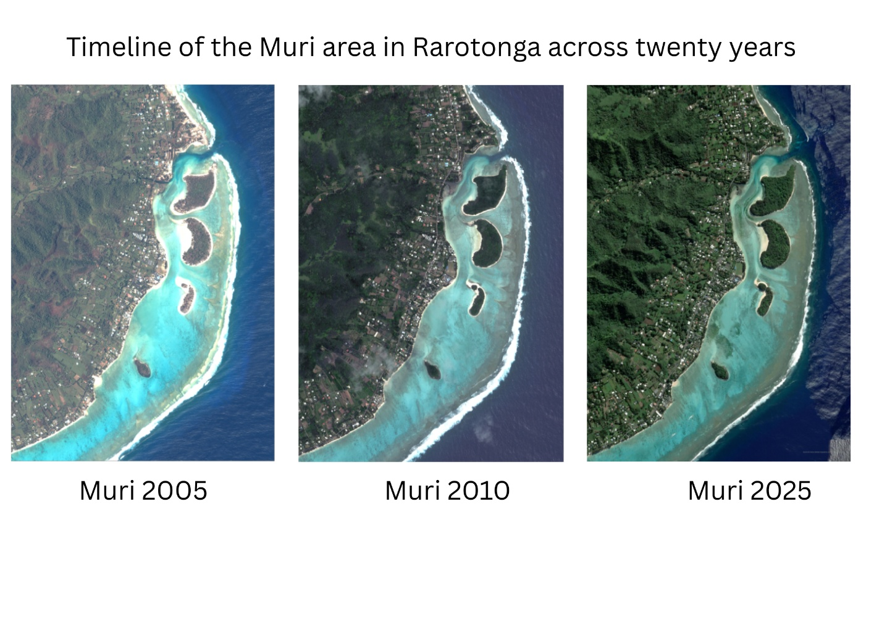
Figure 2:
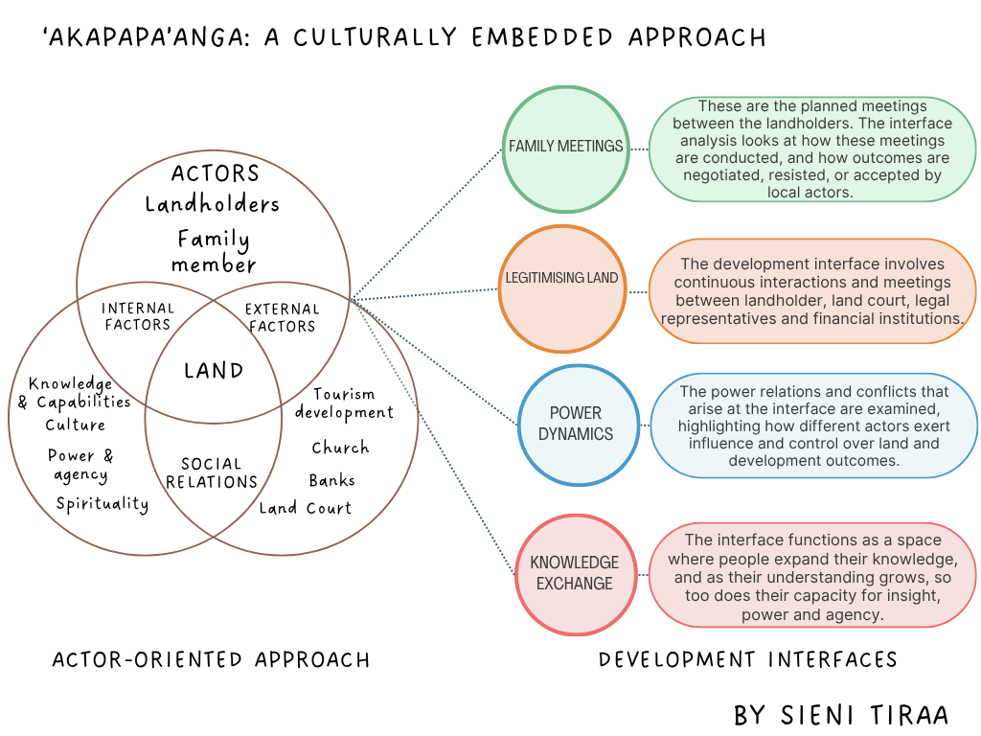
Figure 3:
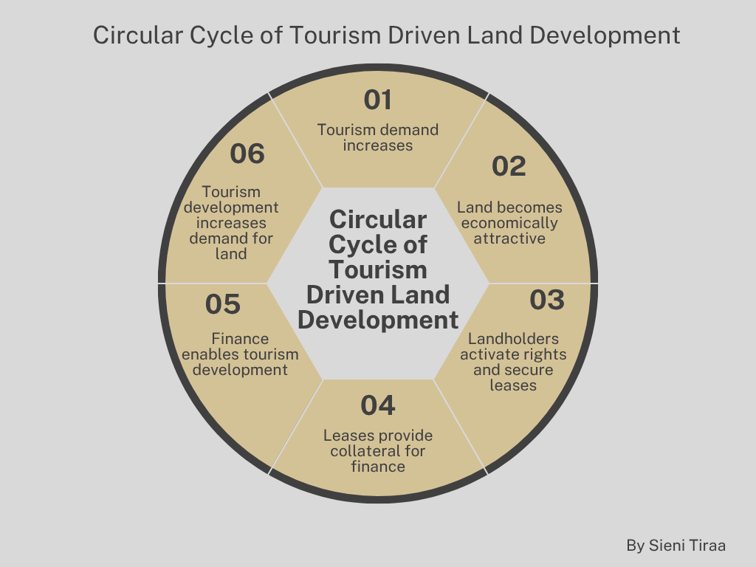

Figure 4:
