Rosie O’Hagan | Master of International Development | Massey University

Combating Gender-based Violence Amid Colombian Armed Conflict: NGO Activities, Empowering Approaches, and Ongoing Challenges

Summary:
- Armed conflict has intensified and weaponised gender-based violence in Colombia, and NGOs play a significant role in addressing this issue through empowering survivors and women more broadly, while bridging the gap between official institutions and civil society.
- NGOs’ efforts to combat gender-based violence have contributed to individual and structural empowerment through access to psycho-legal support and raising consciousness, influencing law and legislation, and challenging ingrained gender norms that perpetuate violence.
- However, NGOs also face significant challenges in their current operating environment, including issues with the concept of ‘empowerment’, staff burnout and safety concerns, barriers within Colombian institutions, deeply rooted gender norms, and international influences on attitudes towards gender issues and funding trends.
- Development actors should recognise the achievements of NGOs in combating gender-based violence, partner closely with them, support locally led approaches and peacebuilding initiatives, oppose gender-regressive rhetoric, and remain committed to advancing gender equality and the global elimination of gender-based violence.

What is the development issue?

Gender-based violence is a widespread issue, affecting one in three women globally (World Health Organization, 2021). In Latin America, civil society has been a prominent actor responding to this issue, including through movements such as Ni Una Menos. This movement materialised in 2015, after 14-year-old Chiara Paez was murdered by her boyfriend in Argentina due to an unwanted pregnancy (Cohen, 2022). As a result of this, and other feminicides in Latin America, outrage became widespread and evolved into a movement across the region. Ni Una Menos has brought attention to ingrained and harmful gender norms that perpetuate gender-based violence in Latin America and across the world.

In Colombia, the nature of gender-based violence has been heavily shaped by decades of armed conflict, which has fostered hyperbolised and militarised notions of masculinity (Hincapié & Rodríguez, 2021). Despite progressive legislation, including unprecedented gender inclusion in the 2016 Peace Agreement between the Colombian government and the largest guerrilla group at the time (Svallfors, 2023), gender-based violence continues to be a significant issue in the country. In 2023, 42,689 cases of intimate partner violence were recorded, with women accounting for 86.1% of the victims (Departamento Administrativo Nacional de Estadística et al., 2024).

As a central part of civil society, non-governmental organisations (NGOs) have played an important role in combating gender-based violence in Colombia by providing support to survivors, influencing legislation, and challenging ingrained gender norms (Gutiérrez & Ramírez, 2024). However, global shifts away from gender issues and funding cuts worldwide, most notably through the United States Agency for International Development (USAID), pose a significant threat to civil society-led gender-based violence prevention (Šišić & Binışık, 2025).

The aim of this research is to examine the causes of gender-based violence in Colombia and the activities NGOs are implementing to address this issue, identifying which approaches have been empowering as well as the challenges encountered in this work.

The following research questions were explored:

- In the context of the Colombian armed conflict and consequential hyperbolised gender norms, what activities are NGOs using in their work to address gender-based violence?

- How have NGO approaches to combating gender-based violence been empowering?

- What are the main challenges faced by NGOs in their efforts to address gender-based violence?

These research questions were considered in relation to the following framework (Figure 1), which is used to explore NGOs’ empowering approaches and ongoing challenges in their work to combat gender-based violence at levels from the individual to the international, taking into account both informal and formal factors. All levels of this framework influence and are influenced by each other.
Figure 1
Framework for examining NGO approaches, successes and challenges
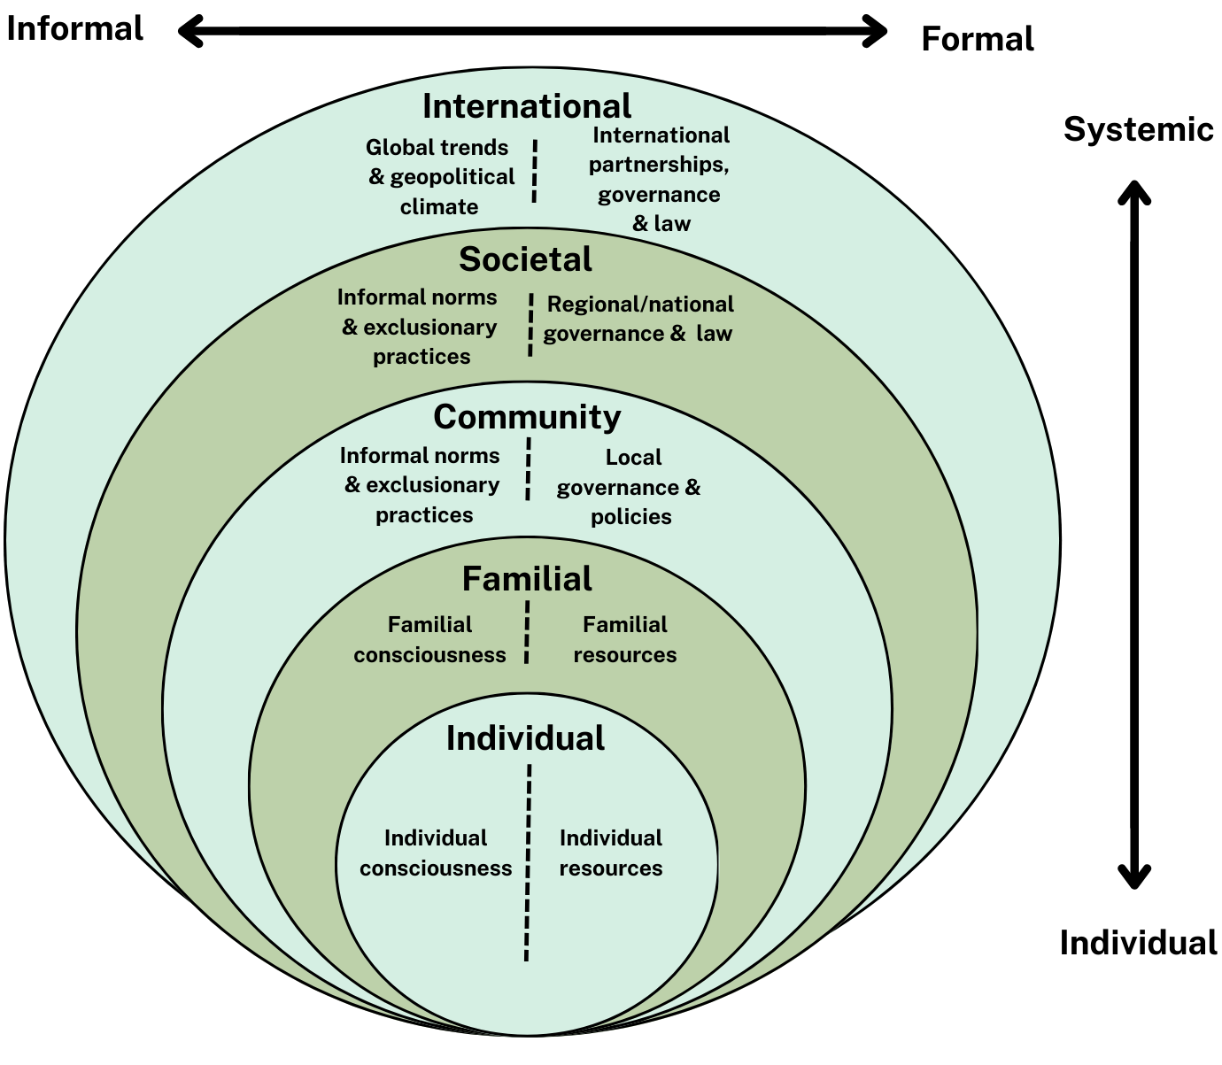

Note: Created by the author, inspired by Krug et al. (2002) and Rao et al. (2016).

Qualitative methods, including content analysis, semi-structured interviews, and reflective journaling, were employed to address the research questions. The research focused on two case study NGOs: Corporación Sisma Mujer (Sisma Mujer), based in Bogotá and with a presence in departments throughout Colombia, and Fundación Mujer & Futuro (FMF), headquartered in Bucaramanga and active in two departments near the Venezuelan border. Additionally, two supporting case studies, Médicos sin Fronteras Colombia (MSF) and la Ruta Pacífica de las Mujeres (la Ruta), were included in the research, adding a broader perspective to the diverse activities NGOs employ, their empowering approaches, and the challenges they face in their efforts to combat gender-based violence.
Key findings

This research found that patriarchal power structures, a culture of machismo, and the ongoing armed conflict, which has permeated all aspects of Colombian society, are all factors that have contributed to high rates of gender-based violence in Colombia. The causes of gender-based violence span all levels of the framework (Figure 1), with societal factors such as the creation and perpetuation of harmful gender norms having an impact on the individual and familial levels, influencing gender expectations and power dynamics within familial structures. The armed conflict has intensified these dynamics, as explained by the following participant:

“The armed conflict is truly both outside and inside people's lives… It is not confined to the jungles or faraway places. It's in the cities. It's in everyday life. As we say in la Ruta Pacífica, ‘in the street, in the house, and in the bed’... It's truly a perpetuation of what's happening in war zones, what's happening within families”.

NGOs are undertaking diverse activities to address gender-based violence across all levels of the framework (Figure 1). The two case study NGOs, Sisma Mujer and FMF, primarily support individual survivors of gender-based violence and their families through psycho-legal activities. At the community and societal levels, they provide gender training to professionals in both the public and private sectors and disseminate information related to gender-based violence awareness and prevention. As supporting case studies, MSF undertakes health-oriented activities, prioritising individual medical care over legal measures, whereas la Ruta, a national women’s movement, focuses more on the societal level through advocacy and collective mobilisation.

Through the activities they undertake, NGOs employ empowering approaches across different levels of the framework (Figure 1), aiding in the fight against gender-based violence by transforming both the individual and structural position of women. At the individual, familial, and broader community levels, NGOs have supported survivors and their families by providing resources such as psycho-legal support, access to health care, and facilitating mutual support groups that aid in collective empowerment for survivors of gender-based violence. These have, in turn, increased access to resources and raised consciousness among individuals, their families, and their communities, helping to change relationship dynamics and break cycles of violence. The following participant reflected on the impact that some of the workshops they hold can have on the lives of women and their families:

“We've seen women who, little by little, through the reflections we have in these spaces, manage to break out of cycles of violence, and we see them as much more secure… We’ve observed them as more confident when they speak. They're no longer afraid”.

At a broader structural level, NGOs have contributed to empowerment in two key areas across both formal and informal aspects of the framework (Figure 1). First, they influence law and legislation related to gender-based violence, including efforts to protect women human rights defenders and to integrate a gender perspective into the 2016 Peace Agreement. Second, through advocacy, collective mobilisation (see Figure 2), gender-training of official and private-sector actors, and the dissemination of information on gender-based violence, they work to shift harmful gender norms and contribute to informal structural change.

Figure 2
8M March for International Women’s Day 2025
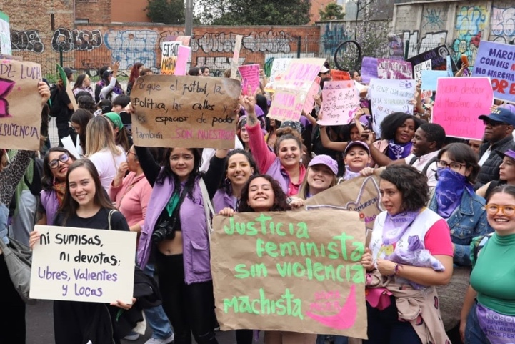
Note: Photograph of the author (purple hat) with colleagues from her internship at the 8M march for International Women’s Day.

Conversely, NGOs also confront numerous challenges in their work to address gender-based violence in Colombia. One such challenge is the concept of ‘empowerment’ itself. Although both case study NGOs highlight empowerment as a key aspect in approaches to their work and many participants see value in this concept, some were more critical. As one participant stated:

“Personally, I don't really like the word empowerment, because I feel that empowerment means saying, ‘you don't have power, and I have to give it to you’”.

Such critiques highlight how ‘empowerment’ can become a buzzword, drifting from its original transformative meaning (Cornwall, 2016). This does not imply that the word lacks value. However, like all words, it is essential that it is used with a clear definition that helps improve women's standing in society and works towards eliminating harmful gender norms that foster violence.

Another major challenge NGOs face is staff burnout and safety concerns. Staff have had to change roles or resign due to the heavy emotional toll working with survivors of gender-based violence can have. Additionally, NGO staff have been threatened by armed actors, who have used threats of physical harm to maintain control over the territories where these NGOs operate. This has created ongoing security risks.

At community and societal levels, barriers within Colombian institutions and persistent harmful gender norms present challenges for NGOs. Despite progressive legislation, officials working with survivors of gender-based violence in the justice and medical sectors often hold traditional views of gender, which contributes to the issue of revictimisation. Furthermore, the state has minimal control over territory occupied by armed groups, leading to weak institutional response to cases of gender-based violence and posing significant barriers to NGO efforts in these areas.

On the broader international level, NGOs also face significant challenges. Global shifts towards right-wing ideals and conservative governments have led to significant cuts in funding for both gender issues and international development more broadly (Šišić & Binışık, 2025). This has greatly impacted Colombian NGOs working to combat gender-based violence, forcing many to reduce their operations and, in some cases, shut down entirely. Consequently, this has wider implications for gender-based violence survivors and Colombian society at large. It also signifies a broader global shift away from support for gender equality. As stated by the following participant:

We believe that the challenges faced by women's organisations are similar. Around the world, right now, the challenges are similar… we are at risk, and women's lives and bodies [are at risk]. Because we know that if we aren't there, access for women will be much more difficult.

However, NGOs have demonstrated resilience through their ability to sustain and adapt over decades of operation despite constantly changing global and domestic dynamics. This highlights their capacity to navigate an uncertain future.

Implications

The findings demonstrate that, although Colombian NGO approaches have supported individual and structural empowerment, they also encounter significant challenges that hinder their efforts and threaten their very existence. They are heavily reliant on development actors for funding their activities, including governments and other international donors. As more aid is withdrawn from development and gender-related issues, the future of NGOs working to eliminate gender-based violence is at risk. This is concerning, as it indicates a broader global shift, where progress made towards gender equality is being undone, and the position of women and other disadvantaged individuals and groups is increasingly threatened.

The following outlines several actions that development actors, including MFAT and New Zealand-based organisations, should take to address this issue:

- Recognise NGOs’ achievements: Although, as mentioned, NGOs face significant challenges in their current operating environment, it is important to recognise and celebrate their successes in the fight against gender-based violence. Development actors should acknowledge and promote their role in addressing this issue.
- Work with NGOs: NGOs depend on partnerships with governments and international donors to sustain their activities. Development actors should engage NGOs in their efforts to address gender-based violence, collaborating closely with them.
- Support locally led approaches: Locally led NGOs often possess context-specific knowledge and the trust of local communities. Therefore, in many cases, development actors should allow them to take the lead in addressing this issue.
- Promote peacebuilding: The armed conflict has intensified and weaponised gender-based violence in Colombia, posing significant challenges for NGOs. Development actors must support peacebuilding efforts to address this issue.
- Counteract harmful rhetoric: In the face of a rise in conservative, gender-regressive ideals, which threaten NGOs working to fight gender-based violence, development actors must promote gender equality and oppose these regressive ideals spreading globally.
- Remain dedicated to supporting gender issues: Development actors must prioritise gender equality if gender-based violence is to be eradicated.
In their current operating context, where funding cuts have forced NGOs to reduce or cease activities, there is growing uncertainty about how society's social fabric will be impacted, both in Colombia and globally. Although the future remains uncertain, my analysis briefly outlines three potential outcomes of recommended development actor actions or inaction.
- Persistent future: Current trends continue, with funding constraints remaining or worsening, while a limited number of donors stay committed to addressing gender-based violence. In this scenario, many NGOs would be forced to reduce operations or shut down entirely, although some would be able to adapt and persist. Gender-based violence rates would likely remain the same or increase, and survivors would continue to lack access to resources and justice.

- Regressive future: A further global shift toward gender-regressive politics leads to widespread withdrawal of funding for NGOs addressing gender-based violence. Given the reliance of many of these organisations on international funding, this scenario would lead to the closure of most NGOs working in this area. This, alongside a broader trend of gender-regressive ideals, would result in rising rates of gender-based violence and severely diminished access to support and justice for survivors, threatening the gains made towards gender equality worldwide.

- Optimistic future: This scenario would see sustained donor commitment and the election of administrations in Colombia and internationally that prioritise gender equality and the elimination of gender-based violence. This would, in turn, enable NGOs to stabilise and expand their operations to previous levels and beyond. It would also lead to greater cooperation among actors, including international donors, other development actors, the state, the private sector, and NGOs, and contribute to more coordinated progress toward eliminating gender-based violence and promoting social and gender justice. It may also see NGOs exploring new forms of collaboration, such as increased South-South cooperation, and expanding their operations into new, more impactful areas, including working more with men to transform harmful masculinities.
Variations of these three scenarios could unfold, and the future largely depends on the commitment of development actors, domestic and global politics, and social changes, including widely held societal views of gender and equality. As outlined, development actors can help by recognising NGOs' achievements in combating gender-based violence and collaborating with them to address the issue. They also need to oppose harmful rhetoric that suppresses gender issues and stay committed to gender equality and the eradication of gender-based violence worldwide. Peaceful and flourishing societies must be free from violence. In the case of Colombia and other countries working towards building peace, the elimination of gender-based violence is critical for this process.
Our hope should be for a world where NGOs working to address gender-based violence can stop their efforts because the problem no longer exists, not because they lack the resources to continue. As one participant expressed:
“We would hope to say one day, ‘Okay, we're closing because there's nothing else to do, the world has changed.’… Unfortunately, women's lives are increasingly stigmatised and violated”.

Limitations and areas for further research

While this research draws on my experience living in Colombia and Spanish-language skills, my positionality as a young, white gringa undertaking field research on a challenging topic for the first time inevitably influences the knowledge produced in this thesis. This positionality cannot offer the same depth of understanding as that of individuals who have lived and worked within the Colombian context over long periods, nor does it replicate the embodied knowledge of those directly affected by gender-based violence. Recognising this positionality is therefore essential to the ethical integrity and reflexivity of the research.
To recognise how my positionality was influencing the research, I practised reflexivity throughout the research process, most notably through my research method of reflective journaling. Through this, I was able to continuously reflect on my assumptions and interpretations, supporting more contextually grounded research. I also made a conscious effort to centre the research on the perspectives of professionals who work daily to address gender-based violence, focusing the analysis on lived expertise rather than relying solely on my interpretation.
Furthermore, the research was limited by scope, time, and resources. These limitations affected the research design and the range of perspectives included. During the research process, several key areas for further investigation were recognised that fell outside the parameters of this study. These include:
- Perspectives from individuals and communities that NGOs work with, including survivors of gender-based violence, human rights defenders, and locally led grassroots organisations
- NGO approaches to addressing gender-based violence against the rainbow community, particularly in relation to intersecting forms of marginalisation and exclusion
- How NGOs and the Colombian government are collaborating in efforts to combat gender-based violence
- International NGO approaches to addressing gender-based violence in Colombia, and how these compare with national and locally led NGO approaches
- Comparative analysis with other conflict-affected regions or across Latin American countries
Further research in these areas would add to the existing literature by deepening the understanding of how NGOs operate across varied contexts, offering a broader range of perspectives on approaches to addressing gender-based violence in Colombia and beyond.

References

Cohen, P. (2022). Not One Woman Less: An Analysis of the Advocacy and Activism of Argentina's Ni Una Menos Movement. Journal of Gender and Law, 29(1), 107-146. https://doi.org/10.5070/L329158298
Cornwall, A. (2016). Women's empowerment: What works? Journal of international development, 28(3), 342-359. https://doi.org/10.1002/jid.3210
Departamento Administrativo Nacional de Estadística, Ministerio de la Igualdad y la Equidad, & ONU Mujeres. (2024). Mujeres y hombres: brechas de género en Colombia. https://colombia.unwomen.org/sites/default/files/2024-11/resumen_ejecutivo_myh.pdf
Gutiérrez, C. S., & Ramírez, L. M. (2024). Las organizaciones feministas como agentes de cambio: avances en el acceso a la justicia para las víctimas de violencias. Sisma Mujer. https://sismamujer.org/wp-content/uploads/2024/03/ORG-FEMINISTAS-WEB.pdf
Hincapié, L. C. G., & Rodríguez, C. A. O. (2021). Violencia basada en género: conceptualización y análisis de su desarrollo en el conflicto colombiano. Misión Jurídica, 14(21), 256-275. https://doi.org/10.25058/1794600X.1960
Krug, E. G., Dahlberg, L. L., Mercy, J. A., Zwi, A. B., & Lozano, R. (2002). The world report on violence and health. World Health Organization. https://iris.who.int/bitstream/handle/10665/42495/9241545615_eng.pdf?sequence=1
Rao, A., Sandler, J., Kelleher, D., & Miller, C. (2016). Gender at work: theory and practice for 21st century organizations. Routledge. https://doi.org/10.4324/9781315693637
Šišić, M., & Binışık, D. (2025). Beyond the Cuts: How the Defunding Affects Feminist and Civil Society Organizations. Heinrich Böll Stiftung. https://www.boell.de/en/2025/03/13/beyond-cuts-how-defunding-affects-feminist-and-civil-society-organizations
Svallfors, S. (2023). Hidden casualties: The links between armed conflict and intimate partner violence in Colombia. Politics & Gender, 19(1), 133-165. https://doi.org/10.1017/S1743923X2100043X
World Health Organization. (2021). Violence Against Women Prevalence Estimates, 2018. https://iris.who.int/bitstream/handle/10665/341337/9789240022256-eng.pdf?sequence=1

Not One Less
Female foreigner

