Adimaitoga Rabuku| MSc in Environmental Science| University of the South Pacific

Assessing the Development and Quality Characteristics of Melrose Tomato (Solanum lycopersicum L.) under waterlogging conditions in western Fiji

Summary:
- Climate change is a global phenomenon that has profoundly impacted agricultural productivity, which relies heavily on weather patterns like rainfall, temperature, relative humidity, and light intensity.
- With the increasing importance of tomato cultivation for economic growth and improved living conditions, it is crucial to develop resilient agricultural systems that can withstand climate change and its associated challenges.
- The effects of waterlogging on the growth and quality attributes of Melrose tomato (Solanum lycopersicon L.) were investigated in a controlled environment during an off-season period in Fiji.
- A toolkit was suggested for off-season farmers to consider a controlled environmental condition with an appropriate cultivar selection, and the best soil requirement aimed at optimizing tomato quality and nutritional value, particularly in the context of water management.

What is the development issue?
Agriculture is a vital sector in Fiji, contributing to food security and economic development. This study examines the effects of duration and depth of waterlogging on growth, yield, and quality attributes of tomato (Solanum lycopersicon L.) cultivar CLN 3150A-5, locally known as Melrose, during the off-season period (November to April) in western Fiji (Figure 1).
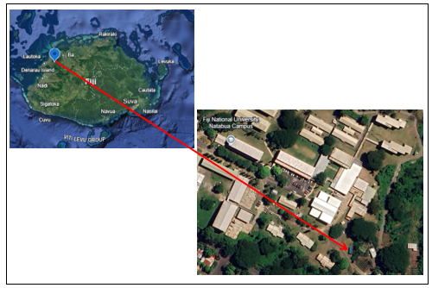
Figure 1: Study site at FNU Natabua Campus, Lautoka, Western Fiji
The months from November to April in Fiji are regarded as our cyclone season, with intense heat and rainfall, hence the research (Rabuku and Cagivinaka 2023)
The study is particularly relevant given the increasing incidence of waterlogging due to climate change, which significantly threatens tomato cultivation. The experiment was conducted in a controlled greenhouse environment at the Fiji National University research facility, adhering to optimal conditions for tomato growth, including a specific soil composition and shade structure.
The Melrose variety was selected based on its characteristics, i.e. open-pollinated, resistant to tomato mosaic virus, firm texture, and moderate resistance to bacteria wilt (SPC, 2018). The Melrose seeds were obtained from Nacocolevu research station following its standard operating procedure for regular cultivation.
A mixed-method approach using a quasi-experimental concept was employed in this project following a randomized complete block design (RCBD) for water stress treatment in a pot experiment, underscoring its rigorous methodology and commitment to scientific investigation (Imakumbili 2019).
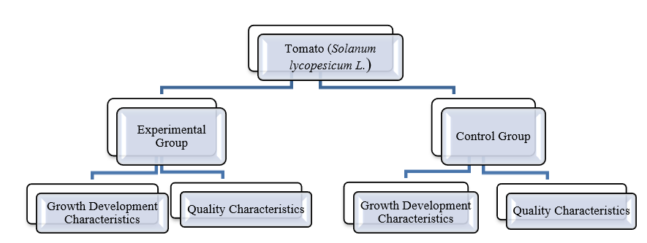
Figure 2: Experimental Design
Key findings
- Tomatoes grown in a greenhouse during the off-season require careful management of several factors to stimulate the ideal growing conditions (Pineda et al., 2021). The greenhouse must provide for constant monitoring and sanitation in the event of pests and diseases so that the plants are put into isolation.
- The optimal environment conditions recommended for tomato growth inside a greenhouse must contain a 70/30 shade of nylon cloth with high roofing to allow open pollination by wind, honeybees, and butterflies.
- Tomatoes thrive in daytime temperatures of (18 - 28ºC) and nighttime temperatures of (15-22ºC) (Hoffman, 1932). Relative humidity must be kept around 60-70% to prevent diseases like powdery mildew with adequate lighting to ensure tomatoes receive 14-18 hours of light per day (Jones 2013).
- Soil is the most crucial element/medium to examine before sowing. It is recommended that a ratio of 2:2:1, loam soil, compost, and river sand, respectively, is ideal for tomato growth with a slightly acidic pH of 6.5. The soil and seeds must be heat treated at 50°C for 2.5 hours and 25 minutes, respectively, to guarantee the viability of seeds with a 100% germination rate in an average of 3 days.
- The impacts of depths (subsurface, ground level, submergence) and duration (24, 48, 72 hours) of waterlogging were obtained through two-way factorial analysis using SPSS software to determine how significant were duration, depth level, and their interactions on the growth and quality characteristics.
- There were 9 characteristics of dependent variables analysed and characterised as growth, yields, and quality variables. The plant height, primary branches, and flower clusters were examined for growth and development characteristics.
- After ANOVA analysis, it can be drawn that both the duration of waterlogging and its depth significantly affect the growth rates of tomato plants, with duration having a significant effect (Figure 3).
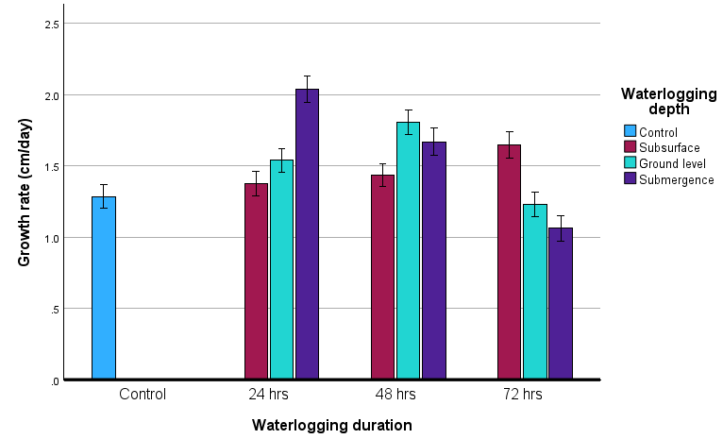
Figure 3: Mean ± SE Growth rates of tomatoes subjected to waterlogging duration and depths calculated at 95% CI. Both factors significantly affect growth rates, with duration having a powerful effect. F- test (f, df) (34.17,2) p-value=0.001.

- A Duncan's multiple range test using SPSS software indicated that the submergence depth was significantly higher for the number of primary branches than the other treatment depths. These data correspond to low oxygen escape syndrome (LOES) which implies shoot elongation in order to restore leaf contact with the atmosphere and offers plants better chances to survive under shallow waterlogging, hence, shoot de-submergence is easily plausible (Bailey-Serres et al. 2012).
- A multivariate ANOVA was used to determine the tomato yield variables, including the number of fruits, fruit weight, and the total yield (Zhou et al. 2022). It was noted that depth may have a limited effect, particularly when compared to duration (p<0.001). Although deep waterlogging produces more flower clusters, fewer flowers developed into fruits thus reducing its fruit weight. This fact supports the hypothesis that excess moisture affects flower and fruit development (Jitsuyama et al. 2019).
- Concerning yield, it was highlighted that the depth of waterlogging has a significant effect on tomato yield (p = 0.040). As the waterlogging duration increases from 24 to 48 hours, yields per plant increase, particularly for submergence. However, at 72 hours, yields start to decline across all depths, indicating that waterlogging for too long begins to harm the plants' yield.
- A univariate ANOVA was used to analyze fruit quality characteristics for maturity, brix, and lycopene content. The number of days it took for the fruits to reach maturity stages (i.e. green, half-ripe, full-ripe) by color changes indicated that the interaction between depth and duration was significant (p =0.008) for all three dependent variables. The findings suggested that prolonged waterlogging can reduce nutrient uptake and hypoxia, negatively impacting the synthesis of carotenoids and other pigments essential for fruit coloration (Ide et al. 2022). The brix value at the full-ripe stage was slightly higher, reaching around 75% for a deep waterlogging stage at 48 hours. This indicates that the fruits were sweeter when fully submerged, almost like the 75% brix value of the same variety cultivated during its regular season.
- Different maturity stages were examined for their lycopene content (Suwanaruang 2016). It can be concluded that half-ripe or breakers were a transitional stage where lycopene accumulates, leading to a noticeable increase in content. In contrast, the final stage of maturity, where lycopene content peaks, gives tomatoes their characteristic red colour.
- The control conditions allow for average lycopene accumulation as the fruit matures, which exhibits moderate, and significant increases in the full-ripe stage. A 72-hour subsurface waterlogging demonstrates the highest lycopene content in the full-ripe stage (73 mg/100g), indicating that this treatment may have positively influenced lycopene synthesis during ripening (Figure 4). The data suggests that different treatments have varying impacts on lycopene accumulation at different maturity stages. Notably, the red ripe stage consistently shows the highest lycopene content across most groups, reinforcing that lycopene synthesis is strongly associated with fruit maturation. However, lycopene content declines sharply when plants are submerged to more than 72 hours. The variability in lycopene content among the experimental groups indicates that specific treatments may enhance or inhibit the natural processes of lycopene accumulation.

Figure 4: Mean ±SE showing lycopene content (mg/kg) of different maturity stages at various waterlogging depths and durations. The combined effect of waterlogging depth and duration is significant (p<0.05). A linear trendline depicts increasing lycopene content across all stages.

- This research suggests a toolkit for off-season farmers that should consider a controlled environmental condition, with appropriate cultivar selection and the amended soil requirement recommended for tomato growth. These strategies could be crucial for agricultural practices aimed at optimizing tomato quality and nutritional value, particularly in the context of water management.

Implications
- The study’s findings on waterlogging in tomatoes highlight a crucial challenge for agriculture in Fiji—climate change. Rising sea levels, increased rainfall variability, and extreme weather events exacerbate flooding and waterlogging, threatening agricultural productivity. Prolonged waterlogging reduces yields, a concern for smallholder farmers who rely on crops for subsistence and income. Understanding how different soil compositions and environmental controls mitigate these effects can help in climate adaptation strategies, ensuring more resilient agricultural systems in Fiji.

- Agriculture was the backbone of Fiji’s economy, providing employment and contributing to GDP. Vegetables and other horticultural crops are essential for local food security, reducing dependence on costly imports. However, the study shows that without proper soil management and environmental controls, waterlogging can significantly impact crop yields. This insight underscores the need for investment in sustainable farming practices, such as improved drainage systems, greenhouse technology, and soil enrichment, to enhance productivity and ensure stable food supplies.

- The study also emphasizes the role of soil quality, shade structures, and controlled environments in mitigating climate stress for off-season crops. For Fiji, promoting agroecological approaches, such as integrating organic matter (compost), utilizing raised beds, and improving irrigation, can be vital strategies for increasing resilience against extreme weather events. Policymakers should prioritize research funding, farmer training, and subsidies for sustainable infrastructure to support smallholder farmers in adapting to climate-induced challenges.

- By addressing these issues, Fiji can strengthen its agricultural sector, ensuring food security, economic stability, and climate resilience for future generations.

Limitations and further research
- Limitations of the current study include the controlled setting of the greenhouse, which may not fully replicate field conditions, particularly regarding pest interactions and natural climatic variations.
- Secondly, the study primarily focuses on growth and yield parameters without delving deeply into the molecular mechanisms underlying the observed responses to waterlogging, which could provide a more comprehensive understanding of plant resilience (Zhou et al. 2022).
- Thirdly, while applying peat moss is recommended due to its superior water retention and aeration properties compared to gravel, the study's findings may not fully capture the long-term effects of different soil amendments on tomato growth. The variability in soil composition can significantly influence nutrient availability and plant performance, and further research is needed to explore the implications of using peat moss in various agricultural contexts. Additionally, the reliance on peat moss raises sustainability concerns, as its extraction can have environmental impacts.
- Lastly, while widely accepted, utilising SPSS software for data analysis may limit the exploration of alternative analytical models that could provide deeper insights into the data. Employing other statistical models could enhance understanding of complex interactions between variables affecting tomato growth. The current reliance on SPSS may restrict the scope of analysis and limit the ability to draw comprehensive conclusions from the data.

- Future research should focus on the long-term effects of waterlogging on tomato plants, particularly in varying climatic conditions and soil types. Investigating different tomato genotypes' physiological and biochemical responses to waterlogging could also provide insights into breeding more resilient varieties. Additionally, exploring the role of nutrient management during waterlogging events may enhance fruit quality and yield, as nutrient availability can significantly influence plant stress responses.

References:
Bailey-Serres, J., S. C. Lee, and E. Brinton, 2012: Waterproofing crops: effective flooding survival strategies. Plant Physiology, 160, 1698-1709.
Hoffman, I. C, 1932: Growing of Greenhouse Tomatoes. Ohio Agricultural Experiment Station, 33pp.
Ide, R., A. Ichiki, T. Suzuki, and Y. Jitsuyama, 2022: Analysis of yield reduction factors in processing tomatoes under waterlogging conditions. Scientia Horticulturae, 295, 110840.
Imakumbili, M. L., 2019: Making water stress treatments in pot experiments: An illustrated step-by-step guide.Protocols.io https://dx.doi.org/10.17504/protocols.io.2xdgfi6
Jitsuyama, Y., A. Ichiki, R. Ide, H. Shimura, and T. Suzuki, 2019: The processing tomato cultivar ‘Natsunoshun’is susceptible to an excess or lack of soil moisture after the flowering stage. The Horticulture Journal, 88, 232-244.
Jones, J. B., 2013: Instructional guide for growing tomatoes in the home garden and greenhouse. GroSystems, Incorporated.
Pineda, I. T., Lee, Y. D., Kim, Y. S., Lee, S. M., & Park, K. S, 2021. Review of inventory data in life cycle assessment applied in production of fresh tomato in greenhouse. Journal of Cleaner Production, 282, 124395.
Rabuku, A. T. W., and V. Cagivinaka, 2023: Farmers resilience and adaptation to climate change and flooding–a case study of a semi-rural settlement in Fiji. Journal of Namibian Studies: History Politics Culture, 34, 2111-2127.
SPC., 2018: Melrose Tomato Seed Production Guide: Standard Operating Procedure
Suwanaruang, T., 2016: Analyzing lycopene content in fruits. Agriculture and Agricultural Science Procedia, 11, 46-48.
Zhou, R., and Coauthors, 2022: Dominant and priming role of waterlogging in tomato at E[CO2] by multivariate analysis. International Journal of Molecular Sciences, 23, 12121.

