- Movono, E. Draunidalo, K. Sharma & M. Stephens | Discipline of Tourism and Hospitality Management | University of the South Pacific

Strengthening Fiji’s Community Based Tourism through Culturally Grounded & Integrated Hospitality Practices, Natalei Experience, Nataleira, Fiji

Summary: Community-Based Tourism (CBT) holds immense potential to drive inclusive and sustainable development in Fiji by creating local employment opportunities, preserving cultural heritage, and promoting the responsible use of natural resources. However, CBT initiatives continue to face systemic challenges related to governance fragmentation, skill gaps, and inconsistent service standards.

This research introduces a hospitality-oriented, Vanua-based Action Research framework designed to address these challenges. By merging principles of professional hospitality with Indigenous knowledge systems, communities can enhance visitor experience, strengthen cultural interpretation, and improve operational safety.

The Natalei Eco Lodge case study demonstrates that collaborative, culturally grounded co-design processes not only elevate service quality but also strengthen community cohesion and ownership of tourism enterprises. Findings indicate that policymakers must foster stronger inter-ministerial coordination, establish national CBT quality standards, and expand capacity-building initiatives to fully harness CBT’s development potential in Fiji.

What is the development issue?
Tourism is a cornerstone of Fiji’s economy, contributing approximately 40% to national GDP and providing livelihoods for over 100,000 people. Yet, a substantial proportion of tourism revenue remains concentrated in urban centres and foreign-owned resorts, with limited flow-on benefits to rural and Indigenous communities. Community-Based Tourism offers an alternative pathway for inclusive growth by placing ownership and management in the hands of local people.
Despite its promise, CBT in Fiji faces enduring challenges. Many enterprises struggle to maintain consistent service quality, ensure visitor safety, and meet the expectations of international tourists. Fragmented governance structures, inadequate coordination among ministries, and limited access to training or marketing support exacerbate these issues. Consequently, village-based tourism projects often operate below their potential, hindering both community prosperity and national development goals.
This issue directly impacts Fiji’s capacity to achieve Sustainable Development Goals (SDGs) 8, 11, 13, and 17, which emphasise sustainable economic growth, resilient communities, and effective partnerships. Addressing weaknesses in CBT systems can improve employment outcomes, enhance resilience to climate shocks, and preserve cultural integrity. In the absence of reform, communities risk continued dependency on external investors and minimal returns from tourism activity.
Key findings
The central question guiding this study was: What approaches can improve Community-Based Tourism in Fiji through a hospitality-focused Action Research method?
The research employed a Participatory Action Research (PAR) design, guided by Vanua-based methodologies emphasising collaboration, cultural sensitivity, and reflection. Fieldwork was conducted at Natalei Experience, involving talanoa sessions, participant observation, co-design talanoa, and validation exercises with feedback from community members, government officers, and visitors.
Findings revealed that while communities possess deep cultural pride and motivation, systemic barriers such as limited access to finance, policy fragmentation, and uneven training continue to impede their full potential. Yet the enterprise has carved out a notably resilient and values-driven model. Since its establishment in 2006, it has weathered three cyclones and the COVID-19 pandemic, retaining eight full-time, paid staff and maintaining a business practice that directly funds core community non-profits, including the Youth Club, the Environment Committee, and the Soqosoqo Vakamarama (women’s club). This approach effectively embeds communalism into the operation, spreading benefits beyond payroll and transforming the enterprise into a hub for social cohesion and collective well-being. As one staff member put it, “Every guest we host doesn’t just pay for a bed; they help keep our youth active, our reefs healthy, and our mothers’ projects alive.”
Operationally, the lodge’s allocations to community bodies are predictable, transparent, and tied to seasonal cash flows, which have built trust and accountability. A Youth Club treasurer explained, “We receive our share directly from the hotel, no middleman, so we can plan activities, maintain the sports ground, and keep young people engaged.” Similarly, an Environment Committee representative noted, “The hotel’s regular contribution helps us organise village-clean ups and mangrove planting. When tourism is steady, conservation is steady.” A leader from the Soqosoqo Vakamarama added, “Our women’s group uses part of the funds for craft materials and micro credit scheme and small grants. It gives us dignity and a say in our community’s future.”
Crucially, the enterprise’s success is tied to Indigenous values operationalised in daily practice, veiwekani (relationships), veilomani (care/compassion), and vakaturaga (chiefly respect/conduct). These values guide guest interactions, staff engagement, and decision-making. A long-serving team member reflected, “Veiwekani is not just a word, we check in on each other, on guests, and on the village. That’s our standard of service.” Guests responded to this ethos; one visitor remarked in feedback captured during fieldwork, “I felt hosted by a village, not just a lodge. The care here is genuine.” This cultural grounding has improved cohesion, reduced staff turnover, and lifted guest satisfaction, even amid external shocks.
The co-design talanoa process translated shared values into concrete improvements. Together with community members, staff co-created interpretive storytelling materials that highlight local history, protocols, and ecological knowledge, and introduced safety signage and briefings that reflect both maritime best practice and Vanua protocols. A boat captain described the shift: “Our safety talk now includes tides and wind, but also how to show respect when we visit a site. It keeps people safe and shows who we are.” A provincial officer who attended a session observed, “This is coherence from the ground up, culture first, then operations. It’s why they’re still here after cyclones and COVID.”
Challenges persist, including training gaps in advanced hospitality skills, compliance burdens, and uneven policy alignment across departments, which can slow progress. Even so, the model has prevailed since 2006, demonstrating both adaptability and durability. As one elder concluded, “Tourism will come and go with the wind, but if we hold to veiwekani and veilomani, the benefits will keep circling through the Vanua.”

Implications
A clear national policy framework for CBT is urgently needed. Ministries of Tourism, iTaukei Affairs, and Rural Development should formalise a National CBT Support Framework to align resources, standardise training, and integrate community enterprises into mainstream tourism strategies.
Expanding Vanua-based hospitality training will ensure that CBT operators acquire both technical and cultural competencies. Partnerships between training institutions and local enterprises can help communities deliver consistent service quality, maintain safety standards, and adapt to changing visitor expectations.
Academic institutions and policy agencies should establish continuous feedback loops through Action Research collaborations. Integrating research insights into policy design will foster evidence-based decision-making and reduce program fragmentation. Effective implementation will yield improved livelihoods, enhanced cultural pride, and stronger national tourism resilience.
Limitations and further research
While the Natalei Experience case study provides valuable insights, its findings may not represent all CBT experiences across Fiji. Future research should compare multiple sites to capture variations in governance and the environment. Quantitative assessments of visitor satisfaction and economic performance would complement current qualitative insights.
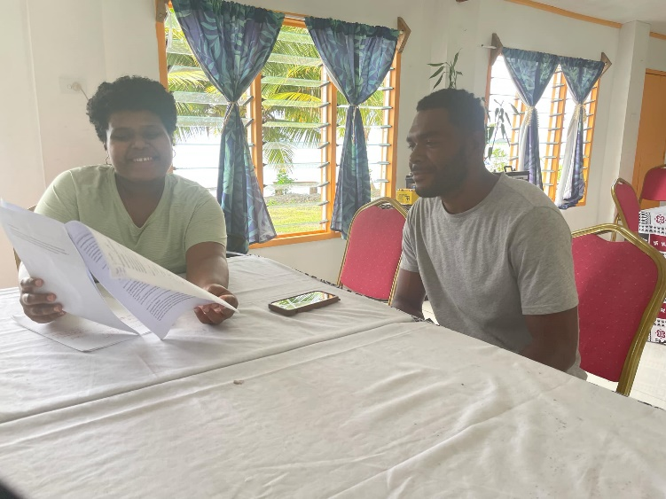
Figure 1: Adi Elenoa conducting interview with a hotel worker
Further investigation into the climate resilience of CBT operations and their role in environmental stewardship is needed. Policymakers and researchers must continue exploring how culturally grounded models can shape the next generation of sustainable tourism in the Pacific.

References
- Tourism Fiji. (2024). Key statistics 2024. Tourism Fiji. https://www.tourismfiji.com
- Movono, A., & Dahles, H. (2017). Female empowerment and tourism: a focus on businesses in a Fijian village. Asia Pacific Journal of Tourism Research, 22(6), 681–692. https://doi.org/10.1080/10941665.2017.1308397
- Salazar, N. B. (2012). Community-based cultural tourism: Issues, threats and opportunities. Journal of sustainable tourism, 20(1), 9-22.
- Đurkin, J., Perić, M., & Šebrek, J. K. (2017). Addressing organisational challanges of cultural tourism in rural areas through community-based tourism model. Tourism in Southern and Eastern Europe..., 4, 145-157.
- Lenao, M. (2015). Challenges facing community-based cultural tourism development at Lekhubu Island, Botswana: a comparative analysis. Current issues in tourism, 18(6), 579-594.
- Sloan, P., Legrand, W., & Simons-Kaufmann, C. (2014). A survey of social entrepreneurial community-based hospitality and tourism initiatives in developing economies: A new business approach for industry. Worldwide Hospitality and Tourism Themes, 6(1), 51-61.
- Mtapuri, O., Camilleri, M. A., & Dłużewska, A. (2022). Advancing community‐based tourism approaches for the sustainable development of destinations. Sustainable Development, 30(3), 423-432.
- DA Tasci, A., Croes, R., & Bartels Villanueva, J. (2014). Rise and fall of community-based tourism–facilitators, inhibitors and outcomes. Worldwide Hospitality and Tourism Themes, 6(3), 261-276.

Appendices
- Draft CBT Framework
