Policy Brief

Name | Louis Morrell
Postgraduate programme | Masters of International Development
Title of research | An investigation into the strategies employed by Samoa’s indigenous fishing industry to manage and mitigate the adverse impacts of climate change.
Location of research  Context | Samoa
Samoa is heavily reliant on marine resources both as a source of income and sustenance. Samoa’s indigenous fishing industry, that is those not involved in the fish-export market, is critical for food security and is highly vulnerable to the adverse impacts of climate change and environmental degradation. There is an urgent need for multi-layered, climate change adaptation solutions that can ensure the sustainability of Samoa’s marine resources and coastal marine environments (Samoa Ocean Strategy 2020–2030).

As many as 10,000 Samoans are actively engaged in subsistence fishing and harvest over 500 species of marine species which provide up to a quarter of daily animal protein consumption (FAO Fisheries and Aquaculture, 2018). The harvesting of marine species has deep cultural, social, and historical ties through that are rooted in the identity of Samoans (FAO Fisheries and Aquaculture, 2018).

Decades of climate change, pollution and overfishing has dealt significant damage to Samoa’s coastal environments. The ‘Third Global Coral Bleaching Event’ which took place in the El Nino event of 2015/2016, destroyed large areas of Samoa’s reefs. Rising water temperatures are not only creating deadly conditions for survival, such as increasingly severe cyclones but are producing knock-on effects that are disrupting the biological production of fish stock (Johnson et al., 2018). Overfishing, environmental pollution coupled with the lasting damage of the 2009 Tsunami that destroyed much of Samoa’s South coast are aggravating these climate change impacts. Under both low and high emission scenarios, these combined impacts will put Samoa’s marine species under high-risk vulnerability by 2050 meaning that catches will no longer be able to sustain minimum marine consumption levels (Johnson et al., 2018).

With an estimated 24% of all animal proteins consumed by Samoans consisting of marine resources, adaptation methods are critical for the livelihoods for Samoans (FAO Fisheries & Aquaculture, 2018). In recent years, several adaption strategies for fisheries have been put forward at the national level including the Samoan Ocean Strategy (SOS) and Community-Based Fisheries Management Program (CBFMP). These frameworks put forward numerous adaption methods across all levels of the fisheries sector. Whether these polices have been successful in connecting with those most impacted by climate change and environmental degradation is the first focus of this research.

Serving as a case-study for this research, aquaculture has been introduced as a potential adaption strategy that could potential replace dwindling marine resources. Samoa has numerous examples of aquaculture-based projects including several Nile tilapia farms that produce on average 12 tonnes of fish per year as of 2014 (FAO Fisheries & Aquaculture, 2018). In 2021, with support from Japanese international cooperation agency (JICA) and the United Nations Development Programme (UNDP), the Samoan ministry for agriculture and fisheries (MAF) began a pilot project across 20 villages in both main islands of Samoa that looked to revitalise the cultivation of limu (sea grapes) (Tiitii, 2021). This research looked to assess the relative viability of limu and other marine resources harvested through aquaculture as an adaptation strategy for Samoa’s indigenous fishing industry.

Findings

Interviews with key stakeholders within the field of fisheries and climate change adaptation revealed that current national adaptation strategies for Samoa’s fisheries and indigenous fishing industry, for the most part, address the needs of those most impacted by climate change and environmental degradation. The Samoa Ocean Strategy 2020-2030 and similar frameworks underwent an extensive process of consultation over several years and made efforts to align local needs with national, regional, and international polices often dictated by climate financing mechanisms and wider trends. National frameworks such as the CBFMP are customed made for individual villages with consultation with locals and the local leaders.

Where the frameworks were often lacking was the inclusion of traditional knowledge. The participants of the research all resoundingly agreed that including traditional knowledge, and more importantly, traditional usage of marine resources, is critical for the sustainability of Samoa’s indigenous fishing industry.

Interviews with the Minister of Natural Resources and Environment (MNRE) and the chief fisheries officer at MAF showed a divide on advocacy for aquaculture as an adaptation strategy. MNRE believed tilapia farming (a robust freshwater species often farmed in tropical areas) and recent efforts to revitalise limu cultivation, are not adequate adaptation strategies and will likely be unable to sufficiently supplement marine protein sources. MNRE Minster Toesulusulu Cedric Schuster explained that limu will not be adopted as staple food source because it historically and culturally has never been a staple. The Minster also explained that majority of Samoans would not consume limu more than a few times per week. However, limu does provide opportunities as an exportable product that could double as an eco-tourism experience. The Minster also explained that it will be difficult for Samoans to adopt tilapia into their everyday diets because of the distinct mud-like taste and a firmly entrenched preference for seafood. This view was echoed through anecdotal conversations with locals who would agree that limu was never more than a condiment eaten on special occasions.

Conversely, Sapeti Tiitii, chief fisheries officer at MAF, believed limu cultivation and other aquaculture projects are essential climate change adaptation strategies for the indigenous fishing industry. Changing mindsets around the consumption of limu by promoting limu as a nutrient rich, healthy alternative food source was a priority for MAF. Limu has relatively high protein content (19%) and is rich in a number of vitamins and minerals. When giving seminars at the National University of Samoa (NUS), Sapeti found that up to 90% of the audience was unaware of the nutritional benefits of limu (Tiitii, 2021). Sapeti believed that removing barriers around the consumption of limu will allow the food to be used as a staple and eaten at the same frequency as the average Samoan family would eat lettuce or other staple crops. Sapeti revealed that the 2021 limu revitalisation project had been a success with limu now growing wildly in several locations as well as a significant harvest completed mid-2022. The project has now been moved to the Toloa multi-species hatchery.

Unity Roebeck, an aquaculture expert based at South Pacific Regional Environmental Programme (SPREP), repeated the assessment that it is unlikely that limu will be adopted as a staple food but did agree that the farming of tilapia is a credible adaptation solution that can produce protein quickly, can withstand some of the major impacts of climate change and have minimal environmental implications if proper systems such as water recycling are implemented.

All participants agreed that the indigenous fishing industry needs multi-layered adaptation solution to combat the adverse impacts of climate change and environmental degradation. A common thread was the promotion of solutions that benefit all involved parties and environments. Strategies such as ecosystem-based adaptation and nature-based solutions involving the creation of marine reserves were suggested as alternatives to aquaculture projects. Coastal marine environment expert Nicolas Rocle explained that ecosystem-based adaptation can help to protect existing environments, adhere to traditional land usage, promote marine species growth, offer tourism opportunities, and provide surplus fish stock through the overspill effect.

Implications

The implications of this research include:

- Potential effort toward prioritising the integration of traditional knowledge and traditional land usage into strategic adaptation frameworks for Samoa’s fishing industry and within the wider region.

- Potential investment into limu cultivation as a food source and as an export earner through eco-tourism and exportation.

- Encourage additional investment into multi-layered, ecosystem-based adaptation solutions such as marine reserves and mangrove recovery.

Limitations/further research
Conducting this research had several limitations. Because of existing connections, I was able to communicate with key stakeholders in climate change and fisheries policy within local government and regional development organisations. However, gaining access to locals who participate in the indigenous fishing industry and accessing local fishing sites proved difficult due to lack of connections, language barriers and unwillingness to communicate. Gaining access to the new Toloa multi-species hatchery, which is serving as the continuation of the limu revitalisation project was also not granted. In Samoa, it is often required that research requests are approved by the highest authority in any given organisation. Seeking this approval was time consuming and restricted mobility in the field.

Further research could involve investigating the potential to scale up limu cultivation. Scaling up the production of limu in a sustainable fashion could prove to be the catalyst for mainstreaming the delicacy into the everyday diet of Samoans.

Further research could also involve development around ecosystem-based adaptation, particularly in the protection of coastal marine environments from the impacts of climate change. There are currently limited options around the protection of coral reefs during extreme heat and weather events which leaves coastal environments around Samoa extremely vulnerable to climate change impacts (Samoa Ocean Strategy 2020–2030) .

This field of research is highly important, particularly for the indigenous fishing industry of Samoa because Samoans rely heavily on the sea for to sustain their livelihoods. Climate change and environmental degradation pose a potentially devasting threat to this crucial resource. The 2023/24 El Nino event is predicted to catalyse the fourth global coral bleaching event which will seriously impact Samoa’s costal resources (Interview with Nicolas Rocle, 16/10/2023). Rapid adaptation that is embed in traditional knowledge is needed to ensure that the nutritional, economic and cultural needs of Samoans are meet through the continued supply of marine resources.

References

Barnet Barnett, J., & Campbell, J. (2010). Climate Change and Small Island States: Power, Knowledge and the South Pacific. Earthscan.
Bell, J. Bell, et al. (2016). Climate Change and Pacific Island Food Systems. The Future of Food, Farming and Fishing in the Pacific Islands Under a Changing Climate. CCAFS and CTA.
Bryant Bryant-Tokalau, J. (2018). Indigenous Pacific Approaches to Climate Change: Pacific Island Countries. Palgrave Macmillan.
FAO Fisheries & Aquaculture. Fao.org. (2018). Retrieved 9 September 2022, from https://www.fao.org/fishery/en/facp/wsm?lang=en.
Food security, climate financing and community-based fisheries are key concerns for Pacific fisheries ministers. The Pacific Community. (2021). Retrieved 10 September 2022, from https://www.spc.int/updates/news/joint-release/2021/08/food-security-climate-financing-and-community-based-fisheries.
Government of Samoa. (2020). Samoa Ocean Strategy 2020–2030 Integrated Management For a Healthy And Abundant Future Of Samoa’s Ocean [Ebook] (1st ed., pp. 1-48). Retrieved 6 September 2022, from https://www.mnre.gov.ws/wp-content/uploads/2018/11/Samoa-Ocean-Strategy_2020-2030.pdf.
Hanich, Q., Wabnitz, C., Ota, Y., Amos, M., Donato-Hunt, C., & Hunt, A. (2018). Small-scale fisheries under climate change in the Pacific Islands region. Marine Policy, 88(1), 279-284.
Johnson, J., Bertram, I., Chin, A., Moore, B., & Pratchett, M. (2018). Effects of Climate Change on Fish and Shellfish Relevant to Pacific Islands, and the Coastal Fisheries they Support. Science Review, 1(1), 74-98
Secretariat of the Pacific Community. (2020). Priority adaptations to climate change for fisheries and aquaculture in Samoa [Ebook] (1st ed., pp. 1-5).
Sen, A Sen, A. (2013). The Ends and Means of Sustainability. Journal Of Human Development And Capabilities, 14(1), 6-20.
Tiitii, U. (2021). Edible Seaweeds of Samoa: Cultural Values, Consumer Preferences and Nutritional Benefits, 1–10. https://doi.org/10.25907/00042
Ziegler, M., Quéré, G., Ghiglione, J., Iwankow, G., Barbe, V., & Boissin, E. et al. (2018). Status of coral reefs of Upolu (Independent State of Samoa) in the South West Pacific and recommendations to promote resilience and recovery of coastal ecosystems. Marine Pollution Bulletin, 129(1), 392-398.

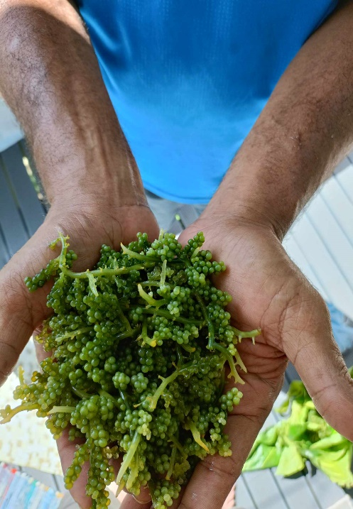
Appendices
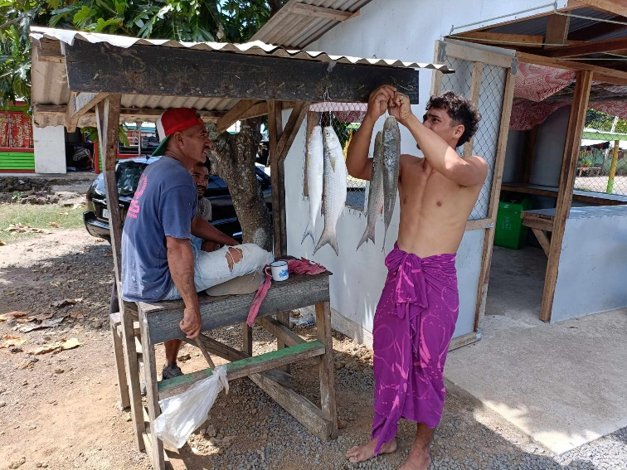
Local fishermen selling Mullet on the road
Fresh limu bought for 10 Tala (Approx 6 NZD)

A ‘alia’ boat used for fishing beyond the reef

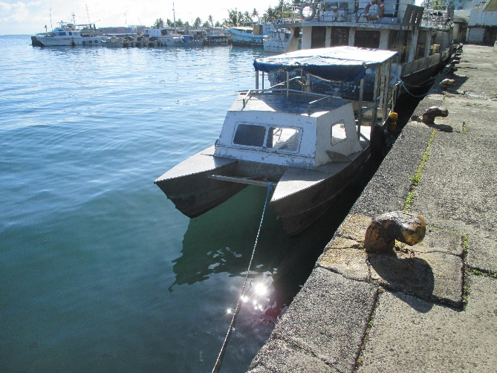
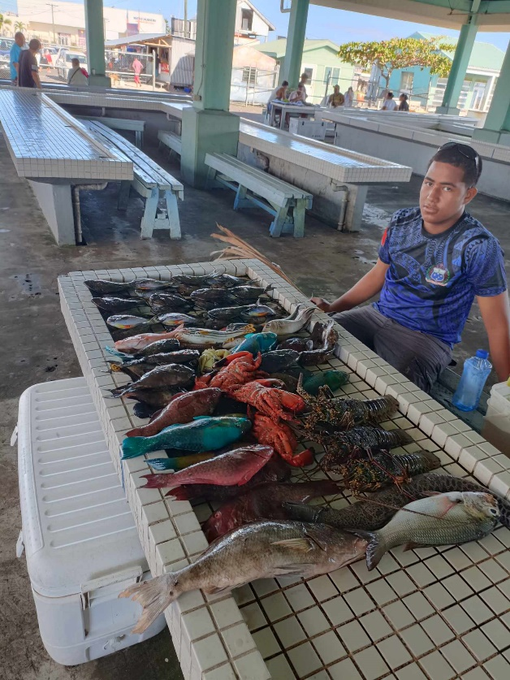

A local at the Apia fish market with a diverse catch, caught by freediving.

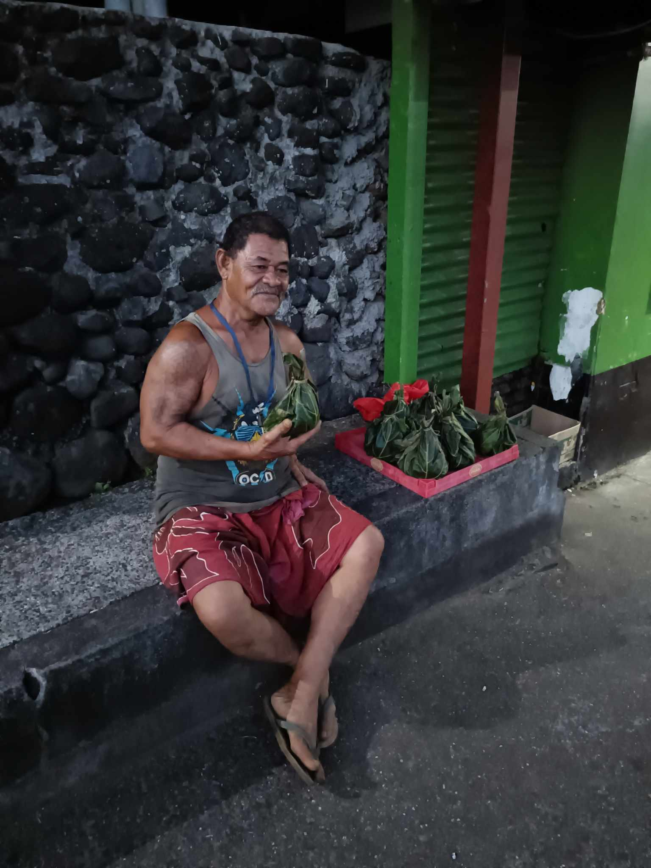

Local selling limu wrapped in mango leaves, outside of lin’s supermarket, Apia

, A.

