 | New Zealand Postgraduate Development Field Research Award  Policy Brief  2024

MATHEA MELISSA LIM | MASTER OF ARTS IN DEVELOPMENT STUDIES | UNIVERSITY OF AUCKLAND

Weathering Together: A Study on Climate Change, Mental Health, and Resilience in Coastal Communities in the Philippines

Summary: Climate change and mental health are some of the most pressing crises of the 21st century. The overlap of these issues is dire in the Philippines, which is simultaneously one of the most disaster-prone countries in the world and a place where mental health is a historically undervalued aspect of public healthcare. This study examines how slow-onset climate events (e.g., sea level rise, increase in heat, and increase in severity and frequency of typhoons) affect mental health in coastal communities, thereby shedding light on the coping mechanisms and structural inequalities that shape community resilience. This policy brief puts forward recommendations for socially just pathways to bolster community resilience, emphasising the importance of systems thinking and intersectional approaches to climate change and mental health.

- Climate change negatively impacts mental health. Direct effects on mental health arise from first-hand experiences of climate change and its destructive nature, whereas indirect effects on mental health are brought about by awareness of wider environmental and societal changes.
- Mental health interventions should not be limited to clinical or biomedical approaches. Those experiencing the mental health impacts of climate change need access to social welfare and opportunities that will afford them better lives overall.
- Policies and interventions that promote resilience must target underlying structural inequalities such as poverty and inequitable access to social welfare.
- Policy frameworks for mental health should take a firmer stance on climate change and other social determinants such as poverty, education, livelihood opportunities, and environmental degradation.

What is the development issue?
Climate change is one of the most significant threats to public health. Mental health and well-being are core components of overall health, and research in the last decade shows that they are negatively impacted by climate change through multiple overlapping pathways. The direct effects on mental health arise from first-hand experiences of climate change and its destructive nature (e.g., injury and loss of livelihood caused by climate-related disasters, mental distress caused by heatwaves), whereas indirect effects on mental health are brought about by awareness of wider environmental and societal changes caused by climate change (e.g., rising sea levels cause shifts in landscapes and local ecosystems). There is ample evidence that exposure to acute weather events (e.g. cyclones, floods, wildfires) and chronic weather events (e.g. heatwaves, drought, rising sea levels) lead to poor mental health outcomes such as higher rates of generalised anxiety, depression, post-traumatic stress disorder, and suicide. On the other hand, mental health systems comprised of services, resources, and infrastructure are burdened when growing mental health needs on personal and community levels outweigh the limited support available (Lawrance et al., 2021; Charlson et al., 2021). The implication is that climate change does not just impact mental health at the individual level, but it compounds and exacerbates existing social inequalities at the systemic level, disproportionately worsening the condition of marginalised communities and fragile health systems.

The Asia Pacific region is an area of concern, given it contends with frequent hazards and significant numbers of people affected by disasters annually, in large part due to climate change and rapid modernisation. Such is the case of the Philippines, which is susceptible to climate-related hazards and tops the World Risk Report as the most disaster-prone country in the world (Bündnis Entwicklung Hilft & IFHV, 2023). As a tropical and monsoonal country that lies along the typhoon belt in the Pacific, it is susceptible to powerful typhoons, sea level rise, landslides, and flooding.

The Philippines has and will continue to see shifts in weather patterns due to climate change. Mean temperatures in the country have increased on average 0.01° Celsius per year from 1951 to 2010, and climate projections anticipate temperatures may rise to 2.2° C by 2050 (Gepte et al., 2020). While climate change effects vary across the regions, data from the Philippine Atmospheric, Geophysical, and Astronomical Services Administration (PAGASA) shows that, in general, the number of hot days is increasing while the number of cool nights is decreasing. Meanwhile, the intensity and frequency of extreme daily rainfall have also increased. Furthermore, sea level rise in the Philippines is three to four times faster than the global average rate, and the country has been experiencing the impacts of sea level rise, such as coastal flooding and coastal erosion – putting the country’s low-lying coastal communities at risk (Department of Foreign Affairs, 2021). Millions of Filipinos live along the coast and depend on coastal livelihoods, and climate change makes their daily lives almost unbearable.

The effects of climate-related disasters on the mental health of Filipinos are well-researched, given the frequency of destructive typhoons, floods, and landslides in the Philippines. What is lacking in climate and health policies is how an awareness of chronic climate change (e.g., increasing heat, rising sea levels, slow-onset environmental changes, etc.) acts as a predisposing and precipitating factor to mental health outcomes. On an institutional level, mental health services are sought as an emergency response at the point of disaster; meanwhile, there is little investment in local approaches to mental health promotion in relation to the long-term threat climate change poses (Aruta et al., 2022; Guinto et al., 2021). Furthermore, efforts to fortify climate resilience often place strain on individuals to adapt to disruptive change, whereas national and global efforts to build stronger and more responsive social systems must be improved to ensure long-term sustainability.

Research aims: This is an original study that examines the mental health impacts of chronic climate change on coastal communities, as they are typically underrepresented as a climate-vulnerable group in the literature. While most mental health research in disaster contexts is clinical in that it seeks to quantify and diagnose, this study takes a social development approach that challenges the medicalisation of distress and suffering. The aim was not to diagnose mental illnesses in the community, but to examine how mental health in the context of climate change may be embedded in oppressive social structures that harm people's well-being, known as the theory of structural violence (Farmer, 2004). Therefore, this study aims to:
- Shed light on how slow-onset climate change events (e.g., sea level rise, increase in heat and typhoons) affect the mental health of adults in coastal communities.

- Understand the coping mechanisms that help or hinder community resilience in response to climate change.
Community profile: The research was conducted in Ajuy, a rural municipality located along the coast of the island of Panay in the province of Iloilo, part of Western Visayas (Region VI) in the Philippines (see Figure 1). Municipalities are equivalent to towns (smaller than cities in population size and annual revenue) and are categorised into six classes based on their income classification. Ajuy is categorised as a 2nd municipality, as its annual regular income sits between the range of 10 million PHP ≤ 15 million PHP (roughly 300 thousand to 440 thousand NZD).
- Climate: As a coastal municipality, Ajuy is experiencing sea level rise, increased heat, and worsening frequency and severity of typhoons.
- Livelihood: Fishing is a main livelihood; there are around 5,000 registered fisherfolk in Ajuy as of 2024. Small fishing vessels, stationary traps, and simple fishing gear such as gill nets are the predominant types of fishing. Other coastal livelihoods include gathering shellfish on the shorelines (e.g., clams, snails), crafting and selling fishing tools made of bamboo and other natural materials, and producing marine products (e.g., fermented fish, shrimp paste).
- Healthcare: There are no hospitals in Ajuy, but there is a Rural Health Unit (RHU) financed by the municipal government. The RHU has limited provision for mental health medication but does not have mental health facilities, therefore, patients with severe cases need to travel to hospitals two hours away by land travel at their own cost.
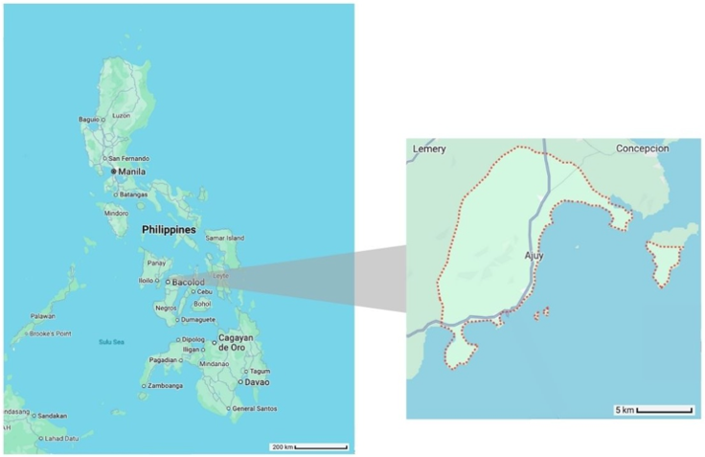

Figure 1. Grey lines represent roads. Dotted red lines represent boundaries. Adapted from Google Maps by the author. Map data ©2024 Google.
Methodology: A total of 39 unique individuals participated in the study, encompassing the perspectives of fisherfolk, health workers, and local government officials to cover an array of insights from the bottom-up and across key sectors. Personal narratives were gathered through a combination of key informant interviews, focus group discussions, and individual interviews. Participants are all adults between 30-68 years old with lifelong histories in Ajuy, to take stock of slow onset environmental changes that have transpired over time.
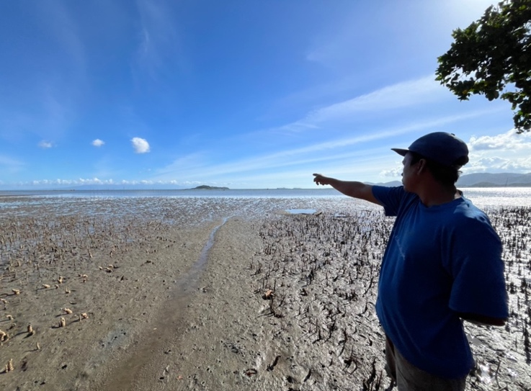Figure 2. A fisherman describes the effects of sea level rise, emphasising changes in the shoreline.
Key findings
The overarching themes are organised into three major sections: the impacts of climate change on mental health, the building blocks to resilience, and the barriers to resilience. See Appendix A for a visual diagram of the findings.

1. Impacts on Mental Health
Climate change negatively impacts mental health. Participants put a name to these impacts in their own words: Chronic fear and anxiety, heat-induced distress, and hopelessness and depression.
Chronic fear and anxiety caused by increasing typhoons and floods lead to long-term impacts like forced relocation, as seen in this example:
“My house before was close to the river. I never returned there; I just let it be. I wanted to have it repaired, but I get anxious when it rains heavily because the river overflows. That’s why I’m nervous about going back there. That’s why I now live with other people. So, that’s a concern about mental health, because I’m really anxious.” (Community health worker, female)
Participants also expressed forms of heat-induced distress. Studies show that exposure to high ambient temperatures leads to adverse mental health outcomes. In one case, anxiety was seen to flare up, especially in heat:
“I have anxiety. Now that it’s too hot, my anxiety is acting up because the heat is affecting my body. I’m getting panic attacks.” (Community leader, female)
Fisherfolk talked about how the rise in heat is causing fish to move to deeper parts of the ocean where simple fishing gear cannot reach. There is a sense of helplessness about their ability to provide for the family now and for the future of their children:
“I feel sad, ma’am. Because as time goes on, fishing becomes more difficult. Fish are decreasing gradually. Life is getting harder now. I am worried because eventually, my children won’t be able to catch anything in the sea. There are no more fish. The fish are now in the deeper parts as the temperature rises.” (Fisherfolk, male)

3. Barriers to Resilience
Participants readily identified the self-driven strategies that aided their coping. They did not identify any gaps in health services or disaster management responses from the government; instead, the barriers they identified were vulnerabilities beyond their control, such as entrenched poverty and lack of social opportunities like education and alternative livelihoods, expressed as conditions they have “no choice” but to endure. This is seen in the case of a fisherman who is distraught over worsening living conditions:
“It feels sad. Sad. And life is getting more difficult. You can't do anything, just endure. Even if you jump up and down on your boat, you can't do anything. [...] As time goes on, the poor become even poorer. They're already struggling. Life is difficult; it's getting harder and harder. The catch from the sea is decreasing.” (Fisherfolk, male)
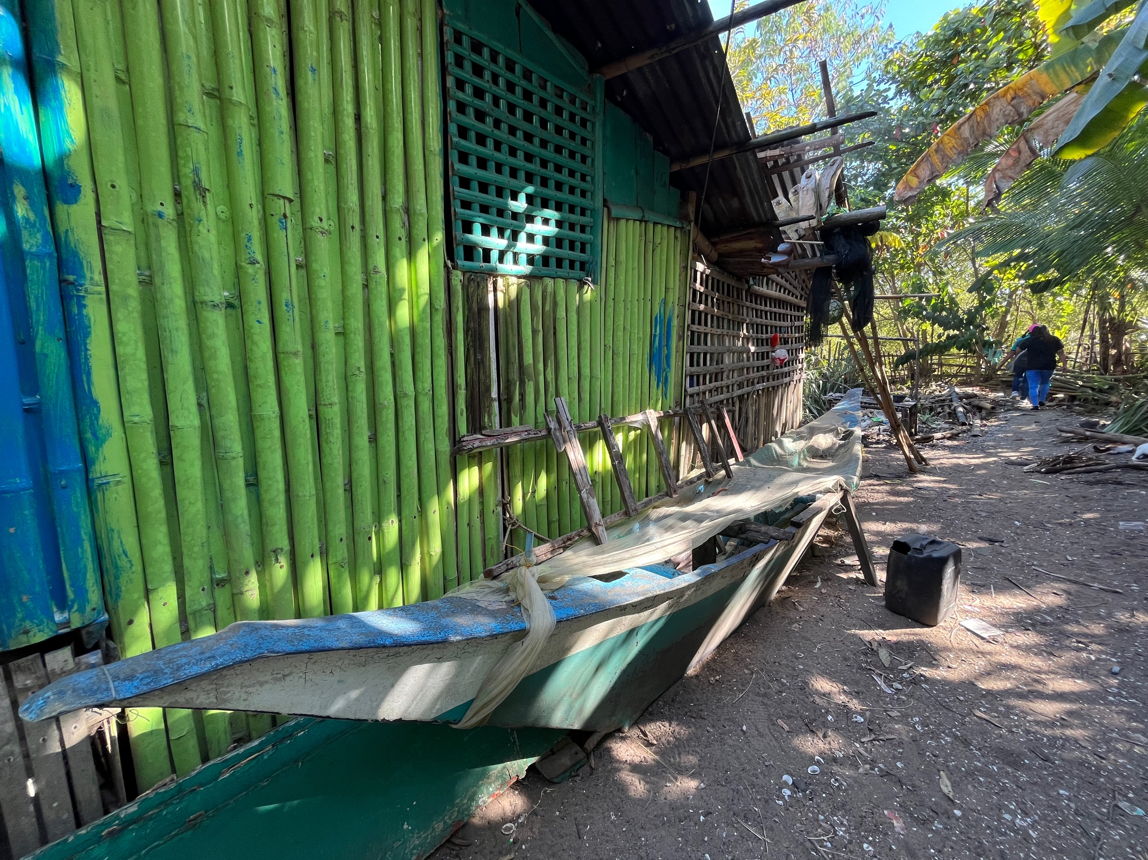Figure 4. A retired fishing boat.
A member of the fisheries council noted that fisherfolk already live in poverty; many do not finish school, and so they do not have other means of livelihood to provide for their families. As a result, fisherfolk struggle with helplessness:
“[The difficulties] can weigh heavily on the minds of fishermen, leading to thoughts like, ‘Is this the life we're stuck with? It's too much; I can't handle it anymore.’ [...] The thought of how to sustain the family may trigger thoughts of desperation, especially when considering that moving to the city is not an option due to a lack of education and academic achievements.” (Fisheries council member, female)

2. Building Blocks to Resilience
The building blocks to resilience consist of the community’s ability to mobilise their collective resources, demonstrated through social cohesion and acts of faith. These were often expressed in the mentality that "we can overcome anything."
Social cohesion refers to connectedness and willingness to share assets in a group. People feel that as long as they are with their loved ones, that they can overcome anything together:
“I have many friends who are fishermen. I know what they’ve experienced. We always say out at sea, “Where we’re together is where we fish.” No matter how challenging it is, as long as we’re together, we can overcome it. It’s really just hard work and perseverance.” (Fisherfolk, male)
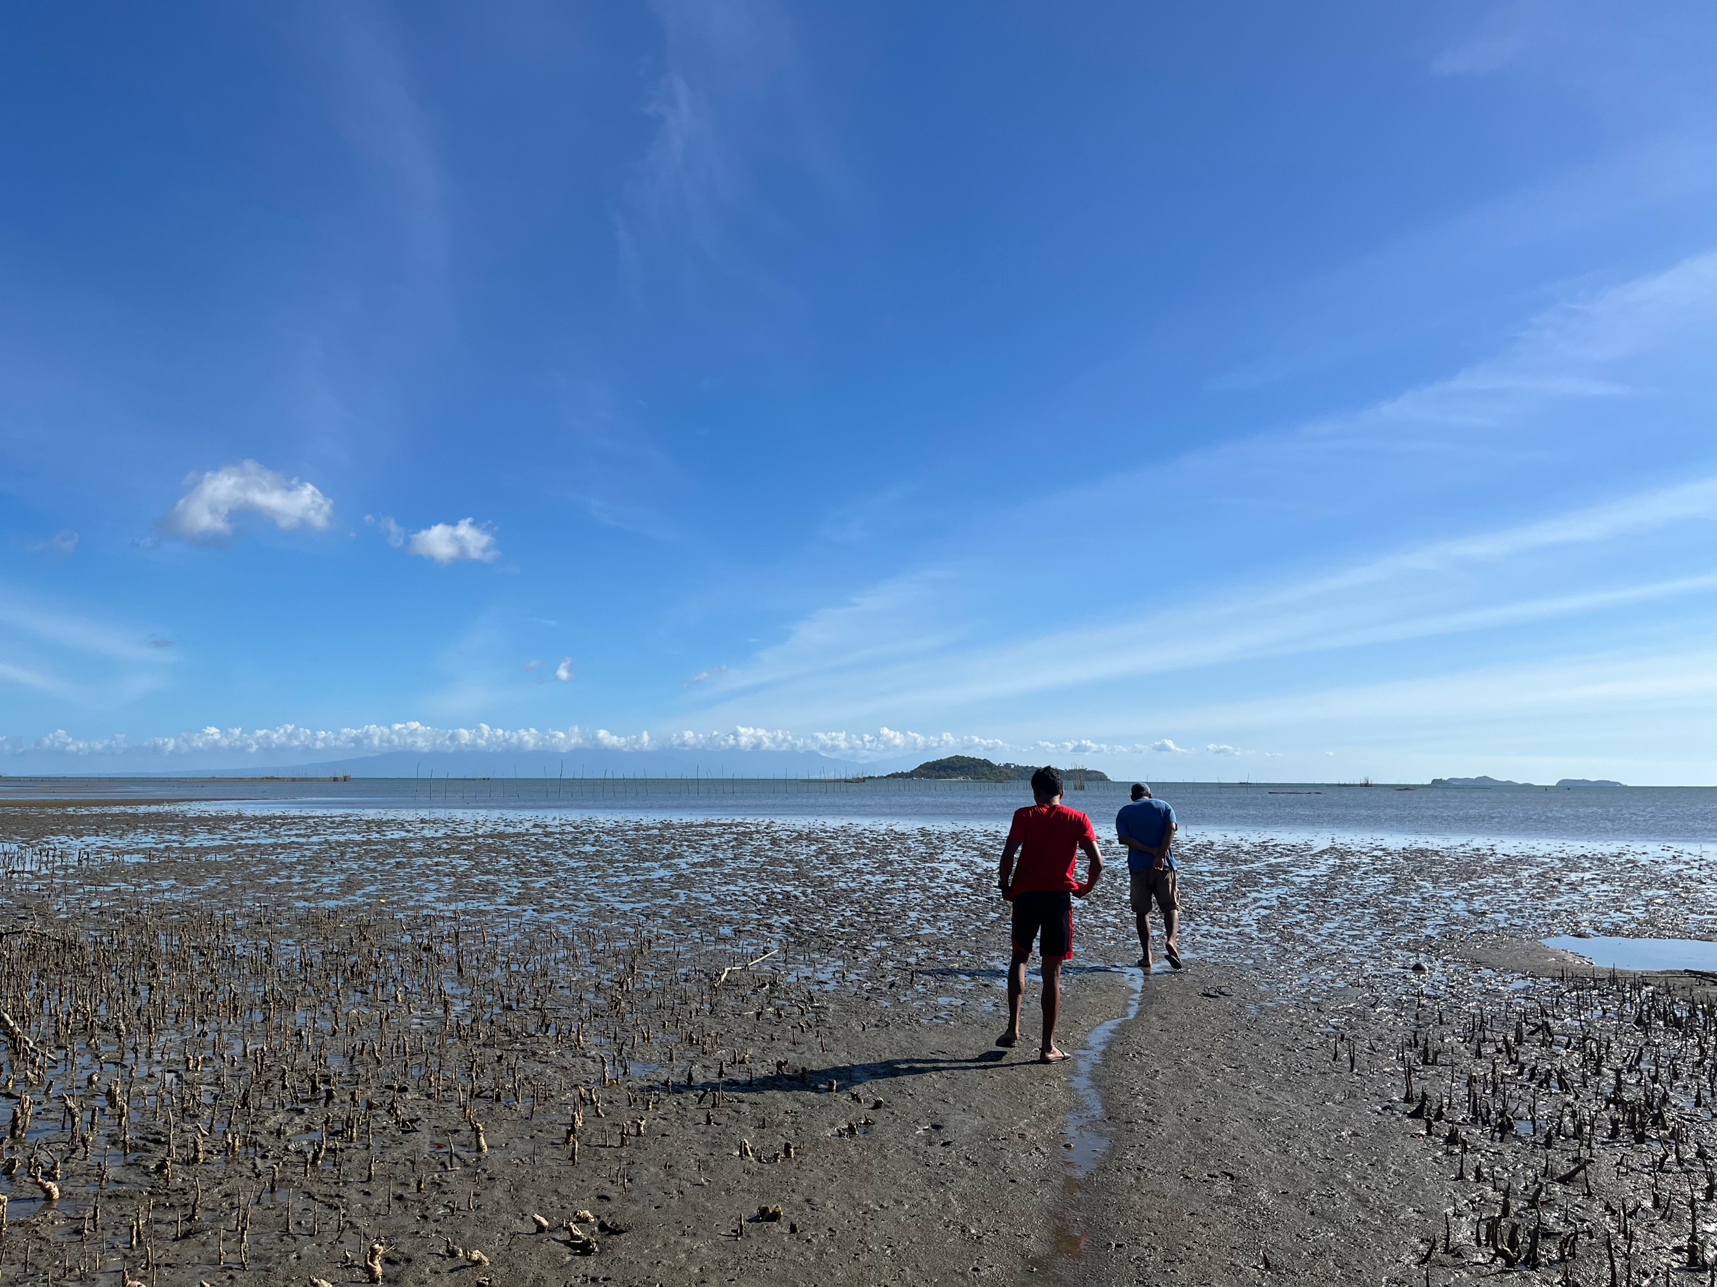Figure 3. Fishermen in Ajuy
Acts of faith are also a key resource. The dominant religion in Ajuy is Christianity, so participants spoke of praying for themselves and each other. A fisherman explained how he lives according to Christian values of serving God by serving each other in times of need:
“In my opinion, it's good to do what, in my belief, are good deeds for our fellowmen as a way of serving our God. [...] We help each other sometimes. If they have something, I receive, and if I have something, I also share.” (Fisherfolk, male)

Implications
Great social injustice lies in how people take it upon themselves to be resourceful in a world of climate change while subject to conditions of misery not of their own making. The Global North and top manufacturing countries are responsible for the majority of GHG emissions, while the carbon footprint of rural community members – such as those in Ajuy – is negligible, yet they are subject to the worst impacts. The following recommendations encourage socially just pathways to building resilience in systems and communities in order to foster a healthy future for people and the environment.
Global governance: Despite the United States’ disappointing withdrawal from key climate agreements as of March 2025, remaining Global North nations and top GHG emitters must continue upholding their responsibility to fund climate mitigation, adaptation, and loss compensation. Global platforms for climate negotiations, such as the Conference of Parties (COP), should regularly include opportunities to discuss matters of public health.
National policy: Mental health frameworks should include climate change considerations and vice versa. Despite evidence that climate change is a key domestic and global policy issue, the Philippines’ mental health framework set by the 2019 Mental Health Act lacks explicit consideration of climate change impacts on mental health and mental healthcare systems. Policy frameworks for mental health should take a firmer stance on climate change and other social determinants – such as poverty, education, livelihood opportunities, and environmental degradation.
Intersectional approaches: The impacts of climate change vary across diverse contexts. The needs of coastal communities are uniquely different from other vulnerable groups (e.g., farming communities). Therefore, intersectional approaches to policy and research are needed. Intersectionality accounts for structural oppression and privilege that shape lived experiences, framing climate change as a widespread chronic stressor that presents specific challenges based on social categories such as race, gender, age, and class (Versey, 2021). Intersectional approaches acknowledge a plurality of identities and can lead to policies tailored to the specific inequities experienced by different groups, requiring the input of local
people, leaders, and stakeholders.

Interventions for resilience building: Any policy that promotes resilience should not stop at fostering community participation and community-driven initiatives, but should ensure these efforts are supported by targeting underlying structural inequalities such as poverty and inequitable access to social welfare. Within the politics of climate adaptation, the framing of community resilience as a normative good to which governments and civil society organisations aspire to build and replicate must be interrogated. Taking a rigid stance ‘for’ or ‘against’ resilience does not do anything for the issues at hand; what matters is whether resilience is promoted as a means of transforming structural inequalities at work.
Interventions for mental health: Mental health interventions should not be limited to clinical or biomedical approaches. While an increase in mental health infrastructure, workforce, and services could address the needs of those with severe mental health illnesses, what the majority of people in under-resourced settings need is access to social welfare and opportunities that will afford them better lives overall. Social problems are not just forces that act upon the mind; overall health and well-being are inextricably tied to the social world. Therefore, it is prudent for mental health researchers and practitioners to think about human psychology as having roots outside the body and conceptualise the mental health effects of climate change as a problem of social injustice and development failures (Summerfield, 2012).
Limitations
The fieldwork was conducted through networks of government actors such as the Rural Health Unit, Municipal Fisheries and Aquatic Resources Council, and local government officials, who all hold positions of power in Ajuy. The snowball sampling recruitment method used in this study, in which participants were recommended to the researcher by key informants by the aforementioned government actors, led the researcher to ideal participants who have positive relationships with the local government and good standing in their communities. Other residents in Ajuy whose narratives deviate from the ideal were excluded from this study, such as those who may have negative experiences of healthcare, social welfare, and other relevant government services. In future research, opportunities should be granted to a variety of community members who have been historically marginalised in their communities.

References
Aruta, J. J. B. R., Salcedo, S. S., Guilaran, J., & Guinto, R. R. (2022). The plight and promise of mental health providers in the face of a warming planet: Perspectives and experiences from the Philippines. International Review of Psychiatry, 34(5), 530–533. https://doi.org/10.1080/09540261.2022.2123701
Bündnis Entwicklung Hilft, & IFHV. (2023). WorldRiskReport 2023. Bündnis Entwicklung Hilft. https://weltrisikobericht.de/wp-content/uploads/2023/10/WRR_2023_english_online161023.pdf
Charlson, F., Ali, S., Benmarhnia, T., Pearl, M., Massazza, A., Augustinavicius, J., & Scott, J. G. (2021). Climate Change and Mental Health: A Scoping Review. International Journal of Environmental Research and Public Health, 18(9), 4486.
Department of Foreign Affairs. (2021). Philippines Raises Alarm on Impacts of Sea-Level Rise. https://dfa.gov.ph/dfa-news/dfa-releasesupdate/29139-philippines-raises-alarm-on-impacts- of-sea-level-rise
Farmer, P. (2004). An Anthropology of Structural Violence. Current Anthropology, 45(3), 305– 325. https://doi.org/10.1086/382250
Gepte, A. D., Dixit, A., dela Cruz, K., Lopez, E., Supnet, D., Martinez, J., Mendoza, I., & David, A. (2020). Climate Finance Adaptation Study Report: Philippines. https://careclimatechange.org/wp-content/uploads/2021/01/Philippines-Climate- Adaptation-Finance-Tracking-.pdf
Guinto, R. R., Alejandre, J. C. P., Bongcac, M. K., Guilaran, J., Salcedo, S. S., & Sunglao, J. A. (2021). An agenda for climate change and mental health in the Philippines. The Lancet Planetary Health, 5(11), e755–e757. https://doi.org/10.1016/S2542-5196(21)00284-9
Lawrance, E., Thompson, R., Fontana, G., & Jennings, N. (2021). The impact of climate change on mental health and emotional wellbeing: Current evidence and implications for policy and practice. Grantham Institute. https://spiral.imperial.ac.uk/handle/10044/1/88568
Summerfield, D. (2012). Afterword: Against “global mental health.” Transcultural Psychiatry, 49(4), 519–530. https://doi.org/10.1177/1363461512454701
Versey, H. S. (2021). Missing Pieces in the Discussion on Climate Change and Risk: Intersectionality and Compounded Vulnerability. Policy Insights from the Behavioral and Brain Sciences, 8(1), 67–75. https://doi.org/10.1177/2372732220982628

Appendices
Appendix A: Visual Diagram of the Key Findings

