Bex Ansell| Development Studies | University of Auckland

Community Access to Tuna in South Tarawa, Kiribati

Summary: South Tarawa, Kiribati, has a thriving small-scale tuna industry which feeds many of the atoll’s 60,000 residents (Park & Diffey, 2025). Small-scale tuna fishing is a way of life and a source of cultural and social wellbeing. However, fishers and fishsellers face challenges including competition with larger operators, increasing competition within the sector itself, gender restrictions, and the impacts of climate change. Through interviews with 25 small-scale tuna fishers and 15 tuna fishsellers in South Tarawa, surveys with 49 fishsellers, and a survey of 242 members of the community of Teaoraereke, in September and October of 2024, this research identifies who benefits from South Tarawa’s tuna, the obstacles they face, their concerns and ambitions, and lived experiences with sustainability.

Highlights from this research:
- The small-scale industry has concerns about their future, with many fishers observing worrying trends over time such as decreasing catch per unit effort (CPUE). Challenges for sustainability include climate change, increasing competition at the small-scale level and increasing competition with the purse-seine industry.
- Existing Government programmes to generate more income for the industry are having an impact, with many fishers motivated to add value to their tuna by developing and marketing tuna jerky.
- There are opportunities for central and local Government to improve access to ice and improve market conditions, particularly at council-run markets.
- Kiribati women are also successful tuna-fishers, and the male fishers who have witnessed their efforts are their biggest champions and allies. There are opportunities to support women’s greater involvement in small-scale tuna fishing by raising the profile of these currently invisible but successful women tuna fishers.

What is the development issue?
Tuna is so vital to the economies of many Pacific Island countries and there are so few alternatives for economic development, that ten of these countries, including Kiribati, have been described as ‘tuna-dependent’ (Bell et al, 2021; World Bank, 2020). Governments collect revenue from foreign fishing fleets in the form of access fees, by selling vessel days through the Vessel Day Scheme (VDS). For Kiribati these fees comprise 70.6% of all government revenue (Bell et al., 2021). Many countries are growing their own domestic purse-seine operations in efforts to retain a greater proportion of the value themselves. Kiribati Fish Limited (KFL) recently launched its seventh domestic purse seine vessel as part of its joint venture operation with China (MFOR, 2025a). An increase in purse-seining activity, whether foreign or domestic, has implications for small-scale fishers, who compete to fish for the same migratory species of tuna (largely skipjack and yellowfin). Local markets can also be flooded with tuna caught on purse-seiners competing with small-scale catch (McCoy, 2012).

Half of Kiribati’s population, some 60,000 people, live in South Tarawa, and largely rely on handline-caught tuna from 5 - 6m single outboard motor vessels for their daily protein. Fishers and fishsellers report that the Betio and Teaoraereke Urban Council cap the price per pound, controlling the domestic market. Small-scale tuna vessels are subject to safety at sea regulations enforced by the Kiribati Marine Division, and captains are required to be licensed, but catch is not regulated, with fishers able to catch as many tuna as they can of any size.
Most of Kiribati’s tuna is caught by wholly or partially foreign-owned purse-seine vessels, with 100% observer coverage on licensed purse-seiners (MFOR, 2025b), but few examples of companies being prosecuted for illegal activities. Tuna is regulated at a regional level through the Vessel Day Scheme (VDS) which increased income for Kiribati since its introduction in 2007, but does not specify catch limits on bigeye, yellowfin and skipjack tuna (WCPFC 2025). High rates of foreign fishing pressure, Illegal, Unregulated and Unreported (IUU) practices, and short-term political and economic pressures raise sustainability concerns (Stimson, 2019; Shen and Huang, 2021; McKinney et al., 2020).

Climate change is likely already impacting availability of tuna for coastal communities in the Pacific. Tuna travel along warm ocean currents, which are projected to shift eastwards, taking tuna away from traditional fishing areas (Amon et al. 2023). Purse-seiners can adapt to follow tuna as migratory patterns shift, whereas small-scale fishers cannot: restricted by the limits of their outboard motor, fuel costs and safety considerations.

Photograph 1: Author (left) holding yellowfin and fishseller (right) holding skipjack tuna for sale, South Tarawa, Kiribati, March 2024. Source: Fiona Kotvojs.
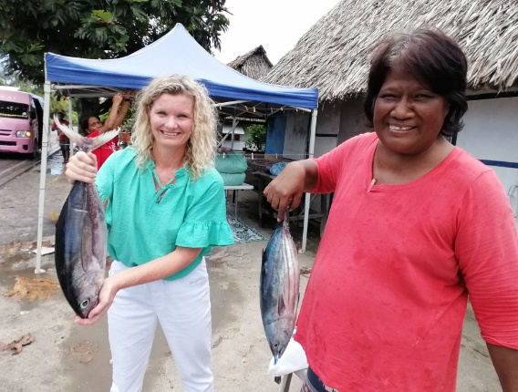

Tuna fishers, almost exclusively male, are not the only ones whose livelihoods are at risk: fishsellers, most of whom are women, rely on this income to support themselves and their children. In Kiribati, the industry is highly gendered, with fishing a male domain and taboos on women’s involvement. Fishermen’s wives are expected to sell the catch, with fishseller earnings far less than fishers’ incomes. In the Pacific, commitments to gender equality in national policies and fisheries development have surged, yet actions are often diluted, and overlook men and gender relations (Lawless et al., 2021, Barclay et al., 2022).

The development of tuna fisheries in tuna-dependent countries in the Pacific, distributes benefits unevenly, creating winners and losers with intergenerational consequences.

Key findings
This research sought to identify who benefits from South Tarawa’s small-scale tuna sector, the barriers to equitable access, and opportunities to increase equity and sustainability. Interviews and surveys were designed to reveal the relationship between identity and access to tuna, considering variables including gender, migration status and marital status. Perceptions of change in the industry over time, sustainability and future access to tuna were explored.

The key findings are:

- Concerns about decreasing catch per unit effort and the future of the small-scale industry. 56% of fishers (n=14/25) report an increase in effort to catch tuna compared to the past. 77% (n= 10/13) of fishsellers identify decreasing catches of tuna as the greatest change over time. When asked about changes over time, 52% of fishers say their catches have decreased (Figure 1), and 52% report that they now travel further to find tuna (Figure 2), with implications for tuna sustainability and economic viability.

“Since I was a boy…we can spend only one to two hours in the open seas and return very soon with plenty fish like more than two hundred tunas. Nowadays, people can go out fishing very early in the morning and return in the afternoon with only a few tunas, about 50 fishes.” Ang, tuna fishing for 29 years.
“Before you can catch it [tuna] close-by but now you have to go 40 plus miles away from the island. When we were younger it used to be around 20 miles.” Nang, tuna fishing for 20 years.

Figure 1: Fisher responses to questions about changes over time, from interviews with 25 fishers. More tuna, less tuna or about the same?
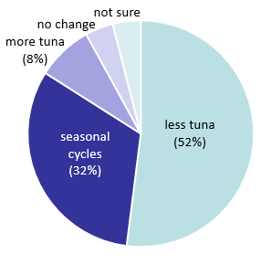
- Concerns about competition with purse-seiners. 32% of fishers (n=8/25) are concerned about the increasing take from purse-seine vessel operations, including KFL and Central Pacific Producers Limited (CPPL), and several fishers reported potentially illegal behaviour of purse-seiners. More than a quarter of small-scale fishers interviewed (28%, n=7/25) were concerned that tuna is declining because of foreign vessels, and 20% of fishers (n=5/25) want greater controls on foreign fishing. One fishseller raised concerns that customers preferences are switching to cheaper purse-seine caught KFL/CPPL tuna.

- Seeing is believing: male fishers are the biggest allies and champions for women tuna fishers. They are largely invisible, but there are successful Kiribati women tuna fishers. 64% of male tuna fishers (n=16/25) support women fishing for tuna and have witnessed female fishers at work. There are barriers to women’s participation in tuna fishing, and pressures on men to fish. Not all men are willing fishers, with some reporting social pressure to fish for tuna, and some fishers reluctant to return to the ocean after traumatic experiences adrift at sea. There are Kiribati women who love the ocean and have always wanted to fish for tuna but have been denied access due to their gender.

Figure 2: Distance to fishing spots at Maiana, Abaiang and seamounts from the fishing village of Teaoraereke, South Tarawa (pin). Source: Google maps.
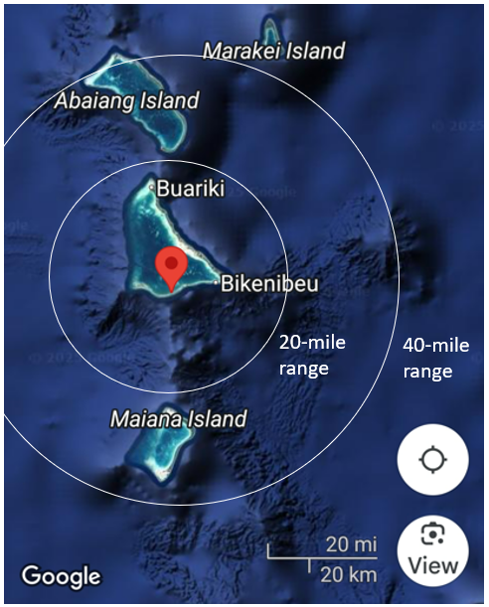

“It was a surprise for me when I first saw a woman join our fishing team… I quickly realized that she was more than capable of handling the same tasks that the men do. She was strong, skilled, and knowledgeable about fishing techniques.” Karau, tuna fishing for 26 years.

“I believe that as a woman, I can fish just as well as males and believe that all women can do fishing just like me.“ Ameria, female fisher, tuna fishing for 15 years.

- Gendered benefits. Women earn about half compared to men in this industry: their role is largely restricted to selling which brings in $24 on an average day, compared to $44 for those who fish (Figure 3). In Kiribati’s small-scale tuna industry profit-sharing model fishsellers (almost all women) receive a 10% commission on sales, while the remainder of the profits are divided equally (a ‘share of five’) between the boat owner, engine owner, captain, and crew, who are mainly male. While an increasing number of women own boats and thus have access to far greater profit-shares, women are reluctant to fish themselves, citing cultural, physical, and mental limitations. Fisher’s earnings can be high, with up to $80 - 100 for a day’s work (more than a typical government salary) but income is inconsistent, and there is the risk of running at a loss, with fuel and other expenses running to $200+ per day. There are no salaried wages in the industry meaning that fishers and fishsellers are eligible for the universal benefit which supplements their income. Fish-cleaners and boat-lifters, usually young boys from the village, may earn one fish for their families in exchange for their labour.

Figure 3: Illustrative profit-share (AUD) for a day’s fishing trip landing a modest catch of forty tuna weighing 5lb each.
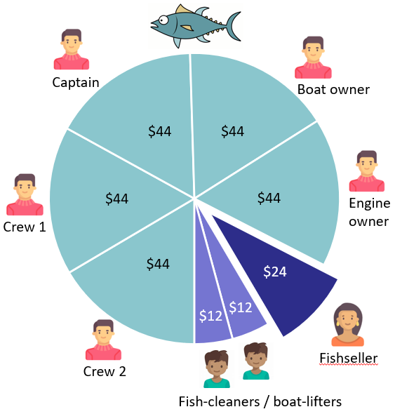

- Rising competition within the small-scale industry. The number of fishing boats and fishsellers has increased over time, with healthy competition at times escalating to a ‘war’ for customers. Over one hundred 6 - 7m vessels may be fishing on a particular day. At some fishing spots there can be 40 to 50 boats vying for the same tuna. 23% of fishsellers (n=3/13) observed that it now takes longer to sell tuna due to increased competition, with fishsellers working from early morning until late at night.
“The number of fishing boats has significantly increased…competition is fierce. Every dawn, as we leave the island, we can hear the roar of multiple engines from other boats in the distance.” Karau, tuna fishing for 26 years.

Photograph 2: Local tuna fishers transport their catch to market in South Tarawa, March 2024. Source: Fiona Kotvojs.

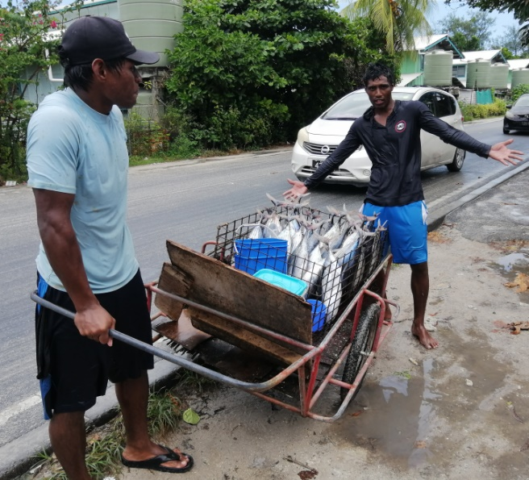

- Better access to ice. Ice is a problem for the small-scale industry with 40% of fishsellers (n=6/15) and 20% of fishers (n=5/25) raising access to ice as the key to improving their livelihood. Without ice, tuna spoils quickly, meaning wastage and lost income. Government owned company CPPL supplies ice to small-scale fishers, as does the Government of Kiribati/Chinese joint venture KFL, but both reportedly turn away small-scale fishers and fishsellers saying they are ‘out of stock’.
“Sometimes, when we go to buy ice, they tell us they have none left. But we know they [CPPL and KFL] are keeping it for themselves because their ships need it for their tuna.” Tubuang, tuna fishing for 40 years.

- Rising expenses. Tuna is sold in an increasingly competitive market, and when the cost of fuel goes up, the income from tuna sales isn’t always enough for fishers to make ends meet. Some note that they rely on Kiribati’s universal benefit to continue to operate. Fishers asked for financial or regulatory help to afford safety gear and fishing gear, with 32% (n=8/25) raising concerns about affordability of and access to necessary equipment. Some call for subsidised fuel, and free or subsidised fishing gear and safety gear.

Photograph 3: Research assistant Aritika Burennara (far right) surveys fishsellers at a South Tarawa tuna market. Source: Fitnih Teem.
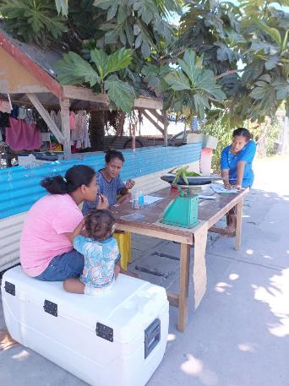

- High ambitions to improve incomes through tuna jerky. When asked about ways to improve their livelihoods, 44% of tuna fishers interviewed (n=11/25) had plans to make tuna jerky, to gain more value from their catch, prevent wastage and preserve food for their families. This interest is likely to have been sparked by value-add programmes initiated by Kiribati’s Ministry of Fisheries and Ocean Resources (MFOR) and FAO.
- Family connections improve access to tuna. Access to tuna is largely, but not exclusively, mediated by family connections and gender. Tuna fishers and fishsellers born on outer islands do not appear to experience discrimination or disadvantage in terms of access to South Tarawa’s tuna. Those born in South Tarawa achieve similar income levels from tuna, compared to those born in the outer islands. High rates of marriage between outer islanders and those from South Tarawa may explain this finding. Marrying into a fishing family provides access for those from outer islands and connects them to buyers from their spouses’ village.
- Deeper meaning and well-being. Both fishers and fishsellers describe the social benefits of tuna fishing and fishselling, in addition to economic and food security rewards. Some fishers attribute deeper meaning to their work, describing fishing as a way of life, an identity, a rite of passage, a way to attract a wife, a chance to bond with family. Fishsellers describe their work as fun, relaxing, social, and flexible. When asked about their children’s future, most fishsellers and some fishers say they prefer their children to focus on education and seeking a Government or salaried job. Fishing is seen as an excellent survival skill, but a salaried job is better for future income security.

Photograph 4: Fisher Willy Uan returns from a long day at sea with a catch of 12 large tuna, some to feed his family and some to sell to pay for fuel. Source: Willy Uan.

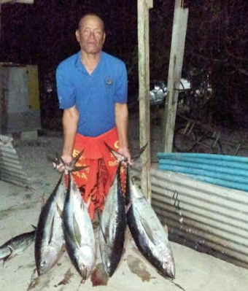

Implications
This research provides insights relevant to several Sustainable Development Goals, particularly food security (SDG 2), gender equality (SDG 5), and sustainable use of marine resources for sustainable development (SDG 14).

Kiribati is growing its domestic purse-seine fleet and continues to gain significant economic value from foreign fishing, but these activities can come into conflict with small-scale tuna fishers. Engaging small-scale fishers in Kiribati’s ongoing Marine Spatial Planning efforts could help minimise competition between purse-seine and small-scale sectors. Greater protections for small-scale fishing grounds may be required, and purse-seine exclusion zones reconsidered. Providing clear information about how larger operators are regulated, and clear processes for reporting observed non-compliance would build confidence within the small-scale industry that the larger operators are being effectively regulated, and that the Government supports the sustainability of the small-scale industry.
Further Government support for preparing and marketing tuna jerky would be well-received by the fishing community, with very high interest expressed by tuna fishers in this value stream.

Local fishers and fishsellers experience day-to-day changes in ability to catch wild tuna and are well-placed to report on catch per unit effort over time. A longer-term project to capture CPUE data from small-scale fishers could provide useful insights into patterns of change and monitor whether CPUE is declining over time, with consideration of the natural variability of South Tarawa’s tuna due the ENSO oscillation and El Niño / La Niña events. This data would allow economic projections for the viability of the industry and associated development support. Depending on the rate of CPUE change, further support for alternative livelihoods or business models (such as the value-add initiative on tuna jerky) may be needed.

“Imagine in the future, I think fishermen will come back with just only 5 tuna. I’m afraid that will happen because that is our main source of income and if tuna vanish, we will also vanish.” Emeri, selling tuna for 10 years.
Access to ice by the small-scale industry could be improved through Government controlled avenues, or by supporting establishment of an independent ice supplier to focus solely on the small-scale sector.
Facilities at council-run markets such as that in Betio can be improved, particularly wastewater management, water availability, lighting and toilets. Past upgrades have now deteriorated, and a sustainable business model with funded maintenance schedule is required (Mike Savins, pers. comm.).

Kiribati women who are successful tuna-fishers could share their perspectives and experiences, providing visible role-models for other Kiribati women who aspire to tuna-fishing. Sharing the perspectives of supportive fishermen would build a greater base of support and encouragement. Facebook video clips, radio interviews, talks at International Women’s Day or Youth events, are potential media channels. MFAT or local NGOs could support MFOR and MWYSA to run ‘have a go’ days for women to try tuna fishing and learn boat skills including operation and maintenance of outboard motors.

Limitations and further research
This research focussed on perspectives at the community level, particularly those of the tuna fishers and fishsellers in South Tarawa. Research could be extended to include perspectives of policymakers, NGOs and the tuna industry, tuna fisheries scientists, and climate change modellers assessing impacts on tuna populations.
Further quantitative biological fisheries research, such as CPUE monitoring for small-scale fishers, localised tuna stock assessments and modelling of future tuna population projections in South Tarawa, would help forecast the future of the small-scale tuna industry, and inform regulatory action to ensure sustainability. Models need to consider population growth, purse-seiner pressure and climate change.

References
Amon, D.J., Palacios-Abrantes, J., Drazen, J.C. et al. (2023) Climate change to drive increasing overlap between Pacific tuna fisheries and emerging deep-sea mining industry. Npj Ocean Sustainability 2, 9. https://doi-org.ezproxy.auckland.ac.nz/10.1038/s44183-023-00016-8
Barclay, K.M., Satapornvanit, A.N., Syddall, V.M., Williams, M.J. (2022). Tuna is women's business too: Applying a gender lens to four cases in the Western and Central Pacific. Fish and Fisheries, 23, 584-600. https://doi.org/10.1111/faf.12634
Bell, J.D., Senina, I., Adams, T. et al. (2021). Pathways to sustaining tuna-dependent Pacific Island economies during climate change. Nature Sustainability 4, 900–910. https://doi.org/10.1038/s41893-021-00745-z
Lawless, S., Cohen., P., Mangubhai, S., Kleiber, D., Morrison, T. (2021). Gender equality is diluted in commitments made to small-scale fisheries. World Development, 140, 105348. https://doi.org/10.1016/j.worlddev.2020.105348
McCoy, M. (2012). A survey of tuna transshipment in Pacific Island countries: opportunities for increasing benefits and improving monitoring. Forum Fisheries Agency. https://imcsnet.org/resource/survey-tuna-transshipment-pacific-island-countries
McKinney, R., Gibbon, J., Wozniak, E., Galland, G. (2020). Netting Billions 2020: A Global Tuna Valuation. A Pew Charitable Trusts report. https://www.pewtrusts.org/en/research-and-analysis/reports/2020/10/netting-billions-2020-a-global-tuna-valuation
MFOR (2025a). April 9 2025. Hon. Minister Tiwau welcomes new purse seine vessel, Maribo 61. https://www.mfor.gov.ki/index.php/news/hon-minister-tiwau-welcomes-new-purse-seine-vessel-maribo-61
MFOR (2025b). Content accessed 29 May 2025. https://mfor.gov.ki/index.php/about/about-us
NOAA (2025, April 10). El Niño & La Niña (El Niño-Southern Oscillation). Climate.gov. https://www.climate.gov/enso
Park, S. & Diffey, S. (2025). Domestic tuna value chain in Kiribati – Analysis and ten-year upgrading strategy (2023–2033). Food and Agriculture Organisation of the United Nations (FAO). https://doi.org/10.4060/cd3836en
Shen, H, S., & Huang, S. (2021). China’s policies and practice on combatting IUU in distant water fisheries. Aquaculture and Fisheries, 6, 27-34. https://doi.org/10.1016/j.aaf.2020.03.002
Stimson. (2019). Shining a Light: The Need for Transparency across Distant Water Fishing. Stimson Environmental Security Program Report. https://stimson.org/sites/default/files/file-attachments/Stimson%20Distant%20Water%20Fishing%20Report.pdf
WCPFC. 2025. Conservation and Management Measures (CMMs) and Resolutions of the Western Central Pacific Fisheries Commission (WCPFC) Compiled 26 May 2025 - 11:46. https://cmm.wcpfc.int/
World Bank. 2020. Kiribati: Pacific Islands Regional Oceanscape Program (P165821). The World Bank. 75 pp. https://documents1.worldbank.org/curated/en/904981584324108717/pdf/Kiribati-Pacific-Islands-Regional-Oceanscape-Program.pdf
Acknowledgements
This work would not have been possible without funding support from DevNet and the University of Auckland. Numerous people have made this research a reality including my supervisors Professor Andreas Neef and Associate Professor Jesse Hession Grayman, Cultural Advisers Dr Agnes Yeeting and Dr Petaia Satalaka, Statistical support Dr Liza Bolton, Dr Victoria Syddall, MFOR Secretary of Fisheries Riibeta Abeta, Director of Coastal Fisheries Tooreka Temari, FAO Consultant Mike Savins, MWYSA’s Tarota Bwebwetara, Betio Council Clerk Maraki Bokai, and Teaoraereke Urban Council (TUC) Mayor Baraniko Baaro. In addition, dozens of people in New Zealand, Kiribati and across the Pacific have given me their time, advice, support and information to help bring this research to reality. My five wonderful Kiribati research assistants and translators were a powerhouse: Ren Teetimwa, Tekimwau Kanoua, Tiein Taebo, Fitnih Teem, and Aritika Burennara. And most importantly, my gratitude to the hundreds of Kiribati women and men who shared their knowledge, stories and views with us.

Catch per unit effort or CPUE is an indicator of the sustainability of a fishery.
The Western Central Pacific Fisheries Commission (WCPFC) requires countries to estimate annual depletion of tuna stocks and compare it to agreed baseline stock levels for 2012 – 2015. This data informs calculations of tuna spawning potential. A target reference point for spawning depletion has been set for skipjack tuna but is not yet agreed for yellowfin and bigeye. Countries develop their own harvest strategies to determine catch and/or effort limits, as part of their management planning.
All figures provided are in Australian Dollars (AUD) the currency of Kiribati.
Government salaries are around $20,000 per year. Assuming 260 working days per year = $77 / working day.
Kiribati is unique in providing a universal benefit for all adult citizens without a salaried job of ~$200/month.
Kiribati experiences three climate settings in any given year: neutral, El Niño and La Niña. Warm El Niño and cool La Niña episodes last from 9 – 12 months, sometimes years, and don’t follow a regular schedule. El Niño is more frequent than La Niña. (NOAA 2025) In Kiribati, El Niño events mean more tuna, and bumper catches. Local fishers refer to these seasons of plenty as e maeu marawa or ‘the sea becomes alive’. When the climate returns to neutral or La Niña, the ocean cools and ‘dies’: e mate marawa.

