Kiera Nelson | Master of Health Science | Massey University
Progress Towards SDG6 on ‘Eua, Tonga: Review of the MORDI Tonga Trust project to enhance disaster preparedness for water security

Summary:
- Enhancement of water security in line with the objectives of SDG6 is a key policy priority for the Kingdom of Tonga. Over the years this has led to a range of water development initiatives, each with its own benefits and challenges. For the island of ‘Eua, one of the most significant was a large-scale rainwater tank installation project implemented in 2020 by the NGO Mainstreaming of Rural Development Innovation Tonga Trust (MORDI).

- This research, carried out in collaboration with MORDI, examined the performance of that project five years on, while considering relevant factors including changes in community attitudes and priorities, complementary work carried out by two other agencies, and upgrades to ‘Eua’s reticulated drinking-water network.

- Overall, our research indicates positive progress towards water security in ‘Eua as a result of MORDI’s water project. However, further progress is required to achieve SDG6. Several recommendations have been made to MORDI for both consolidating the benefits of existing work, and developing future projects. Some high-level findings of the research are that self-sufficiency, including pathways for ongoing resource procurement and training, should be prioritised as an integral part of the development; Community Development Plans (CDPs) are a key resource to inform project design and evaluation across agencies; plans for implementation assessment should be determined in the design-phase; and aid efficiency would greatly benefit from increased data transparency and sharing among government agencies and NGOs in Tonga.

The Development Issue
Access to safe water is a fundamental human right, essential for health and development. It is the focus of the United Nations’ Sustainable Development Goal 6: to ensure availability of sustainable management of water and sanitation for all. This is a key challenge for the Kingdom of Tonga. In 2022, Tonga reported some of the lowest rates of access to safely managed water and sanitation in the world, at 30% and 34%, respectively (United Nations 2024).
As a key development priority for Tonga, significant work and expenditure has aimed to enhance water security through improvements to rainwater harvesting (household and community), expansion of groundwater access, and development of water treatment capabilities. However, despite this focus, the effect of these projects on water security remains poorly characterised due to limitations in evaluation and data sharing (Government of Tonga 2024).

To understand the opportunities and barriers in the delivery and evaluation of water security projects, this research focused on the island of ‘Eua as a case-study. ‘Eua is an island located approximately 20 km southeast of Tongatapu, home to approximately 5,000 people, divided into two districts and 15 communities.
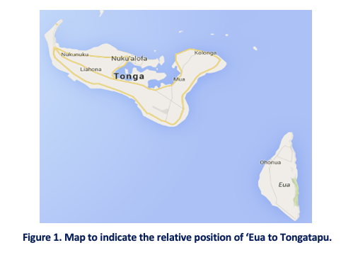
Since 2020, ‘Eua’s communities have been the recipients of projects to enhance water security delivered by: Mainstreaming of Rural Development Innovation Tonga Trust (MORDI), Live and Learn Environmental Education (Live and Learn), Tonga’s Ministry of Meteorology, Information, Disaster Management, Environment, Climate Change and Communications (MEIDECC), and Sione’s Foundation. MORDI, Live and Learn, and MEIDECC’s projects focused on household rainwater catchment systems, while Sione’s Foundation improved the performance of the treatment plant for the reticulated network.

Water sources on ‘Eua typically differ by use. Drinking water is primarily drawn from tanks connected to household roof catchments, while water for other uses is primarily drawn from the reticulated supply. This division is typical of communities across Tonga. However, while most Tongan communities rely on groundwater for reticulated supplies, ‘Eua’s reticulated network utilises a combination of surface water and groundwater (being one of the few Tongan islands with access to fresh surface water). As such, unlike most reticulated supplied in Tonga, ‘Eua’s supply is not impacted by high salinity.

MORDI is a key NGO contributing to community development in Tonga. Supporting community-driven development, the cornerstone of MORDI’s approach is Community Development Plans (CDPs). These plans identify priority areas for community development and the related opportunities and barriers. Developed with each community through participatory processes, priorities are negotiated first within each community’s demographic groups (women, men, youth) and then as a whole community. These processes ensure that these plans are representative of the community.

The Research
This research aimed to assess the impacts and effectiveness of MORDI’s 2020 ‘Eua water resilience project and associated work undertaken by Live and Learns, and MEIDECC, and to identify strengths and limitations of the approaches taken by these agencies with reference to progress towards SDG6 on ‘Eua. Actionable recommendations to consolidate gains and strengthen future approaches were then developed.

Prioritising the views of community members, CDPs were used as a key source of information. Progress towards water improvement on ‘Eua was measured by comparing ‘Eua’s 2019 CDPs (developed prior to water project implementation) and ‘Eua’s 2025 CDPs (developed post water project implementation). These CDP findings were then supported and further contextualised through semi-structured interviews with community members, local implementers, and key public service personnel from health, government and utilities.

Findings
Changes to the position of water within the development priorities of ‘Eua’s communities from 2019 to 2025 are shown in Tables 1 and 2. Table 1 shows the change in the prioritisation of water in the CDPs as set by each demographic group in ‘Eua’s 15 communities, while Table 2 shows the change in the prioritisation of water in the final CDP for each community.
Table 1. The changes in the prioritisation of water within community priorities as set by each demographic group in each community in ‘Eua.

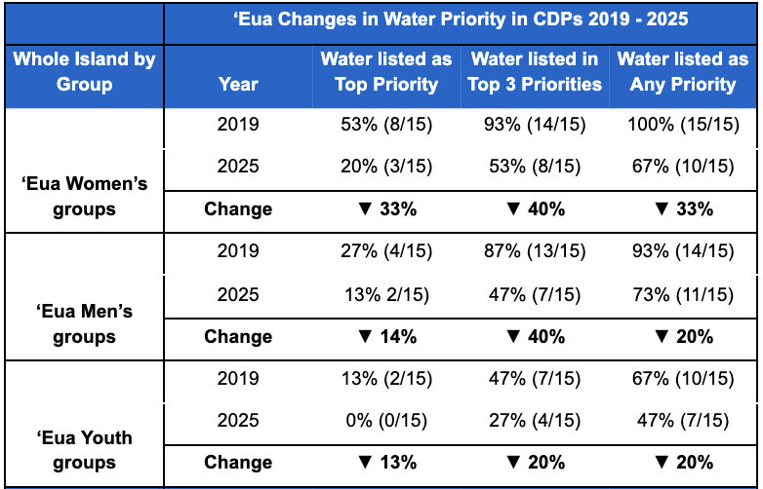
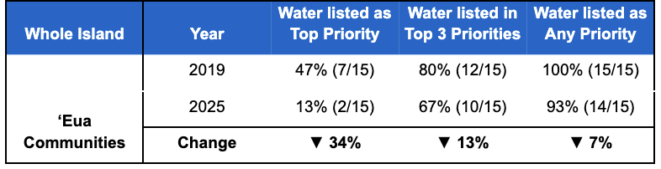
Table 2. The changes in the prioritisation of water in the final CDP for each community.

These results demonstrate clear progress towards addressing water issues in ‘Eua’s communities. However, water’s continued presence within priorities highlights that further work is required to achieve water security in line with SDG6. CDP comments along with interview responses identified the following key gaps and opportunities.

Gaps and Opportunities
Water Safety
Aligned with SDG6, the goal of MORDI’s project, and indeed all water projects across Tonga is to support the provision of safe water. To date, physical resource delivery at the household level (tanks, gutters, tank stands) has been the focus of water security projects. Less focus has been given to ensuring the safety of these water supplies.

Lack of attention to water safety is highlighted by an Asian Development Bank (ADB) study. Their Village Water Committee Pilot Report identified bacterial contamination, using E.coli as an indicator, in rainwater tanks to be alarmingly high in 2023. While this report only measured tanks on Tongatapu, Tonga Public Health (TPH) assert that these findings can be extrapolated across Tonga. ADB and TPH attribute these high levels of contamination to declines in water safety practices, such as cleaning of water systems (tanks and gutters), TPH suggesting that the reduction in waterborne disease outbreaks across Tonga (the last occurring in 2015) has led to complacency.

While MORDI and Live and Learn have delivered maintenance training as part of implementation, limited on-going training and support has reduced long-term effectiveness. Tonga Public Health identified health literacy as a key limitation, suggesting that while many community members are aware of recommendations for water system maintenance, and to boil water for children and elderly people, understanding of the importance of these measures and their impact is lacking. External support (training, and community tank maintenance) is limited due to lack of resourcing for Tonga Public Health.

Sustainability
For long-term effectiveness, interventions need to focus on capacity development to support self-sufficiency. MORDI recognises this, intentionally building community ownership in projects through co-design, co-payment, and by working in partnership with town officers and Village Water Committees (VWCs). However, increased focus on developing sustainable systems may better support communities to provide regular training and continue to support improved water access. For example, supporting the development of reliable supply systems between ‘Eua’s communities and suppliers in Tongatapu may help to overcome barriers to accessing repair materials.

VWCs are a valuable, yet under-utilised resource for ‘Eua’s communities. Collaboration between VWCs, Tonga Water Board and TPH is a key opportunity. With targeted capacity building and resourcing, VWCs could effectively address many of the identified community-level training and routine maintenance gaps. However, lack of engagement from VWC members is a key limitation, It is likely that increasing engagement and output will require meaningful incentives.

A further finding identified through our research was that the use of disaster response assets (such as The Tonga National Youth Congress tank cleaning) during peacetime needs to be carefully considered and well communicated to ensure it does not disincentivise the development of sustainable approaches to routine maintenance.

Equity
Equity appeared to be a strength of water projects delivered on ‘Eua, supported by implementer’s adherence to strict inclusion criteria that prioritised the most in-need households. However, further focus on the inclusion of women is recognised as an opportunity. Their typical role in the household results in increased awareness of water supply issues and increased availability during times of water system malfunction. Targeted capacity building for women is likely to support greater maintenance and sustainability of systems.

Systems thinking
While CDPs identified that additional water tanks are still required on ‘Eua, a notable finding was that many reports of insufficient tanks reflect a growing desire for households to have more than one tank to increase resilience to droughts. This is indicative of the low trust communities have in the improved water treatment plant. This distrust highlights weak coordination between Tonga Water Board and other public services involved in Tonga’s water system.

Systems thinking is essential to resilient water development (resilient to weather events and disasters). Water resilience on ‘Eua is supported by capacity across the water system (reticulated supply, household catchments, and community facility catchments). However, for these systems to effectively increase perceived water security, widespread understanding of water source capacities and trust in those sources is essential.

Data and evaluation
Overall, there is a lack of data to track progress toward water security in Tonga. MORDI’s commitment to evaluating and reporting on projects is a move towards addressing this gap. However, expanding the breadth of reporting beyond implementation assessment to measure long-term impacts on elements of SDG6 (e.g. water security and quality) will enable greater identification of remaining gaps and opportunities for implementation improvement. To ensure these findings are representative of community perspectives, going forward, CDP analysis should be included as one of these measures.

Lack or insufficiency of interagency data sharing was a key finding of this research. Greater data sharing would enable implementers to assess overall progress towards key targets, and support aid efficiency. Development of digital infrastructure to support this data sharing needs to be a priority action area for the Government of Tonga. In the interim, increased effort by implementers to share data including; project evaluations, community plans, and implementation data is required.

Recommendations
A range of recommendations have been made to MORDI with a view of maximising the benefits of both existing and future initiatives. These include:

- Ensure that projects aiming to improve water access have an explicit focus on practices supporting safe drinking water alongside the delivery of physical resources.
- Public health education to support system maintenance and water safety practices in communities (including the chlorination of community supplies) is currently challenged by limited capacity in Tonga Public Health. Explore how Village Water Committees may be supported to address this gap.

- Investigate ways to improve the frequency of bacterial water testing of ‘Eua’s water tanks (household and community), to assess water contamination. Better data in this area would both characterise the scale of the public health issue and serve as a valuable resource for VWCs, and TPH, to motivate safe water practices.

- Encourage mutual support between Village Water Committees. Explore how collaboration between committees may be facilitated to encourage knowledge sharing and greater engagement, and ultimately strengthen capacity.

- Continue to support and develop the use of Community Development Plans (CDPs). This research demonstrated the utility of CDPs for research and evaluation. Developed through inclusive co-design processes, CDPs are a representative reflection of community priorities and perspectives. Therefore, to support community-centred development, organisations should be encouraged to utilise these plans for project evaluation, and development research.

Limitations and Further Research
Due to a lack of research to evaluate water projects in Tonga and specifically on ‘Eua, this research took a broad focus, identifying gaps and opportunities across the water sector. Future research should focus on assessing and refining solutions to these more specific gaps and opportunities to improve approaches to water development.

Importantly this research was based in ‘Eua, centred around their water system and the development priorities of their communities. While it seems likely that findings will be relevant across Tonga, further research to delineate those findings that are specific to ‘Eua’s context is encouraged.

Specifically three areas have been identified for further research:

- Water conservation is an emerging topic on ‘Eua as water becomes more available. Current water use data indicates that significant volumes are being drawn from the reticulated supply. Analysis of water usage is encouraged. This should include comparisons of household meters and water plant output to indicate whether this volume is linked to true household use or network loss, enabling appropriate remediation steps to be determined.

- Currently, lack of interagency data sharing limits aid efficiency. Research to support the development of effective digital infrastructure, and processes to enable greater data sharing and shared insights, would contribute to more effective, coordinated efforts towards SDG6 in Tonga.

- CDPs have significant capacity as a source of data for community-based research. CDPs from other Islands should be assessed to understand how water projects have impacted SDG6 priorities in other Tongan contexts.

References
Asian Development Bank. Village Water Committee Pilot Report. (2023).
Clarke, M., Feeny, S., & Donnelly, J. (2014). Water, sanitation and hygiene interventions in the Pacific: Defining, assessing and improving ‘Sustainability’. European Journal of Development Research, 26(5), 692–706. DOI:10.1057/ejdr.2013.67
Haak, E., & Nakamura, N. (2021). Perceptions of local community members towards foreign aid: A case study of Vava'u, Tonga. New Zealand Geographer, 77(1), 32–41. DOI:10.1111/nzg.12284
Howard, G., Bartram, J., Williams, A., Overbo, A., Fuente, D., & Geere, J. (2020). Domestic water quantity, service level and health World Health Organization. Retrieved from http://eprints.whiterose.ac.uk/170082
Mainstreaming Of Rural Development and Innovation. (2020). The project to enhance disaster preparedness for water security - project completion report. Retrieved from https://www.morditonga.to/wp-content/uploads/29-_Eua-Island_Water-Tank-Project-Completion-Report.pdf
McNamara, K. E., Clissold, R., Westoby, R., Piggott-McKellar, A. E., Kumar, R., Clarke, T., Nunn, P. D. (2020). An assessment of community-based adaptation initiatives in the Pacific Islands. Nature Climate Change, 10(7), 628–639. DOI:10.1038/s41558-020-0813-1
Sione's Foundation. (2023). 'Eua water quality improvement project. Retrieved from https://sionesfoundation.com.au/case-study-eua-water/
The Government of Tonga. (2024). Tonga water sector plan: Ensuring a resilient and water secure Tonga. (draft)
United Nations. (2024). SDG 6 Snapshot in Tonga. Available from: https://www.sdg6data.org/en/country-or-area/Tonga#anchor_6.1.1 [Accessed 10 May 2025]
ANNEX 1
Prior to the research commencing, this research was self-assessed as low risk using the Massey University Human Ethics Committee checklist and evaluated by peer review. The MUHEC were notified about the project (Massey University Ethics Notification Number 4000030317). The author of this report is responsible for the ethical conduct of this research, which was conducted in accordance with the principles of privacy, informed consent and harm avoidance.
If you have any concerns about the ethical conduct of this research that you want to raise with someone other than the researcher, please contact Massey University Human Ethics by email: humanethics@massey.ac.nz.

