Rokoduru, Avelina| Doctor of Philosophy (Māori, Pacific & Indigenous Studies) University of Otago| Ōtākou Whakaihu Waka

“Masculinities and Gender-based Violence (GBV) in Fiji: The Perceptions of iTaukei (indigenous Fijian) Men”

Summary: Gender-based violence (GBV) is an ongoing global development issue of the 21st century. Fiji recorded exceptionally high rates of GBV; trends continue unabated; male spouses and partners identified as main perpetrators. Using a feminist, human rights, and law approach, a national multistakeholder response by government guides programs and projects. This study explores perceptions of indigenous (iTaukei) men and their engagement with GBV and the national response. It reveals the need for men-inclusive responses which consider socialization impacts of indigenous institutions as well as understanding of masculinities. This policy brief highlights key study messages regarding the national response status, an institutional basis of GBV infliction and data needs for combined programs for victims, perpetrators, collectives, and their relationships.

- Review of Fiji National GBV Response: Fiji has a comprehensive response strategy that includes laws, policies, and directives (MOWCPA, 2024:8) and regular reporting at the United Nations. However, in April 2025, these were declared ineffective by Fiji’s Prime Minister Sitiveni Rabuka and the Minister for Women, Sashi Kiran after the death of 3 more women in a single weekend. The national response does not actively engage with iTaukei men – an obstacle to prevention and rehabilitation. There is urgent need to review the effectiveness of Fiji’s national GBV response, i.e. its approach, focus, targeted populations, activities targeting GBV perpetrators and intended final outcomes for intimate partner relationships (IPR), families, collectives, and the country;

- iTaukei Marriage Institution as Enabler of Intimate Partner Violence: Violence inflicted by iTaukei men upon their intimate women spouses or partners occurs under many contexts. Framings and expectations articulated at iTaukei weddings and applied within iTaukei marriages thereafter are enablers of violence.

- Generating Evidence for GBV Perpetrator Profiling: Accessible de-identified data for Fiji men and especially iTaukei men GBV perpetrators and their service needs are scarce. Available data raises questions about definitions, quality, completeness and consequently hinder meaningful analysis for policy change. A national GBV response which develops, gathers, and uses data for everyone affected, i.e. victims, survivors, perpetrators, and all relationships affected, is required for Fiji.

What is the development issue? Background Gender-based violence (GBV) is a global development issue, with breaches of human and women’s rights posing serious political, socio-economic, and public health challenges. Its destructive and damaging consequences are costly and long-lasting. Despite four decades of national, regional and international response, and the Republic of Fiji being recognized as a global leader in condemning violence (MOWCPA, 2024:30), GBV continues unabated in Fiji.
Fiji has one of the highest rates of GBV. For example, the country’s average prevalence rates in the lifetime for the years 2000 to 2018 was 51% higher than the global average of 27% and for Least Developed Countries (LDCs) at 37% (WHO, 2021). The Fiji GBV study 2010/2011 found that more than 72% of 3035 women participants experienced one form of physical, emotional and or sexual violence at the hands of spouses or partners (FWCC, 2013:5). More than 3 of every 5 women (61%) were subjected to physical violence (Table 1); 1 of every 3 women (34%) subjected to sexual violence (Graph 1a) and 3 of every 5 women, emotional violence (Ibid).

Table 1: Fiji Police: Crime Against Women, 2015 – 2021*
Source: Adapted from Fiji Police Criminal Statistics Reports (2019:38) and (2021:63). *No disaggregated data showing sex of perpetrator committing the crime as yet.

Fiji’s GBV national response is coordinated by the Ministry of Women, Children and Poverty Alleviation (MOWCPA) in partnership with other ministries and development partners. Total foreign aid for GBV in Fiji since 2016 to next year, 2026 is estimated to be FJD$140.4millions (NZD$106.1m) through assistance from Australia, New Zealand, the European Union, World Bank and the Asian Development Bank. Laws and policies governing the national response include, the Employment Relations Act (2007), Crimes Act (2009), Criminal Procedures Act (2009), Domestic Violence Act (2009) – includes the Domestic Violence Restraining Orders (DVRO); and the Family Law Amendment Act (2012) – MOWCPA, (2024:8). Policies and directives include the Fiji Police Force (FPF) “No Drop” policy (1995) and the Chief Magistrate’s 2018 directive opposing use of Bulubulu (iTaukei traditional reconciliation) to determine sentencing for VAWG-related crimes (Ibid).

Graph 1a: Sexual Violence Perpetrators 2019 2024
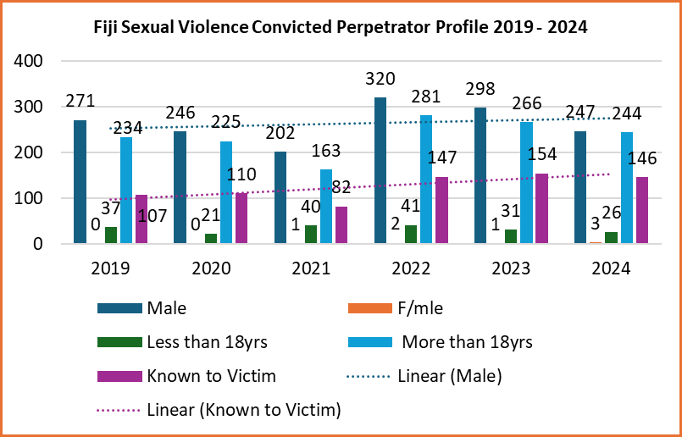Source: Adapted from Fiji Office of the Director of Public Prosecutions (ODPP), Media Releases 2020 – 2025.

Research
Titled, “Masculinities and Gender-based Violence in Fiji - the Perceptions of i-Taukei (indigenous Fijian) Men”, this qualitative study explores perceptions, understandings and lived experiences of iTaukei men’s engagement with the knowledge of gender and GBV in their IPR. The study draws on social constructionism (Burger and Luckmann, 1967; Burr, 2003). Its tennets assert that realities are collectively constructed through social processes and interactions (Ibid). An approach using the iTaukei social relationships institution of Veiwekani was used to further explore ‘veiwekani ni veiwatini’ - intimate partner relations (IPR). This was to establish ‘vu’ (origins) and ‘na yaga’ (purpose) for violence use from an iTaukei man’s perspective. Thematic and narrative analyses methods (McAllum, et. al., 2019) were used to engage recurring themes, views, ideas and experiences of iTaukei male realities in engaging with GBV (Braun, et. al., 2017). Study participants included: 31 iTaukei men; Method: 3 focus group discussions; 15 in-depth interviews and 5 informal interviews. The participants’ ages ranged from 22 – 79 years. All are Christians and had acquired tertiary-level education. They either worked, had retired or lived within the research location. The fieldwork took place from November 2023 to July 2024 in Lami, Suva to Nausori corridor, Fiji. Ethical approvals: provided by Fiji Min. of iTaukei Affairs, and the Uni. of Otago Ethics Committee (Ref. Code: 23/128).
Key Research Question: Why do iTaukei men inflict GBV on women in Fiji? Four sub-questions: 1) What are indigenous male understandings, knowledge and lived realities of ‘gender’ and ‘gender-based violence’ as words, ideas and ways of life or approaches, especially in IPR)? 2) What forms of IPV do they inflict and why? 3) In what ways do iTaukei men engage with GBV? Are these addressed in the national GBV response? 4) From these perspectives and lived experiences, what are some ways to address iTaukei male violence against women?

Brief Literary Context
The Fiji national GBV response since 1984 has targeted women and girls as victims/survivors. The same applies for Fiji GBV studies; for example FWCC, (2013); FWRM, (2016); George, (2016); Newland, (2016); Mannell, et, al., (2022), and reports, example. MOWCPA, (2023); WHO, (2021); Erikson, et., al, (2019); World Bank, (2016); ADB, (2016).
Women and girls experience GBV in Fiji because of patriarchy (MOWCPA, (2024:14). Evidence on Fiji’s male perpetrators (Adinkrah, 1999; 2003; 2021) and their female counterparts (Ibid, 2000) link poverty, urbanisation, unemployment, and patriarchy to homicides (ibid). In the Pacific, example Papua New Guinea (PNG) and Fiji, male masculinities have been repeatedly implicated in abuse and violence discourses without their active voice (example. FWCC, (2013) study). There is a dearth of studies on perpetrators of GBV in Fiji (Mannell, et. al., (2022); Adinkrah, (2022), Presterudstuen, (2019), and especially on iTaukei males (Masta, 2020).
In 2015, the estimated economic cost of GBV to Fiji was FJD$290million or 7% of Gross Domestic Product (GDP) – Movono, (2017). Direct costs of GBV for ministries that address it i.e. the ministries of Justice, Home Affairs, Health, Women and Education, have never been established or published. Stark implications for cost gaps become evident if, as forecast, 15,725 women will experience GBV-related injuries annually (of whom 10,733 will have their eardrums broken or eyes injured), and 5,678 women will need health care for injuries annually (FWCC, 2013:14). More than half (55%) indicated children witnessing the violence (Ibid). This latter finding has long-lasting social and economic costs for families, collectives, government, and Fiji. Fifteen years after the last national study (the FWCC 2013 one), there is need to conduct another one to assess behaviour change, to evaluate the effectiveness of Fiji’s GBV national response since its 1984 origins.

Key findings
Review of Fiji National GBV Response
Even though not labelled as such, domestic and IPV appear in the annuls of Fijian history (Brewster, 1922). Fiji’s lead advocate’s public admission that the national GBV response was ineffective in 2020 raised doubts. Despite four decades of national, regional and international response, GBV especially in the form of intimate partner violence (IPV), is regularly reported to date, 2025 and motivated this PhD thesis. Colonial institutional legacies have stifled the national GBV response because: “gender advocates working to eliminate gender violence in Fiji navigate a difficult path…they do so in an environment constrained by militarism, state authoritarianism and communal division”, George (in, Biersack, et. al., 2016:81)

Why? iTaukei Male Understanding of Gender & GBV
With their introduction as words, concepts and approaches in the early 1980s, iTaukei men view gender and GBV as new and recent knowledge within IPR because; a) there are no parallel words or phrases in the iTaukei language; individuals have constructed their own understanding and engagement with these terms for 41 years; b) gender as a word, idea and approach is neither well regarded nor received by the study participants. The chronological physiological sex binaries of “yalewa/tagane” girl/boy and “marama/turaga” woman/man inform iTaukei culture and identity. Male and female gender labels refer to the same biological sex binaries in Fiji. Participants demanded clarity on this; others felt their lives being monitored under the gender approach. Some questioned the conflicting definitions and values of gender and GBV against their understanding of being men with specific responsibilities in IPR.
“What do gender roles look like? What even is the indigenous term for gender (sic)?” – Participant 25, In-depth Interview, 05 Feb.,2024.

“…(T)hat question is a bit of a challenge to us, iTaukei. Because for us, there really are just two…just male or female. The sex…for us it’s the sex, eh? So gender for males and females...it’s more on the sex…So it’s either male or female” – Participant 22, In-depth Interview, 15/12/23.

” I don’t like this word ‘gender’. I just close up when I hear that word. To me it’s a blame game. It accuses me…that I’m not doing enough for my family, my work and my community [sic]” - Participant 32, Informal discussion, 14/12/23.
“What is gender to us? We place more emphasis on relationships between men and women; how to maintain those relationships. To us, it’s all about how we live as a couple, raise our family in a community. Its more about knowing your place, position; the responsibilities that come with that” - FGD 1, Retired Teachers, 16 Nov 2023.
In the context of IPR, iTaukei men engaged through 3 framings, i) gender and GBV viewed as rejected knowledge – a framing where there is lack of consultations concerning the gender and GBV discourses with and in the Vanua and males prior to their introduction; the national response lacks male voice; violence is normal part of life; participants see the continuation of current status quo and the introduction of men’s rights; ii), gender and GBV is passive assimilated knowledge – the stance is adopted by iTaukei male GBV service providers; there is on-going consultations and initiatives within government and all development partners and communities to address GBV; there is recognition that men’s voices are not heard in the national response; violence is no longer normal; there is need to educate and change iTaukei mindset on masculinity, power and violence; and, iii) gender and GBV is negotiated knowledge – it is assumed that everyone knows and agrees with their discourses; there is lack of consultation with males about them; violence is no longer normal, individual iTaukei men use personal research, knowledge and experience to negotiate engagement with GBV in private and public spaces. Even though professionally qualified, most of the male participants (18) rejected gender and GBV as new knowledge as these are not part of iTaukei culture; they viewed the introduction of gender and GBV laws via decrees (example Domestic Violence Decree (2010) unfavourably, as being enforced upon them; that iTaukei men were not included in the initial consultation processes prior to their formalisation as laws and policies and, the lack of male representation in the national response;
“From a development perspective…we are patriarchal society, and the voices of women traditionally are not heard. So… planning implementation (projects) has had to focus more on women and what needs to be given them, but along the way, we've lost or forgotten to keep men on the journey as well, and now we're struggling to go back to get them on the journey” – Participant 28, In-depth Interview. 28 Jul. 2024.
The iTaukei men in this study are disconnected from the GBV national response. Similar to Shamima Ali in 2020, Fiji’s Prime Minister Sitiveni Rabuka, and the Minister for Women, Children and Poverty Alleviation (MOWCPA), Sashi Kiran, both declared the national response ineffective after the death of three more women to GBV at the hands of their spouses or partners in the last week of April 2025 (Rabonu, 2025). Fifty-four women died from GBV between 2013 and November 2024 (Ali, 2024), now at 57 at the end of April 2025. A national GBV response with a feminist approach which focuses on rehabilitation and agency of women and girls as victims and survivors at an individual level and uses national policies as enablers is not only ineffective, but also costly to individuals, collectives, and the country.

Generating Evidence for GBV Perpetrator Profiling
Accessible de-identified data for Fiji men and especially iTaukei men GBV perpetrators is scarce. Fiji Bureau of Statistics data does not include perpetrators. Available data prevents meaningful analyses. A national GBV response which develops, gathers and uses data for everyone affected, i.e. victims, survivors and perpetrators – is required for Fiji. For example. Graph 1, show numbers of VAW events without the relationships between victims and offenders or the latter’s sex. These omissions weaken analyses.
Graph1: Sexual Violence Types Reported, 2019 – 2024*
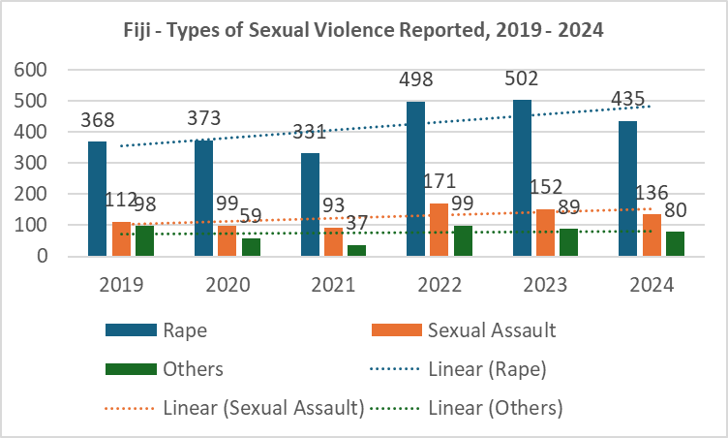Source: Adapted from ODPP Media Releases 2020-2025. *Data not disaggregated to show sex or other data about perpetrators.

Using the term ‘gender’ to identify offenders in the FPF reports requires clear definitions whether they refer to the biological binaries of boy/man and girl/woman or their social roles (Lindqvist, 2023). Male GBV perpetrator data while insufficient is publicly available from only two sources – FPF (Table 2), and the Office of the Director of Public Prosecutions (ODPP).

Table 2: Fiji Offenders Age & Ethnicity, 2016 – 2020*
Source: Fiji Police Force, 2021, Crime Statistics Annual Report, 2020:63. *Sex and perpetrator crime not provided together in report.

This included information such as numbers incarcerated according to ‘gender’, crime types, age cohorts, religion and division each came from. The available data raises questions about definitions, quality, completeness. They hinder meaningful analysis and interpretation for policy change. For example in 2019, 10 of the 13 women murdered (Table 1) were beaten to death by husbands or partners as ‘male sexual jealousy homicides’ in Fiji (Adinkrah, 2022). Fiji’s IPV perpetrators are male spouses and partners known to their victims (MOWCPA, 2023; WHO, 2021; FWCC, 2013) – Graph 1a.
There is little GBV perpetrator data coordination and centralisation between Fiji Islands Bureau of Statistics (FIBOS), the FPF, the Fiji Corrections Service, the Family Courts in Fiji, Legal Aid Fiji, the Social Welfare Department, the Office of the Director of Public Prosecution, and the Fiji Births, Marriages & Deaths Registration Office. There is inconsistency in data reporting from these institutions too.

iTaukei Marriage Institution as Enabler of IPV
The study found that framings of iTaukei marriages are enablers of violence in the context of Veiwekani (relationships), and ‘bula ni veiwatini’ (life of couples (sic) or IPR;
“At the tataunaki (the entrusting/ the handing over),
words such as; “we have raised our daughter to who and where she is. Today she leaves us and joins your family. If there have been shortcomings in our rearing of her, please forgive us. Please, continue with her learning as she is now part of your family, she is now your daughter,” are said” – Participant 24, In-depth Interview, 15/01/24.

Orations such as, “please forgive us, please continue with her learning as she is now part of your family, she is now your daughter”, is formal transfer of care for the bride to her husband and his family. These words are license to inflict violence for perceived errors i.e. as discipline or reprimand for “learning as she (bride) is now part of your (the husband’s) family” Errors are to be expected where differences exist between couples (incompatibilities). Conventional wisdom dictates that no human being is perfect so that errors are to be expected and accepted. This latter view is widely accepted as truth and reality for the Christian faith which most iTaukei belong to. However there is cognitive dissonance on this matter. Wives are reprimanded for their errors and incompatibilities verbally, physically, emotionally, psychologically, sexually or through combinations of them; especially if violence is the ‘language’ of instruction for both families. Secondly, the framings invite perpetual censorship of the wife’s actions and demeanour:
“Relationships within marriage are to be treasured;
both spouses have to work at it. GBV is caused by
many factors. The men are heads of their
households. But there are many incompatibilities
that can lead to violence. Example, we have women
who work, and their husbands stay home. Women
are well-educated and their husbands aren’t. Some
women come from renown families and their
husbands don’t. Some women earn higher than their
husbands. All these create difficulties. If couples
don’t talk to each other about them, what follows
are arguments and beatings” – FGD 2, Post-graduate
Students, Suva. 30 Nov 2023.

Thirdly, these discourses are well known and expected in such ceremonies; their absence or alteration brings shame to the bride’s families. The constructions of the iTaukei marriage institution have led to socialisation and conditioning of men and women towards hierarchical IPR which can lead to ‘merited’ violence. This explains why violence within iTaukei IPR is expected and accepted. Change in language in traditional oral presentations can alter those framings.

Implications
- The lack of voice and consultation with iTaukei traditional institutions, the continued practice of some nuptial protocols, a perception of the marriage institution as a GBV enabler, the unfavourable regard for gender and GBV as rejected knowledge, the participant’s acceptance of the status quo that violence is normal, the increasing GBV rates, women victims dying, and the national response declared ineffective since 2020, all suggest an urgent independent review of it;
- Fiji’s National Action Plan to Prevent All Violence Against Women and Girls, 2023 to 2028 (MOWCPA, 2024) wrongly assumes the acceptance of gender and GBV as words, ideas and approaches of doing IPR in Bula Vakavanua. The explanation that patriarchy and men’s hunger for power are causes of GBV in Fiji (Ibid, 14) is western in nature. No studies have been conducted in Fiji to inform that assumption and needs to be addressed;
- Civil Society Organisations may adopt a feminist approach to GBV. However, the same approach cannot drive a national GBV response. In Fiji’s case, it has prevented data collation to inform perpetrator-targeted policies, thus weakening the response. Government must prioritise public good, everyone’s needs and welfare, which is its usual mandate (social contract);
- This study has established that iTaukei male perceptions, understandings and lived experiences of masculinities, more than patriarchy are drivers of iTaukei men’s violence.

Limitations and Further Research
- Views of iTaukei men in urban, rural and remote villages and other areas outside Suva including those not tertiary-qualified and are unemployed are needed;
- For behaviour change, further studies are needed to inform the knowledge gaps about social constructions of iTaukei masculinities, femininities, socialisation, and conditioning on gender and GBV.

Reference
Braun V., Clarke V, and Gray, D, (2017), (Eds.), Collecting Qualitative Data: A Practical Guide to Textual, Media and Virtual Techniques, Cambridge University Press. DOI: DOI: 10.1017/9781107295094
Burr, V., (2003), Social Constructionism (2nd Edition), Routledge, London
Fiji Police Force, (2019 - 2021), Various Crime Statistics Annual Reports, FPF HQ, Suva, Fiji
Fiji Office of the Director of Public Prosecution, (2019 – 2024) Various Sexual Violence Media Releases, ODPP, Suva, Fiji
Fiji Women’s Crises Centre, (2013), Somebody’s Life; Everybody’s Business, FWCC, Suva
Masta, M., (2019), Pac. Masculinities: Understanding Men's Perspectives & Experiences on Masculinity in PNG & Fiji, RMIT University, Melbourne
Min. of Women, Children & Poverty Alleviation, (2024), National Action Plan to Prevent All Violence Against Women and Girls, 2023 to 2028, MOWCPA, Suva, Fiji
Rabonu, I., (2025), “Man Up and Stop Hitting Women: Rabuka”, Fiji Sun, Suva, Fiji. 30th April 2025 edition.

The Fiji Women’s Crises Centre (1984), the first ever non-government organisation (NGO) to address violence against women (VAW) in Fiji (Mishra, 2012) paved the way in raising national awareness about it.
GBV responses are ‘legal, therapeutic, behavioural, educational, and literacy-based interventions to "empower" them (victims/survivors) individually and through the courts and the criminal justice system’ – Murshid, (2023). Author’s inverted commas.
https://www.bnz.co.nz/personal-banking/international/foreign-exchange-calculator Accessed 15 Apr. 2025; 09.42am
Movono, L., (2017), ‘Gender Violence: We Pay $290M A Year’: https://www.fijitimes.com.fj/gender-violence-we-pay-290m-a-year/
The Fiji Women’s Crises Centre was established in 1984, the first ever non-government organisation (NGO) to address violence against women in Fiji (Mishra, 2012), paved the way in raising national awareness about it.

