Malathi Hansa Rambodagedara | Development Studies | Massey University

Summary:
- Sustainably managed and robust shared resource systems provide strong incentives for collective action, which in turn brings greater economic returns, improves well-being, and enhances community resilience in the face of climate adversity
- The size of a resource system does not determine the strength of collective action. What matters more is the condition of the system and the incentives it offers to the well-being of water users. When a shared resource system fails to deliver expected benefits for the water users, tensions grow, especially during times of water scarcity.
- Collective action of water users is often, but rather invisibly, shaped by power asymmetries, with influence clustered among those who hold greater authoritative resources that can negatively influence equitable resource sharing, collective action and community resilience.
- Given the evolving dynamics of the socio-ecological landscape of the Small Tank Cascade System in Sri Lanka, there is a need for pragmatic, context-sensitive, and forward-looking solutions in strengthening collective action and empowering local institutions to address diverse livelihoods and resource challenges associated with climate uncertainties.
- Water users have sustained the small tank-based socio-ecological systems for generations. As custodians of these shared resources, their voices must be meaningfully and equitably integrated into rehabilitation and development initiatives to ensure long-term resilience.
Cultivating Resilience: Collective Responses to Climate Challenges of Water-Dependent Agrarian Communities in Sri Lanka

What is the development issue?

Being an ancient hydraulic civilisation, Sri Lanka has a robust heritage of small-scale communal irrigation systems, which have been recognised as a Globally Important Agricultural Heritage System by the Food and Agriculture Organisation (FAO) of the United Nations. Small Tank Cascade Systems (STCSs) are complex socio-ecological systems (SES) that function as ideal water harvesting mechanisms that support local communities to pass through difficult times during extended dry periods and mitigate floods (Madduma Bandara, 2009). The unique characteristics of STCSs have contributed to socio-ecological resilience and have traditionally been sustained through local collective action (Ratnayake et al., 2021).

Historically, small tanks were nurtured by the village water users or local communities who made appropriate decisions that suited their livelihoods and needs. In the water-scarce dry zone in Sri Lanka, human existence is considered impossible without irrigation (Panabokke, 2009). Today, 14,421 small tanks remain in operation, supporting over 300,000 smallholder farmers and providing a significant contribution to national food security (Imbulana et al., 2023).

However, these historically successful, collectively managed irrigation systems are now under threat from increased climatic variability (Gunaratne et al., 2021), along with overarching issues of socio-economic and political tensions in the post-independence and post-conflict contexts (Bebermeier et al., 2023).

Long-term challenges such as climate change and resource scarcity require more than individual action alone; they demand collective, systematic responses (Nikolaou et al., 2020). As such, collective action is critical in confronting these prolonged socio-ecological challenges (Ardoin et al., 2023).
Therefore, the study aimed to understand the endurance of these shared resources and livelihood systems of dry zone Sri Lanka, using a local collective action lens. This research builds on collective action and critical institutionalism theories. Data were gathered through in-depth qualitative field research that focused on a comparative case study of two Small Tank Cascade Systems (STCSs) of Paluagaswewa and Bellankadawala that are situated in the Anuradhapura District in the Dry Zone of Sri Lanka.

Key findings

Climate change is intensifying pressures on resource-dependent livelihoods, positioning collective action as a key pathway to resilience

Climate variability was evident in both case study locations, intensifying pressures on resource-dependent livelihoods. Historically, typical monsoon rainfall patterns have structured the agricultural and water management practices of farmers in the dry zone. Alterations to these patterns have contributed to rising tensions among water users.

“ …Conventionally, the northeast monsoon brings rain around mid-October.. However, this rain pattern has gradually changed over the last decade. This year, until now, the absence of rainfall has prevented timely agricultural activities.”

Ratnadeepa, Palugaswewa STCS

“…If water is scarce, even if we need to cultivate, we discuss with farmers and go for the Bethma (share) cultivation system. We share our lands considering the water availability, with the feeling that we all need to eat rice…There are a few against such action, but we get their consent too and proceed with what the majority supports.”

Felix, water user, Bellankadawala STCS

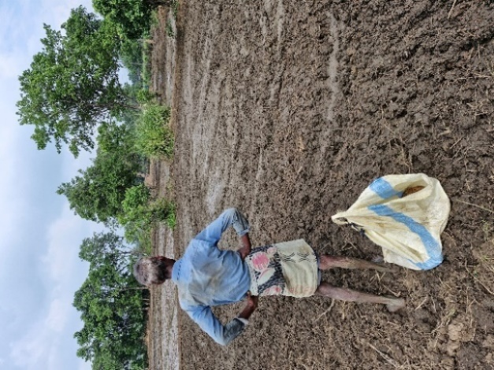

Figure 1. Resilience or fragility?: Water users need to consider many fronts before taking cultivation decisions when an extended dry period hits their shared resource systems and livelihoods

Climate resilience and collective action were among the key factors influencing the long-term sustainability of the STCSs in Sri Lanka. Resource-dependent farmers in both study areas collectively determined cultivation plans, which helped maintain consistency in resource allocation and cropping patterns amid uncertainty. This was well reflected in the last main cultivation season (Maha season in 2024/2025), when a shift in rain patterns caused shifting cultivation decisions and practices among many farmer groups in both case study locations.

Collective action is shaped by the interplay of socially embedded practices and formal institutional structures

My research revealed that the collective action of water users is deeply rooted in their long-standing relationships with shared resources and associated livelihood patterns. In the present context, farmer organisations play a decisive role in water management and governance at the grassroots level, providing water users with a collective, legitimate platform that is formally enforced by rules and regulations.

In times of water scarcity, formal and socially embedded institutional arrangements are merged, where appropriate, to promote equitable access and livelihood security.

Field research revealed that rules, regulations, and sanctions function as critical mechanisms for avoiding free-riding and sustaining collective action. With evolving dynamics of socio-environment relationships, these formal mechanisms have increasingly dominated collective action processes, albeit at the expense of traditional socially embedded values.

”…Nowadays, rules and regulations guide the actions, but in the past, strong kinship ties played a major role. Humanity was superior to rules. People worked together in harmony to make collective decisions about tank maintenance. If they agreed on a day to work, they simply did it. Now everything is dictated by formal rules…”

Ratnadeepa, water user, Palugaswewa STCS

Incentives from shared resource systems drive collective action

Water users' involvement in collective action is largely shaped by the incentives associated with shared resource systems and being a member of the farmer organisation. The good condition of the irrigation commons and associated resource system brings notable incentives for collective action among water users, which in turn brings substantial benefits and economic returns. These include, for example, securing sufficient water for rice cultivation in extended drought periods, strengthening the capacity of water users to cope with climate-related uncertainties and risks, which enables them to have a reasonable income. This is well evident in Palugaswewa STCS when compared to Bellankadawala STCS.

“…Our tank plays a fundamental role in supporting our cultivation efforts. It serves as the main tank in our small tank cascade system. Water fills it rapidly… we think it's really a blessing... The tank includes essential components of the tank ecosystem. All these are actively maintained by the farmer organisation.”

Ratnadeepa, water user, Palugaswewa STCS

Figure 2. Good Old Days: An illustration of a traditional tank-based resource system from many decades ago, showing a tightly knit community with common livelihoods and shared resources (Drawing by Nimal Karunaratne, a resource user of Bellankadawala STCS)

In two case studies, the size of a resource system had no connection with how collective action works. If the resource system is deteriorated, not giving incentives as expected, and not maintained properly, there is more tension in coping with water scarcities during the extended drought periods, which leads to collective action dilemmas over sharing limited resources. The long-term neglect of some irrigation tanks has created numerous collective action dilemmas in Bellankadawala STCS when compared to Palugaswewa STCS, which are generally well-maintained.

“….The primary obstacle is that the tank is never rehabilitated….No one takes responsibility for its upkeep.. As there was no renovation, farmers do whatever they prefer. This is what has happened. In previous seasons, the water controller was active and engaged, but this season, he lacks enthusiasm, because this tank will not be renovated. Then, the challenges he is expected to deal with have only intensified…”

Bradhra, water user, Bellankadawala STCS.

Water users who share similar livelihood patterns, social values, and common interests demonstrate stronger collective action that fosters resilience

In the two case study communities, I observed stronger collective action among groups where water users shared similar livelihoods and social norms.

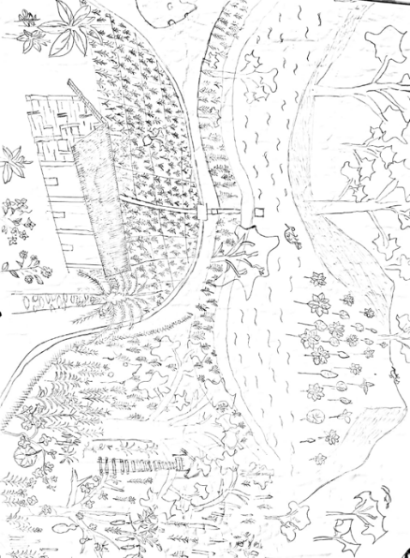

Where water user groups were more socially and economically diverse, maintaining cohesion was more complex. Differences in income, land access, or livelihood priorities can create tensions or reduce incentives to engage in collective efforts. This highlights the importance of inclusive institutions, leadership and shared decision-making that foster better collective action, hence supporting the resilience of the communities.
Inequalities and power asymmetries pose significant barriers

Collective action of water users is often, but rather invisibly, shaped by power asymmetries, with influence clustered among those who hold greater authoritative resources such as wealth, strong kinship ties, networks and formal official positions within the farmer organisation. These advantages enable those who have more power to steer collective efforts in ways that may not always reflect the broader interests of the community, thereby undermining collective action, inclusive participation and equitable resource sharing. This was evident in both case study locations in different shapes, despite the conditions of their shared resource systems.

“…Unlike traditional society, kinship bonds have been loosening. Now, no such attitudes of togetherness and conflicts have emerged in the village setting. Even in the farmer organisation, only a certain group of people get the benefits”

Ranatunga, water user, Paluagaswewa STCS

However, there are limited voices against the misconduct of more powerful groups, and resistance efforts often remain weak. In particular, marginalised groups such as tenant farmers and those with weaker community ties and social networks often find themselves voiceless and unheard.

“….No one talks against the persons involved in the misconduct. When I ask them to be against him, others say, Mind your own business… I am just a tenant farmer. If I talk against this, I won’t get a field to cultivate next time…. “

Darmasiri, water user, Bellankadawala STCS

Effective development interventions can be instrumental in fostering collective action and improving resilience to emerging uncertainties

Unlike in the past, the expansion of the needs of a growing population and boundaries of shared resource systems has made it increasingly difficult for water users to manage resources on their own. In this context, development interventions can play a crucial role. Palugaswewa, STCS, and water users scattered throughout the area have been supported by the long-term and inclusive Climate Resilient Integrated Water Management Project (CRIWMP), alongside usual government development efforts and other occasionally funded projects. This comprehensive support has enabled water users in Palugaswewa STCS to foster collective action and strengthen their resilience to climate challenges.

“…This project connected with a good concept...It supports storing more water in our irrigation tanks through rehabilitation, and now we can cultivate both cropping seasons. ”

Saliya, Palugaswewa STCS

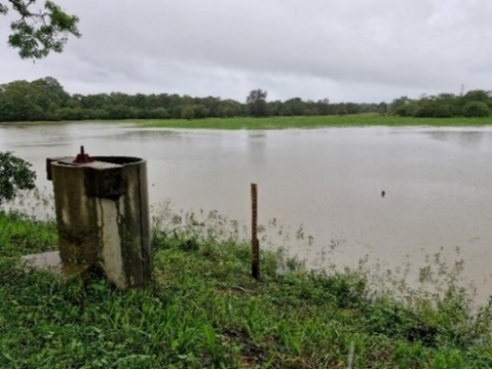

Figure 3. If the shared resource system is healthy, livelihood is less risky for water users: Well-functioning Palugaswewa Mahawewa (an irrigation tank)

In contrast, in Bellankadawala STCS, where such inclusive development interventions have not been implemented, collective action and farmer resilience tend to be comparatively weaker. Some small tanks haven’t been restored for a long period, despite some of their surrounding tanks being restored occasionally. STCSs are integrated socio-ecological systems; the lack of systems thinking in rehabilitation efforts in Bellankadawala STCS poses a significant constraint to long-term resilience building.

Deteriorated conditions of the resource systems create tension in the extended drought periods, along with other long-overdue issues. Water users feel frustrated and ignored as their needs are frequently overlooked in development efforts (maybe because of the limited resources), despite the continued demand of water users for inclusive rehabilitation that supports them to enhance their livelihood security in Bellankadawala STCS.
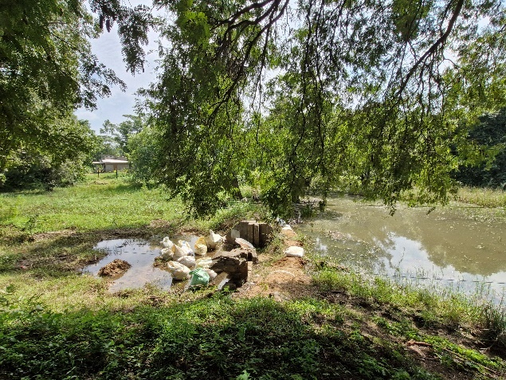

Figure 4. This is what we can do: Broken tank structures of the Demunnewa irrigation Tank. The water users' temporarily preventing leakages using sandbags.

Implications and Recommendations

The traditional small tank-based socio-ecological system in Sri Lanka has undergone significant transformations, including shifts in physical boundaries, changes in key elements (such as surrounding forests and uplands), and a gradual transition from a predominantly agrarian base to a more diversified livelihood structure. These changes have altered the traditional form and functioning of the system, underscoring the need for context-sensitive, forward-looking approaches to enhance collective action, local institutions, and community resilience in the face of evolving socio-environmental interactions.
Figure 6. This is how our shared resource system has changed over this period and what it looks like now: a participatory map produced by the water users demonstrates why community voices are worth in development initiatives.

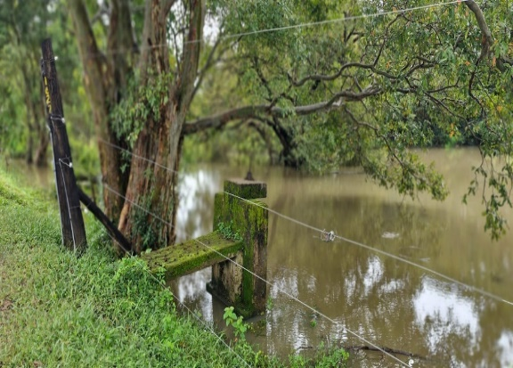

Figure 5. No more access beyond this point: Elephant fence and forest reserves are marked in places, indicating the changes in the shape of the traditional shared resource system.

Water users have sustained small tank-based socio-ecological systems for generations. As custodians of these shared resources, their voices must be meaningfully included in restoration and development efforts to facilitate the successful navigation of environmental and other uncertainties that affect their livelihoods. When their needs are properly identified and addressed, it can significantly strengthen their livelihood security, wellbeing, and community resilience at the broader level.

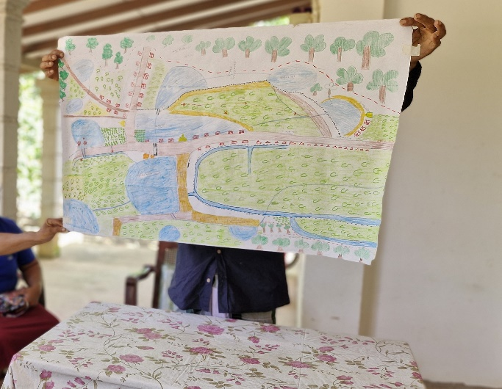

It is crucial to explore strategies that enhance the incentives for resource users' collective action in ways that balance the well-being of water users with the sustainability of the ecological systems they depend on. Strengthening this alignment not only encourages active participation in collective resource management but also ensures the long-term resilience of both communities and ecosystems.

With the expansion of shared commons over time and the increasing complexity of social and ecological challenges, farmer organisations need continuous support for routine maintenance, monitoring, and follow-up activities. This operational assistance must be coupled with meaningful collective participation of water users, building on local knowledge to develop effective resilience plans that address current and future system management challenges.

To ensure sustainable outcomes, there is a need to strengthen and expand the role of farmer organisations by combining both socially embedded and formal arrangements that support forward-looking collective action. This may include integrating innovative livelihood opportunities such as eco/agro-tourism, land consolidation, and farmers' corporations, while linking with broader economic sectors to promote income diversification. Strategic initiatives, however, must be designed inclusively and with a clear understanding of potential risks and mitigation strategies to reinforce socio-ecological wellbeing around the STCS and enhance long-term adaptive capacities.

Limitations

This study focused on collective action and institutional arrangements at the local level in water-dependent agrarian communities. However, the governance and management of STCS operate within a complex, polycentric system involving multiple institutions and actors. While this research offers insights into the grassroots-level collective action aspect, it does not fully capture the roles and interactions of all institutional layers. A more comprehensive analysis of the collective practices across different
institutions and farmer organisations would be crucial to deepen the understanding of collective action within the broader water resource governance landscape, including the collective action dilemmas that emerge at various levels in dealing with diverse uncertainties. This highlights a key limitation of the study.

Although this field study was limited to three months, the complex and deep-rooted nature of socio-ecological challenges requires a broader and more sustained engagement. Expanding the scope of research to capture these long-term dynamics would provide critical insights into commons-related challenges, collective action dynamics, and pathways to resilience. Such understanding is vital for informing inclusive and context-sensitive development planning and implementation.

The study captured the insights of two case study areas. Covering multiple case studies would provide broader insights for planning just, climate-resilient initiatives that foster collective action through local institutions and promote inclusive development.

Notes:
- Respondents' names have been anonymised and presented using pseudonyms
- All images are by the Author
References

Ardoin, N. M., Bowers, A. W., & Wheaton, M. (2023). Leveraging collective action and environmental literacy to address complex sustainability challenges. Ambio, 52(1), 30-44.
Bebermeier, W., Abeywardana, N., Susarina, M., & Schütt, B. (2023). Domestication of water: Management of water resources in the dry zone of Sri Lanka as living cultural heritage. Wiley Interdisciplinary Reviews: Water, e1642.
Gunaratne, M. S., Radin Firdaus, R., & Rathnasooriya, S. I. (2021). Climate change and food security in Sri Lanka: Towards food sovereignty. Humanities and Social Sciences Communications, 8(1).
Imbulana, U., Aheeyar, M., Amarasinghe, U. A., & Amarnath, G. (2023). Governance issues for sustainable management of village irrigation in the Dry Zone of Sri Lanka. International Water Management Institute.
Madduma Bandara, C. (2009). Village tank cascade systems of Sri Lanka: a traditional technology of water and drought management. Proceedings of the third annual workshop on disaster reduction hyperbase—Asian application (DRH-Asia), Tokyo, Japan,
Nikolaou, G., Neocleous, D., Christou, A., Kitta, E., & Katsoulas, N. (2020). Implementing sustainable irrigation in water-scarce regions under the impact of climate change. Agronomy, 10(8), 1120.
Panabokke, C. (2009). Small village tank systems of Sri Lanka: their evolution, setting, distribution, and essential functions. Hector Kobbekaduwa Agrarian Research and Training Institute.
Ratnayake, S. S., Kumar, L., Dharmasena, P. B., Kadupitiya, H. K., Kariyawasam, C. S., & Hunter, D. (2021). Sustainability of village tank cascade systems of Sri Lanka: exploring cascade anatomy and socio-ecological nexus for ecological restoration planning. Challenges, 12(2), 24.

