Ruveni Tuimavana | PhD Development Studies | Massey University

Exploring iTaukei resettlement in Fiji: The relationality of migration

Summary:
- Development has been discussed extensively amongst iTaukei population in Fiji. They have been labelled as resource-rich but cash-poor. However, there are some intricacies about land access, land use and land ownership that may affect the iTaukei villagers in rural areas and complicate understandings of development and migration.
- The iTaukei population in villages are complex and diverse as there are different layers of land use, access and identity that are embedded in the communities. In general, development agencies have adopted policies which mimic colonial and capitalist approaches to use iTaukei land ownership for economic exploitation.
- Government, through the Ministry of iTaukei Affairs (MTF), must be proactive in engaging villagers in development programmes that can still maintain and harmonise communal relations within which iTaukei identity and society is embedded.

What is the development issue?
Development has been actively discussed and pursued over the past century by the Fijian government especially in terms of the interests of Indigenous Fijians. However, the development programmes pursued have strongly mimicked the colonially created codification of iTaukei land ownership, which have been institutionalised in state agencies that were set up to look after the welfare of the indigenous population.

The pursuit of sustainable livelihoods and opportunities have led to demographic shifts amongst iTaukei dwellers in rural areas. For development partners and agencies, land access, use or ownership seems to be assumed outright for villagers. However, within these village social settings lie multiple layers of ownership, identity, land use, access, and rights that interface with the historical, colonial and cultural narratives that come into play in the day-to-day activities of the village. These have been overlooked by the dominant perspectives of development and understanding the different factors that come into play will not only enhance harmonious living but will give insights of how development partners and agencies can efficiently implement their programmes to ensure that no one is left behind in terms of economic activity and well-being and in approaches to resettlement.
There is a lack of data that captures the migrant villagers that have re-settled in other villages. Yet, these demographic data can be collated by the various Turaga ni Koro (Village headman), Mata ni Tikina (District representatives) and Valenivolavola ni Yasana (Provincial Office).
The focus of internal migration has been mainly on the rural-urban drift along with the perception that such movements have placed added pressure on resources in towns and cities. However, the intention of this study is to focus on cultural mobility that mostly occurs through kinship networks. This provides an opportunity to explain why these movements happen and how the migrants are accommodated along with the associated nuances that occur within the village culture.
In colonial Fiji, movement away from home villages was viewed by authorities with disdain or restricted: colonial administrators feared that migration out of villages would lead to disruption and conflict resulting from the possible breakdown of traditional chiefly authority and led to clashes with Indians and Europeans in the plantation sector. This colonial attitude continues to be reflected in some attitudes within Fijian society today. Those seeking opportunities elsewhere are generally castigated as running away from village obligations and this does not go well with the rest of the clan members as it involves giving up hope (soro).
In Fiji, movement is not always one-way as Fijians do maintain their social relationships across various points. Young (1985) concurs that movement can be classified as two types: 1) involves the change of residence and 2) individuals may return to their place of origin. It is the latter which provides a social safety net for many indigenous Fijians who engage in movements. Bedford (1988) noted the return migration to rural villages for those that lost their jobs due the military coup in 1987. Similar movements were noted when the COVID-19 closed the international borders resulting in thousands of job losses in the tourism and hospitality industry. Some returned to their villages as a way of coping and sustaining their livelihoods.
The study involves three villages in the Province of Cakaudrove on Vanua Levu (see map below). 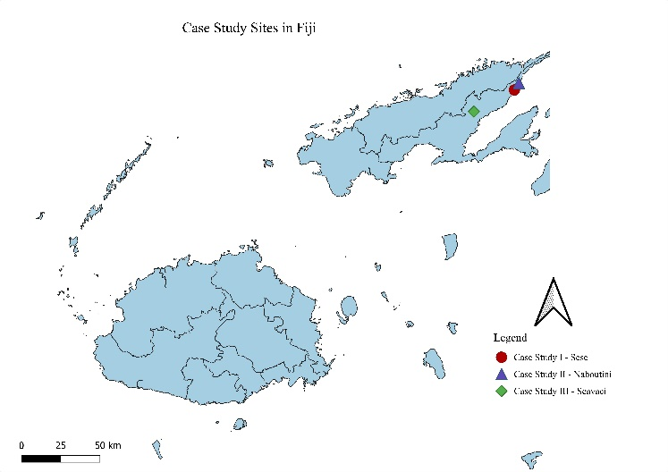
Figure 1: Case study sites in Fiji
Participants includes representatives from migrant villagers and their host communities from the three sites.

Key findings

The purpose of this study is to investigate the implications of bula vakavewekani (relational living) for re-settled iTaukei villagers in terms of identity, access, equity, land use, and social inclusion. It further examines how customary practices can contribute to a new way of framing development and wellbeing that can inform development practitioners, policy makers and (non) state actors in Fiji.
- The study highlights that development agencies continue to adopt the colonial codification of communal land with their policies and these in turn do not resemble traditional ways of living. The colonial codification that were developed were context-based and were relevant in the time it was meant for (Vaai, 2024).
- This fails to address the social and cultural processes that have been part and parcel of the rich tapestry of iTaukei society that have been built over centuries.
- The demographic population shift due to intermarriages, matrilocal obligations, traditional alliances, etc. that have occurred over time have also altered land access and use in some iTaukei communities that development agencies fail to recognise. Pre-colonial systems of land use were flexible and subject to change due to demographic shifts due to alliances, marriages and kinships and reflected in land holdings (Ward, 1987, 1994). However, the current system has not responded to these changes.

A village elder narrates how assistance or development projects have failed or leave the communities in a worse state than the intended goals of this assistance or projects.

Raica mada ga ‘o na veivu’e levu ni ‘fibre glass boat’ mai na’oro e la’o yane na veivu’e ni matanitu. Io qai la’o yane I matavura arai sa va’atoboicu na boto, sa leva tu na idini eh… ‘ani veiva’atoroca’eta’i to’a bau’o levu to’a na ’ena veivala- o cei me kavetani? ‘E kavetani o ‘a maqa o rawa e dua na i lavo, sa lai yaco, e na veidusi, na veiqati sa tu mai loma, wasea viroga na veiwe’ani arai na gauna e da sa ti’o ‘ina ‘o. E sau lailai na boto, e sau levu na veiwe’ani oya sa mai va’acacani.

There was an assistance of fibre glass boat in the village. However, today these boats are lined upside down on the front coast of the village and some of the engines are missing. This is a type of development that is not well thought out as there were already infighting amongst villagers of who should be the captain of these boats and there were accusations of previous financial discrepancies. These pointing of fingers have led to internal animosity, are divisive and have left the village in a far worse state than the intended aim. The cost of the boat is negligible in comparison to the damage it has done to the relationships within the village.

The village elder felt that the veivu’e (assistance) of the gifting of the fibre glass boat was worse than the intended goals. This raises the questions of the latent motive of veivu’e.
The Chairman of the Crime Prevention Committee for three districts of the Natewa West coast peninsula highlights the deficiencies of governing structures in policing for the three districts – Tawake, Saqani and Vaturova.

Eitou dabe mai Naboutini na matabose ni crime …. sa lewai mai vei Liuliu ni Tabana ni Ovisa ena Vuali’u me sa veisau na ‘ada’ada ni community policing, me sa zone-wise me rawarawa na ‘ena qaravi. Qai maqa vakadua ni cakacaka na ‘ena ‘ada’ada ‘arai. ‘Eitou qai raica lesu, qai tovola o Turaga ni Ovisa va’acegu mai Saqani community policing (zone-wise) e rawa ga mai iTauni se ‘oro va’avalagi. ‘o ‘eda na tu ‘o sa tu na na vanua da va’arurugi tu ‘ina. E maqa sara ni ca’aca’a na ‘zoning’ ‘arai.

We sat down at Naboutini village as part of a crime prevention initiatives … the Divisional Police Commander – Northern had directed that crime prevention be done zone-wise. The villages are clustered in groups of 3 – 4 in these zones. This was simply ineffective. We sat down afterwords to do a SWOT analysis and Retired Police Officer stated that community policing (zone-wise) is only effective in towns or urban settings. Here we already have a vanua structure in place where villages are aligned to. The zone-wise community policing simply did not work.

There are existing traditional governing structures which are inbuilt and perfected over time within these communities. The synergies and symbiotic relationship within these structures continues to be lived out in their day-to-day activities. State and non-state actors need to ensure that their policies or intended projects are planned with these communities.
The failure of matanitu (state or state led) policies in responding to vanua or va’avanua-led initiatives have also been a let-down to rural communities. For instance, Waisea Rokocati, an internal migrant, voiced his frustration with the institutions that he thought would support him;

Au lomani au saraga vata ‘ei ‘edra na sotava na ‘a au ma sotava ni ‘ena gauna au sa dei voli vale ina. E maqa saraga ni veivu’e rawa na baqe. O va’lesilesi ni Fiji Development Bank e Savusavu ‘eitou vale ni lotu vata e Savusavu e maqa saraga ni rawa. Au oca saraga na vei’adaya’i na va’ayasa veivu’e, niu maqa ni ‘ila e dau ca’a va’acava. Au ma dei tagi saraga ni sa tu na yaqona, ia se maqa ni va’abauti au o baqe ni na sauma se rawa se me dua na ‘ena ivesu ena gauna au sausaumi ti’o ‘ina niu teitei tu ena vanua ba ‘arai. Sa ‘eimami ‘amoni va’atamata ena vanua o Vaturova ia o matanitu se o ‘edra na baqe se maqa ga.

I felt pity for myself and others in similar situations when trying to purchase a property. There was no assistance from the banks. The Fiji Development Bank official attended the same church as I and was helpless. I was tired of running around for help or assistance as I don’t know how to do it. I wanted to cry as I had the yaqona to assist in my purchase, but the banks could not ascertain a collateral on my behalf as it was on that type of land. The vanua of Vaturova has accommodated and facilitated the means of economic sustainability but the state and banks still cannot be of assistance.

With frustrations, Waisea traditionally approached the property owner (using a whale’s tooth and a bundle of kava roots) as ‘erei ni yalo (to solicit trust & confidence) as he intends to purchase the property by making gradual cash payments from his yaqona harvest. The transfer of title happened upon the conclusion of the payments or towards the end when the property owner felt imminent. He did this type of arrangements and bought two neighbouring properties in Savusavu town and purchased a Toyota Landcruiser worth more than $100,000 from the sales of kava that was planted on resettled land. He recalls that years later after all his struggles then the Ministry of Agriculture turned up with intention to recall how many crops did, he plant to capture his success story which he turned down as when he was in need, no one assisted him and now they want to use his story as testimonial of the government’s effort in the agriculture sector.

Implications
Development projects should ensure that they acknowledge traditional ways of living and encompassing philosophies. Otherwise, these projects will be divisive and can cause more harm than harmony.
The enticement of development projects or veiva’atoroca’eta’i/veivu’e narratives may be so strong that may suppress the intricacies that exist in these rural communities. Rural communities have been inundated with development projects that have become white elephants in the villages. Hence, it is crucial to support an internally driven project that the villagers identify with and will be able to make meaning out of it.
The 1905 Native Lands and Fisheries Commission Act have codified and homogenised the iTaukei way of living in these rural communities and have not responded to modernity changes of demographic shifts, economic opportunities, diasporic movements, climatic relocations or other external factors that have impacted the way of living in these villages.
At the time of the fieldwork there was a consultant appointed to review the 1905 Native Lands and Fisheries Commission Act, to which the researcher has also made submissions. The review has been completed and handed over to Ministry of iTaukei Affairs for actions and implementations.

Due to the rigid and hierarchical structures embedded in these colonial policies, state and non-state actors must be aware of the multiple layers of land ownership and access that exist in iTaukei communities.
Capitalist ownership structures or exclusive perspectives have encroached on traditional relationships and suppressed the inclusive way of the vanua (land and people). Similarly, conceptualisation of well-being have been found to be fluid, relational and holistic (Scheyvens et al., 2023). The state and non-state actors tend to amplify these rigid western infused narratives that have become critical reference points in iTaukei land ownership. The traditional and cultural perspectives of access to land and development appears incoherent from the western-infused economic market viewpoints (Curry & Koczberski, 2013; Overton, 1999; Vunibola, 2023).

Limitations and further research
There is no current data available that correctly categorise the ratio of migrant villagers that reside in the iTaukei villages. However, during the fieldwork phase there was a review process of the Native Land and Fisheries Commission 1905 Act, and the researcher has put a submission to the review team.
The extent of ascertaining the percentage of iTaukei migrants in rural communities cannot be aggregated due to lack of data. However, this could be easily collated through the Ministry of iTaukei Affairs administration that is present in all villages through Turaga ni Koro (Village headman), Mata ni Tikina (District representatives) with coordination from Vale ni Volavola ni Yasana (Provincial Council offices).
An important knowledge gap that can be explored further is in critiquing dominant reference points that have been taken for granted and are normalising into the iTaukei way of living. The critiques can be extended to health and wellbeing, educational attainment, poverty and other social indicators that continues to have frames non-western communities as deficient societies.
Critiquing these social indicators will highlight hegemonic assumptions and shed more insights into how the issues can be better addressed. It is important to note that in critiquing the cultural reference points, research will unbury some of the unique, symbolic values and processes that have been eroded by the waves of modernity.

References
Bedford, R. D. (1988). Population movement in post-colonial Fiji: Review and speculation. GeoJournal, 16(2), 179 - 192.
Curry, G. N., & Koczberski, G. (2013). Development implications of the engagement with capitalism: Improving the social returns of development. In Engaging with capitalism: Cases from Oceania (pp. 335-352). https://doi.org/10.1108/s0190-1281(2013)0000033015
Overton, J. (1999). Vakavanua, vakamatanitū: Discourses of development in Fiji. Asia Pacific Viewpoint, 40(2), 173-186. https://doi.org/https://doi.org/10.1111/1467-8373.00090
Scheyvens, R., Movono, A., & Auckram, J. (2023). Enhanced wellbeing of Pacific Island peoples during the pandemic? A qualitative analysis using the Advanced Frangipani Framework. International Journal of Wellbeing, 13(1), 59-78. https://doi.org/10.5502/ijw.v13i1.2539
Vaai, U. L. (2024). An indigenous philosophy of restraint: A quest for a Pasifika 'Whole of Life' development consciousness. In A. Casimira & U. L. Vaai (Eds.), The 'Whole of Life' way: Unburying Vakatabu philosophies and theologies for Pasifika development (pp. 23 - 46). PTC Press.
Vunibola, S. (2023). “Want to help someone? ‐ Shut up and listen”: Foreign aid, maladaptation, and community development practices in the Pacific. Development Policy Review. https://doi.org/10.1111/dpr.12751
Ward, G. R. (1987). Native Fijian villages: A questionable future? In M. J. Taylor (Ed.), Fiji: Future Imperfect? (pp. 33-45). Allen & Unwin.
Ward, G. R. (1994). Fijian villages: A questionable futures? In R. Crocombe & M. Meleisea (Eds.), Land issues in the Pacific. Macmillan Brown Centre for Pacific Studies, University of Canterbury & Institute of Pacific Studies, University of the South Pacific.
Young, E. (1985). Circularity within migration: The experience of Simbu and New Irelanders, Papua New Guinea. In M. Chapman & R. M. Prothero (Eds.), Circulation in population movement (Routledge Revivals): Substance and concepts from the Melanesian case. Routledge. https://doi.org/https://doi-org.ezproxy.massey.ac.nz/10.4324/9780203118481

Appendices
Images from the research sites: All photos from the authors

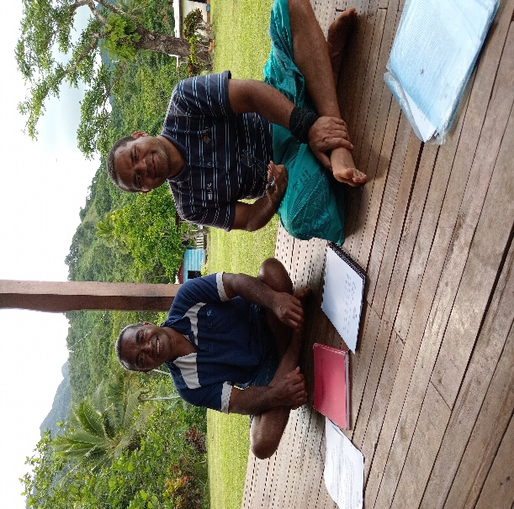
Photo 1: Researcher with a Participant in Case Study III
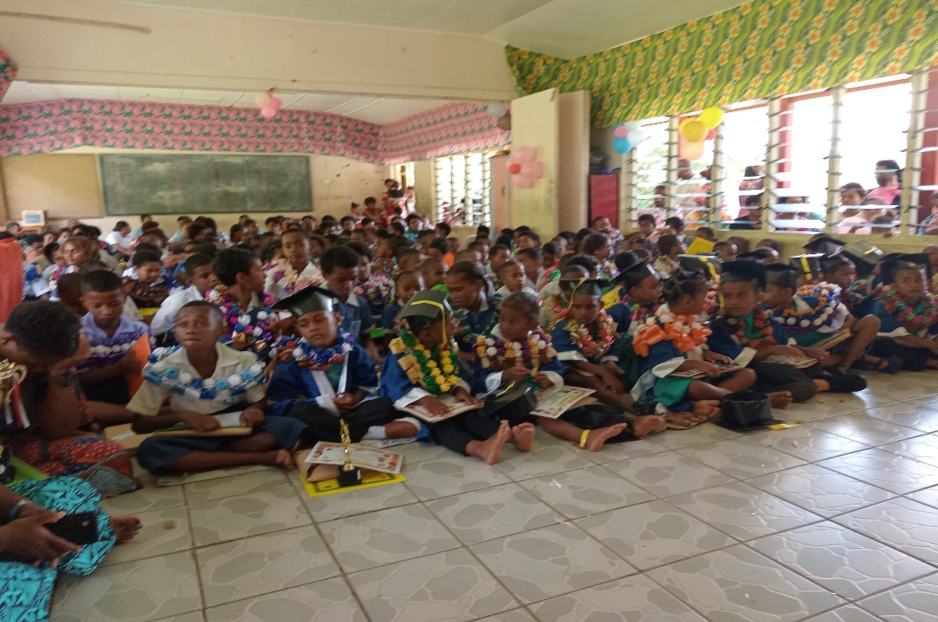
Photo 2: During the local (Case Study I & II) School 2024 Annual Prize giving that Researcher was invited as a Guest

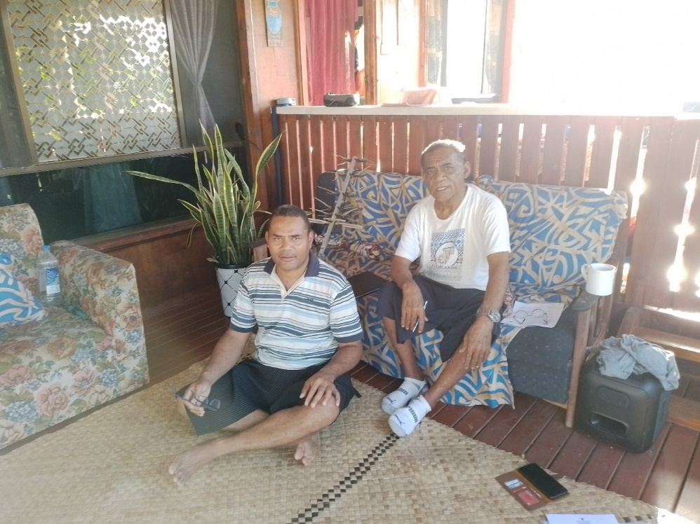
Photo 3: Researcher with the Waisea Rokocati an internal migrant in Case Study III at the veranda of his two Savusavu properties that he acquired from the proceeds of sales of kava that was planted on re-settled land.

