REBECCA THOMAS| MASTER OF ARTS IN DEVELOPMENT STUDIES |WAIPAPA TAUMATA RAU - UNIVERSITY OF AUCKLAND

Climate Mobility, Adaptation and Community Resilience in Fiji
Findings from the villages of Galoa and Yadua

Summary:
- Climate mobility in Fiji is shaped by intersecting environmental, development, social, cultural, and livelihood pressures rather than climate change alone. Communities in Galoa and Yadua are already responding through locally embedded adaptation practices and mobility strategies.
- Strong attachment to Vanua – understood here as the relational connection between land, people, ancestors, identity, customary obligations and place - underpins a preference for adaptation-in-place before relocation. In-situ adaptation, temporary movement, plantation homes, and circular mobility often operate together as layered adaptation pathways rather than as separate choices between “staying” and “moving.”
- Women, particularly younger women and mothers, emerged as central actors in sustaining adaptation, caregiving, household continuity, and community resilience. These contributions remain under-recognised in climate adaptation policy and planning.
- Combining the Fijian Vanua Research Framework (FVRF) with Participatory Visual Methods including Photovoice, mobility mapping, creative artworks, and illustrated fieldwork journalling supported reciprocal, culturally grounded, and participant-led climate mobility research. These methods revealed lived experiences and relational dimensions of adaptation often overlooked in conventional policy approaches.

What is the development issue?
Climate change is increasing environmental pressures across Fiji through sea-level rise, coastal erosion, flooding, saltwater intrusion, stronger cyclones, and changing rainfall patterns. These impacts threaten housing, livelihoods, food security, infrastructure, and cultural continuity, particularly in rural and coastal communities.

Fiji has become internationally recognised for its climate mobility policy response, particularly following the relocation of Vunidogoloa village in 2014 and the development of the Planned Relocation Guidelines. Six communities have now been relocated, while 42 communities are identified as requiring urgent relocation and approximately 830 communities are considered potentially at risk in coming decades.

However, climate mobility discussions in Fiji have focused strongly on planned relocation, potentially overlooking the smaller-scale and everyday ways communities are already adapting while remaining connected to their land, social relationships, and cultural identity.

This research examined climate mobilities in the villages of Galoa and Yadua between 2024 and 2025 using the Fijian Vanua Research Framework (FVRF) alongside Participatory Visual Methods including Photovoice, mobility mapping, Q-sort, illustrated fieldwork journalling, and directed artworks. This Master’s research formed part of the wider APN project, Moving to Remain in Place: Micro-Mobilities and Circular Migration as Adaptive Strategies to Gendered Climate Risks in Fiji and Samoa. The research was conducted with guidance from Professor Andreas Neef and Associate Professor Jesse Hession Grayman, and support from the Fijian research team: Renata Varea, Eseta Drova, Talei Rokotabua, and Rufino Varea. The team supported village protocols, cultural and linguistic guidance, participant engagement, , and interpretation. The research explored how communities understand and respond to environmental change, and how mobility decisions are shaped by social, emotional, cultural, and relational factors.

Stakeholders include village communities, women and caregivers, traditional leaders, government agencies, regional organisations, researchers, and development partners involved in climate adaptation and mobility planning. The findings are relevant to development actors including MFAT and Pacific climate agencies seeking to support adaptation approaches that are community-led, culturally grounded, and responsive to lived realities.

Existing scholarship on climate mobility in Fiji has increasingly challenged simplified narratives of climate displacement and planned relocation. Research has highlighted the importance of attachment to Vanua, relational place attachment, social norms, gender, kinship obligations, and community agency in shaping mobility and adaptation decisions (McNamara & Des Combes, 2015; Neef, Benge, & Boruff, 2018; McMichael & Katonivualiku, 2020; Yee et al., 2022).

Recent studies have also drawn attention to voluntary immobility, adaptation-in-place, partial relocation, and everyday forms of mobility that operate alongside more formal relocation processes. This research contributes to that literature by demonstrating how mobility pathways are layered and interwoven in everyday life, and by showing the value of combining the Fijian Vanua Research Framework with Participatory Visual Methods to better understand lived experiences of climate change.

Key findings
- Multiple intersecting drivers shape climate mobility
The research found that climate mobility in Galoa and Yadua was shaped not by a single trigger, but by overlapping environmental, economic, social, and cultural pressures.

Figure 1. “We have observed that the size, quality and quantity of our catch has drastically changed over the years. I think it’s due to the ocean warming.” (Participant, Yadua Village)
Photovoice findings identified climate change impacts, development pressure, livelihood loss and food security, and gendered impacts as key mobility drivers. Participants described coastal erosion, flooding, storm surges, crop damage, changing fishing access, and disrupted daily routines alongside concerns about land development, livelihoods, infrastructure, and future opportunities.

The findings suggest that climate mobility in Fiji cannot be understood through environmentally deterministic frameworks alone. Instead, mobility pathways emerge through the interaction of climate pressures with broader development, livelihood, and social change.

- Attachment to Vanua supports adaptation-first strategies
The research found that strong attachment to Vanua underpinned a preference to adapt in situ before considering relocation. Participants described deep emotional, cultural, ancestral, and relational connections to village land, burial grounds, family networks, and community identity.

Figure 2. “The village hall is significant to me because it’s a place where people can come together to evacuate during times of disasters”. (Participant Galoa village)

Communities were already engaging in multiple adaptation-in-place strategies including seawall construction, drainage improvements, mangrove planting, raised housing, evacuation planning, and maintaining plantation or inland homes. The findings suggest that remaining in place was not passive immobility, but an active and ongoing adaptation strategy grounded in attachment to Vanua and community continuity.

Figure 3. “My grandparents built this home…today I am the only surviving occupant, and this house holds so much sentimental value to me…it grounds me, it situates me, it’s a story of survival, a story of hope…. memories of my Mum and Dad echo through the walls.” (Participant, Yadua Village)

- Gendered and generational differences shape climate adaptation and mobility
The research found that climate impacts, adaptation practices, and mobility experiences differed across genders and generations, with young women emerging as central to in-situ adaptation and strongly committed to staying.

Figure 4. “My grandparents are both from Yadua and they are both buried here. This always holds me back and keeps me grounded here.” (Participant, Yadua Village)

Photovoice findings showed that younger women frequently expressed strong attachment to Vanua and resistance to permanent relocation, despite recognising increasing environmental pressures.
The findings suggest that climate adaptation policy should recognise women not only as disproportionately affected by climate change, but also as central actors in sustaining resilience and adaptation within village communities.

- Micro-mobility functions as a form of resilience
The research found that short-term, circular, and selective forms of mobility enabled households to sustain livelihoods, relationships, and identity across dispersed spaces.
Participants described temporary movement during disasters, maintaining plantation or inland homes, labour mobility, education-related movement, and movement between kinship networks as important adaptation practices. These forms of mobility were often flexible, ongoing, and reversible rather than permanent.
Rather than severing ties to place, micro-mobility enabled participants to maintain connections to Vanua while responding pragmatically to changing environmental and social conditions.
The findings challenge policy frameworks that focus primarily on permanent relocation and highlight the importance of recognising localised and everyday forms of mobility within climate adaptation planning.

- Combining the Fijian Vanua Research Framework with Participatory Visual Methods supported relational, reciprocal, and culturally grounded climate mobility research

The research found that combining the Fijian Vanua Research Framework (FVRF) with Participatory Visual Methods including Photovoice, mobility mapping, creative artworks developed from participant photographs, and illustrated fieldwork journalling created a culturally grounded and relational approach that was highly effective for climate mobility research in Fiji.

Photovoice generated rich participant-led insights into lived experiences of climate change, while the FVRF ensured that research processes were enacted through relational accountability, co-creation, care, and reciprocity. Q-sort and mobility mapping complemented these approaches by supporting interpretive rigour and spatial understanding.

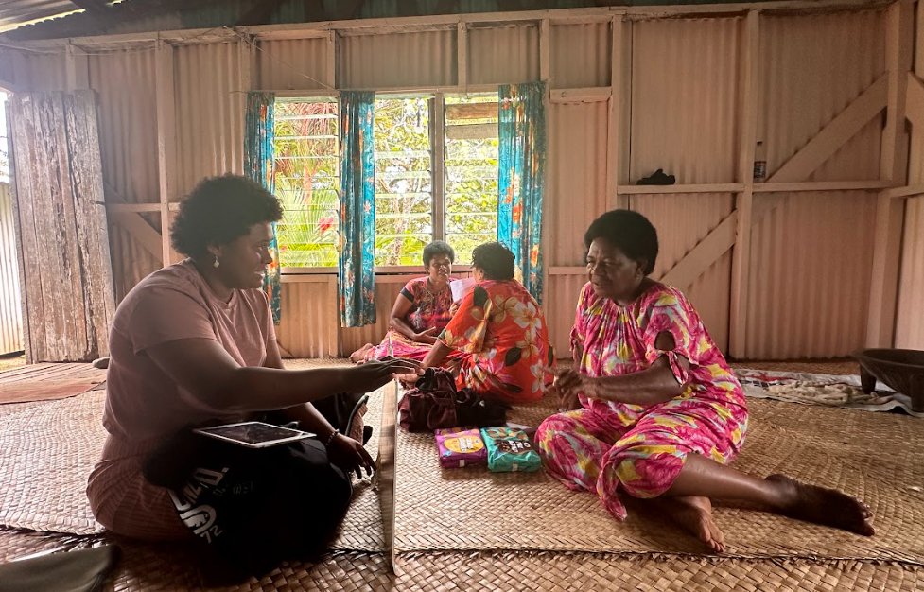
Figure 5. Collecting Photovoice images and stories with local participants in Galoa, September, 2025.

A creative artwork process developed within the research designed to extend the reciprocal principles of the FVRF. Participant-selected photographs were transformed into painted artworks by volunteer artists in Auckland and returned to communities as framed gifts.

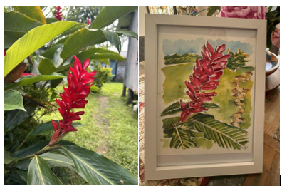
Figure 6. Participant directed artwork painted by volunteer in Auckland. Gifted to Participant in Galoa.

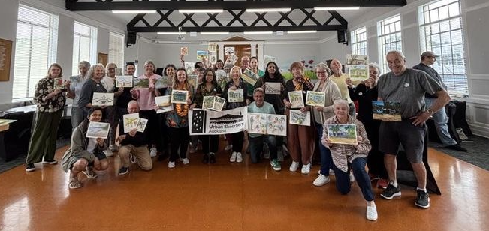

Figure 7. Volunteer artists from Urban Sketchers Auckland gathered to paint directed artworks to gift to participants from Galoa and Yadua.

Illustrated fieldwork journalling also supported slow observation, reflexive analysis, and collaborative interpretation across field visits, reviving an underused ethnographic practice within a Pacific research context.
Together, these approaches revealed emotional, relational, and cultural dimensions of climate mobility that may not have emerged through conventional research methods alone.

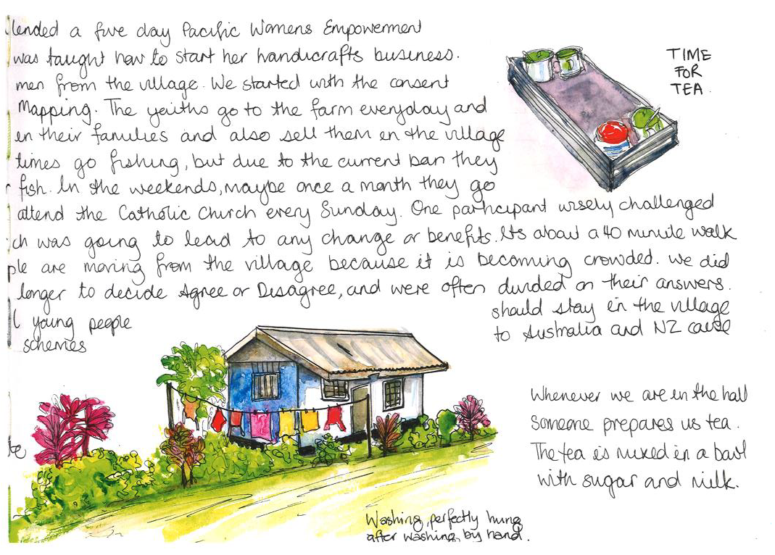Figure 8. Researcher’s fieldwork journal entry 19th September 2025, Galoa Village
Implications
- Expand climate adaptation policy beyond planned relocation
Fiji climate mobility policy and development partners should recognise micro-mobility, circular mobility, temporary movement, plantation homes, and second homes as legitimate forms of climate adaptation alongside planned relocation.
Current climate mobility frameworks focus strongly on permanent relocation, despite evidence that many communities are already adapting through smaller-scale and locally embedded mobility strategies.

Recognising these practices within adaptation planning would improve the visibility and support available for community-led adaptation responses.

- Support community-led adaptation-in-place
- MFAT, partner governments, and development organisations should continue investing in locally identified adaptation priorities that enable communities to remain safely in place where desired.

- The findings suggest that adaptation-in-place remains a preferred and meaningful strategy for many communities and should continue to be supported alongside relocation planning.

- Research participants identified practical adaptation priorities including:
- seawalls
- drainage systems
- raised walkways and evacuation infrastructure
- mangrove planting
- safer communal buildings
- local food security strategies

- Embed gender-responsive adaptation planning

- Climate adaptation policy should recognise women’s caregiving, household labour, and community roles as critical forms of resilience work rather than treating women solely as vulnerable populations.

- The findings suggest that women, particularly younger women and mothers, play central roles in sustaining adaptation, continuity, and social cohesion within village communities.

- Adaptation planning should therefore ensure women are meaningfully included in climate mobility discussions, local decision-making, adaptation funding processes, and community planning initiatives.

- Use culturally grounded and participatory approaches in climate adaptation planning

- The research demonstrated that the Fijian Vanua Research Framework (FVRF), used alongside Participatory Visual Methods, can support more relational, culturally grounded, and participant-led understandings of climate adaptation and mobility.

- Approaches such as Photovoice, mobility mapping, and creative visual activities can help governments and development organisations better understand lived experiences of environmental change, adaptation priorities, and community perspectives that may not emerge through conventional consultation processes alone.

- The research also highlights the importance of reciprocity, ongoing relationships, and community return within Pacific climate research and adaptation practice.

- 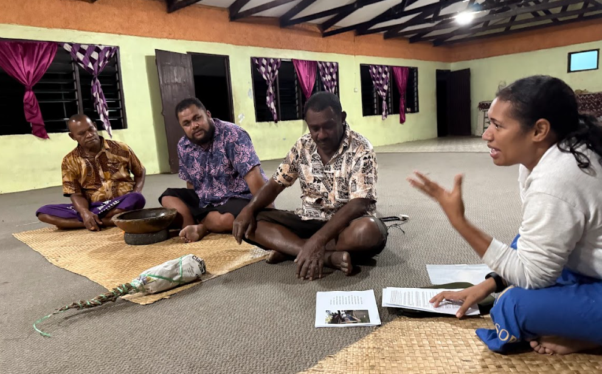
Figure 8. Eseta from the Fijian research team guides us through the Sevu Sevu ceremony in Yadua, an important step in the Fijian Vanua Research Framework.

Limitations and further research
This research focused on two case study villages, Galoa and Yadua, and findings may not reflect climate mobility experiences across all Fijian or Pacific communities.

The research was qualitative and participatory, prioritising lived experience and relational understanding rather than statistical generalisation.

Climate mobility pathways are also changing over time in response to environmental change, development pressures, livelihoods, and intergenerational change. Longer-term research would help examine how these adaptation pathways evolve.

Further research is needed on:
- climate micro-mobility in other Pacific contexts
- the interaction between climate and development pressures
- gendered and intergenerational mobility experiences
- long-term adaptation-in-place outcomes
- the use of Pacific research methodologies and Participatory Visual Methods in climate adaptation planning

These limitations reinforce the importance of ongoing, locally grounded, and participatory climate mobility research in the Pacific.

References
Farrelly, T., & Nabobo-Baba, U. (2014). Talanoa as empathic apprenticeship. Asia Pacific Viewpoint, 55(3), 319–330. https://doi.org/10.1111/apv.12060

Government of Fiji. (2018). Planned Relocation Guidelines: A framework to undertake climate change-related relocation. Ministry of Economy.

Kuschnir, K. (2020). Ethnographic drawings and the benefits of using a sketchbook for fieldwork. In Ecologies Design (pp. 149–157). Routledge. https://doi.org/10.4324/9780429279904-19

McMichael, C., & Katonivualiku, M. (2020). Thick temporalities of planned relocation in Fiji. Geoforum, 108, 286–294. https://doi.org/10.1016/j.geoforum.2019.06.012

McNamara, K. E., & Des Combes, H. J. (2015). Planning for community relocations due to climate change in Fiji. International Journal of Disaster Risk Science, 6(3), 315–319. https://doi.org/10.1007/s13753-015-0065-2

Nabobo-Baba, U. (2008). Decolonising framings in Pacific research: Indigenous Fijian Vanua Research Framework as an organic response. AlterNative: An International Journal of Indigenous Peoples, 4(2), 140–154. https://doi.org/10.1177/117718010800400210

Neef, A., Benge, L., & Boruff, B. (2018). Climate adaptation strategies in Fiji: The role of social norms and relocation. In Y. Matsuda (Ed.), Climate Change and Development Policy (pp. 137–160). Springer.

Piggott-McKellar, A., McMichael, C., & Powell, T. (2021). Generational retreat: Adaptation to climate change in a Fijian coastal village. Regional Environmental Change, 21(2), 80.

Wang, C., & Burris, M. A. (1997). Photovoice: Concept, methodology, and use for participatory needs assessment. Health Education & Behavior, 24(3), 369–387.

Yee, M., McNamara, K. E., Piggott-McKellar, A. E., & McMichael, C. (2022). The role of Vanua in climate-related voluntary immobility in Fiji. Frontiers in Climate, 4, 1034765. https://doi.org/10.3389/fclim.2022.1034765

Acknowledgments
Vinaka vakalevu to the communities of Galoa and Yadua for their generosity, participation, and collaboration throughout this research.

This research was supported by The Aotearoa New Zealand International Development Studies Network (DevNet) through the New Zealand Postgraduate Development Field Research Award, and by the Asia-Pacific Network for Global Change Research (APN) through the project Moving to Remain in Place: Micro-Mobilities and Circular Migration as Adaptive Strategies to Gendered Climate Risks in Fiji and Samoa.

The author also gratefully acknowledges the guidance and support of Professor Andreas Neef, Associate Professor Jesse Hession Grayman, and the Fijian research team: Renata Varea, Eseta Drova, Talei Rokotabua, and Rufino Varea, whose knowledge, care, and collaboration were central to this research, and the Auckland Urban Sketching group for their volunteer art works.

